05b Internal Consistency and Item Analysis

Topics
1. Internal Consistency Logic
2. Employment Thoughts Data
3. Cronbach’s Alpha and Item Analysis
4. Alpha and Item Analysis Statistics for Perceived Control
5. Comparison of Results with Menon
6. Dimensionality
7. Reverse Scoring and Composite Scores
8. Published Examples

1. Internal Consistency Logic

Indicators of constructs should demonstrate internally consistent responses. This means responses on one indicator should correlate positively, and moderately or strongly, with responses to another indicator unless one indicator requires reverse scoring, then the correlation should be negative and of moderate or strong strength.

It is possible to logically identify items that are inconsistent:
- Assume an extreme position on the measured construct when responding to indicators
- Examine whether items and responses fit with other indicators, i.e., do they measure same thing, same dimension or domain?

Table 3 and 4 examples:

http://www.bwgriffin.com/gsu/courses/edur7130/content/reliability.htm

2. Employment Thoughts Data

Some of you completed questionnaire twice for this course. The items were selected from Menon (2001) and were designed to measure three employment related constructs. Responses to each item scaled from Strongly Disagree (1) to Strongly Agree (6).

Perceived Control
Q1: I can influence the way work is done in my department
Q2: I can influence decisions taken in my department
Q3: I have the authority to make decisions at work

Goal Internalization
Q4: I am inspired by what we are trying to achieve as an organization
Q5: I am inspired by the goals of the organization
Q6: I am enthusiastic about working toward the organization’s objectives

Perceived Competence
Q7: I have the capabilities required to do my job well
Q8: I have the skills and abilities to do my job well
Q9: I have the competence to work effectively

None of these required reverse coding, so composite variables can be computed directly by taken the mean across the three indicators for each construct.

SPSS data file link (can be found in Reliability section on course web page):

http://www.bwgriffin.com/gsu/courses/edur9131/2018spr-content/06-reliability/06-EDUR9131-EmploymentThoughts-Merged.sav

Items with _1 are from the first administration, and those with _2 are from the second.

3. Cronbach’s Alpha and Item Analysis

Check internal consistency for each construct based upon first administration
- Compare reliability estimates with Menon
- Alpha and Test-retest
- Menon (2001): p. 171 alpha and test-retest reliabilities reported on 9 item scale

http://www.bwgriffin.com/gsu/courses/edur9131/2018spr-assignments/02-Menon-ST-2001.pdf

Steps in assessment of internal consistency:
- Check for outliers and missing data (i.e., scatterplots, frequency displays, etc.)
- Examine correlations among indicators
  - correlations should be moderate or strong
  - negative correlations signal scores may need to be reverse scored
  - weak correlations may indicate items that do not function well with other indicators of the construct, could be due to sample data or theoretical issues with wording of item
- Calculate Cronbach’s alpha
- SPSS reports two Cronbach's alpha values if correlations are requested
  - Cronbach's alpha = calculated on raw data items that usually have different variances, unequal variances, based upon covariances, not correlations
  - Cronbach's alpha based on standardized items = estimate of reliability if all items have equal variances; called Spearman-Brown stepped-up reliability coefficient; value of alpha obtained if all variables are standardized to have equal variances
- Item Analysis Information
  - How well does this item contribute to measurement of the construct/dimension relative to other items?
  - Correlations among items – example with Perceived Control items
  - Corrected item-total correlation – example with Perceived Control items
  - Alpha if item deleted – example with Perceived Control items
  - Important Considerations
    - Avoid making mechanical decisions about retaining or removing items
    - Consider carefully theoretical contribution of item to measurement of targeted construct
    - Goal is not just to maximize internal consistency (e.g. alpha) because this leads to narrow content items which may limit validity of construct measured
    - Goal is to create scale that maximizes validity with acceptable, good, or excellent reliability – better to have items that offer wider assessment of construct than narrow items that omit important components of a construct
- Students run above analysis on
  - Goal Internalization
  - Perceived Competence

Cronbach’s alpha interpretation:
“Cronbach's alpha can be interpreted as the percent of variance the observed scale would explain in the hypothetical true scale composed of all possible items in the universe. Alternatively, it can be interpreted as the correlation of the observed scale with all possible other scales measuring the same thing and using the same number of items.” Garson (2016) p.43

4. Alpha and Item Analysis Statistics for Perceived Control

SPSS Data Entry
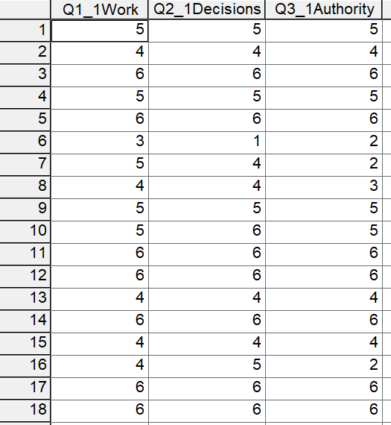

SPSS Commands
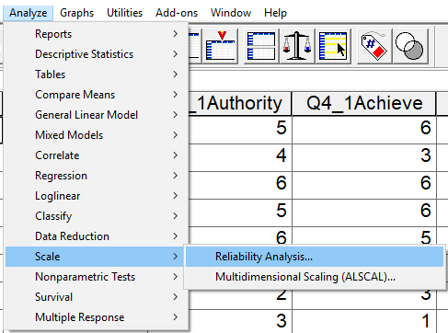

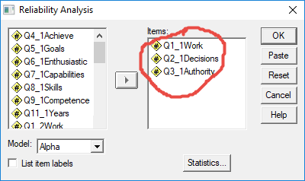

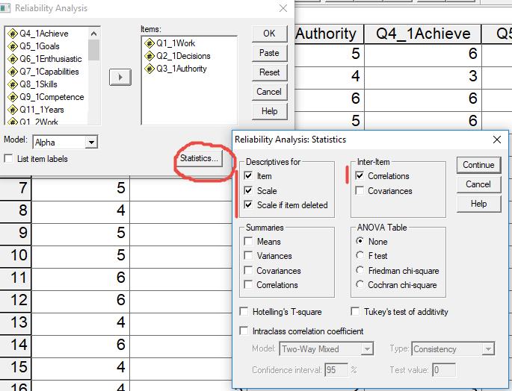

SPSS Results
Overall alpha
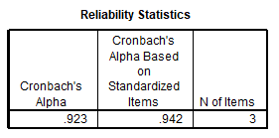

Item statistics and correlations
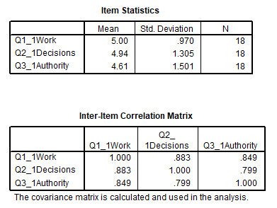

Item-total Statistics
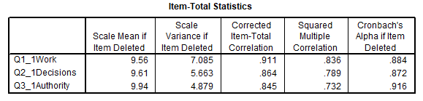

Questions 2 and 3 added (summed)
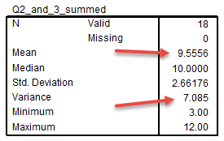

Correlation between Question 1 and sum of Questions 2 and 3
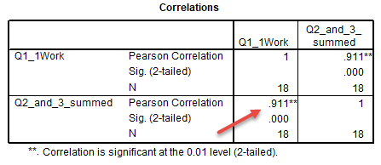

Alpha for Questions 2 and 3 (omitting Questions 1)
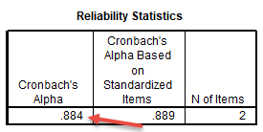

5. Comparison of Results with Menon

Note that estimates of reliability are sample specific so one should always check reliability for each sample. It can be useful to know how well an instrument behaves across samples. How do our results compare with results reported by Menon (2001) p. 164? Use results from the 1st administration of the employment thoughts questionnaire.

For Cronbach’s alpha we found:
 |  | Menon  Alpha | EDUR 9131  Alpha
P. Control | = | .83 | .923
Goal Internalization | = | .88 | .986
P. Competence | = | .80 | .947
6. Dimensionality
- Cronbach's alpha is not a measure of dimensionality (does not assess internal structure, use factor analysis instead)
- should not be used as overall internal consistency measure on instruments with diverse constructs
  - calculate alpha only for uni-dimensional constructs
  - if more than one construct present, calculate alpha separately for each
  - not appropriate for items not designed to form a single construct, e.g., inappropriate to calculate alpha for sex, race, and age
- What happens if we calculate overall alpha on the nine items of Employment Thoughts data?
  - Might be okay if those three dimensions are part of an overall measure of employment empowerment otherwise overall alpha should be used for each construct separately
  - Likely lower alpha despite alpha becoming larger with more items due to different nature of constructs and constructs may not be strongly related

Below is part of a post I made to a discussion group explaining why Cronbach’s alpha cannot be used as an assessment for uni-dimensionality.

Cronbach's alpha is not designed to measure internal structure (think in terms of factor analysis here), but can provide a measure of internal consistency (think in terms of mean inter-item correlations here), although that appears to be questionable too.
As noted by Bruce above alpha is a function of covariances (and correlations), and it is also a function of number of items. Here is a formula for Cronbach's alpha in terms of mean inter-item correlations (m[r] ) and the number of items (k):
alpha = (k * m[r] ) / ( 1 + (k - 1) * m[r])
where
k = number of items on instrument used to calculate alpha,
m[r] = mean correlation among the k items.
Given this formula, the following two scenarios are possible:
1. Researcher has instrument with 4 items designed to measure the same construct, so there should be one factor here. The mean correlation among items is m[r] = .5862. Using the formula above:
alpha = (k * m[r]) / (1 + (k - 1) * m[r])
alpha = (4 * .5862) / (1 + (4 -1) * .5862) =~ .85
2. Researcher has an instrument designed to measure 4 unrelated or weakly related constructs. Factor analysis reveals that the internal structure to contain four distinct factors. There is a total of 50 items on this instrument (10 items for factor A, 8 items for factor B, 17 items for factor C, and 15 items for factor D). The mean correlation among all 50 items is m[r] = .1018. If one erroneously applies the alpha reliability formula to these 50 items, the result would be:
alpha = (k * m[r]) / (1 + (k - 1) * m[r])
alpha = (50 * .1018) / (1 + (50 -1) * .1018) =~ .85
Note that Cronbach’s alpha is the same, within rounding error, in both situations, yet the internal structure is very different in both cases. These two examples demonstrate that Cronbach’s alpha is not designed to reveal internal structure of items. Better to use EFA or CFA to assess structure.
These examples also illustrate that Cronbach’s alpha also does not reveal much about the mean correlations among items because alpha is so influenced by the number of items.

7. Reverse Scoring and Composite Scores

Brief review
- Formula:
  - Reversed Score = (minimum score) + (maximum score) – actual score
- Calculation Check: Correlate original and reversed item, r = -1.00
- Composite: Sum vs. Mean (see presentation above)
- How affect reliability?
  - Weakens alpha if items not reversed scored
  - Composite score reliability lowered
  - Composite score not interpretable

Example: Leisure Activities
- Complete Leisure Activities questionnaire: http://goo.gl/forms/JrMtZmVHF5
- Leisure Activities data: https://tinyurl.com/yb7ted67
- Save to SPSS file, upload
- Assess reliability, form composite

How to determine which items are reversed
(a) Logical check reversed items – assume extreme position and answer each item
(b) Mechanical check for reversed items – examine correlation matrix.

SPSS Results from an old sample; current sampled data will produce different correlations and alpha values.
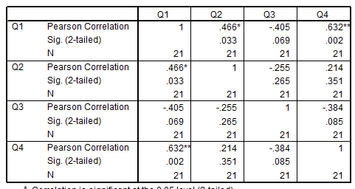

Reverse Scoring in SPSS
Transform Compute : then enter equation and name of new variable
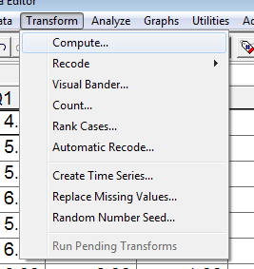

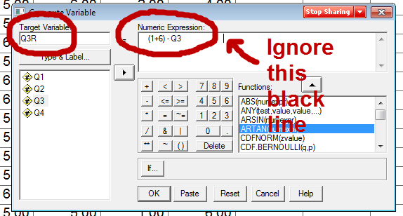

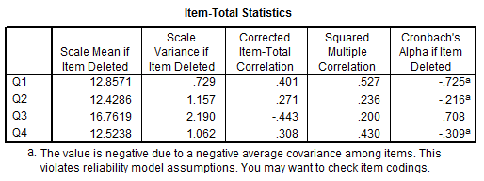

8. Published Examples
- Menon 2001: Reported in text format; p. 164 Cronbach's alpha and test-retest reliabilities reported on 15 item scale; p. 171 Cronbach's alpha and test-retest reliabilities reported on 9 item scale
- Kanning, Böttcher & Herrmann 2012: Reported in table format; see Table 2 p. 145 (alpha and test-retest)
- Frey & Bos 2012: Reported in table format; see Table 4 p. 34 (alpha, item-total correlations minimum and maximum)
- Fassinger 1994: Development and Testing of the Attitudes Toward Feminism and The Women's Movement (FWM) Scale. Item-total correlation, Table 1 p. 395

References

Garson, G. D. (2016). Validity & Reliability. Statistical Associates Publishing. Asheboro, NC.

Menon, S.T. (2001). Employee empowerment: An integrative psychological approach. Applied Psychology: An International Review, 50, 153-180.

