02c – Review of Correlated Samples t-test

3. Correlated Samples (or Paired-samples) t-test

3a. Characteristics

Correlated samples t-test:
- used to compare two sets of matched (paired) scores on a quantitative variable
- IV = categorical (nominal) variable identifies the sets of matched scores:
  - before-after: people measured weight before and after diet
  - natural pairs: compare twins or husband-wife on something
  - matched scores: compare achievement scores between classes after matching students on motivation levels
- t-ratio is formed just like with independent samples t-test - compare group mean differences on the dependent variable and this mean difference is divided by a standard error of that difference
- the larger the t-ratio (in absolute value), the more evidence that sets of scores differ

3b. Reading t-test Results

Example 1
Source: Hughes, Nzekwe, & Molyneaux (2013). The Single Sex Debate for Girls in Science: A Comparison Between Two Informal Science Programs on Middle School Students' STEM Identity Formation. Research in Science Education.

Study Purpose: Female performance differences in female-only vs coed classes?
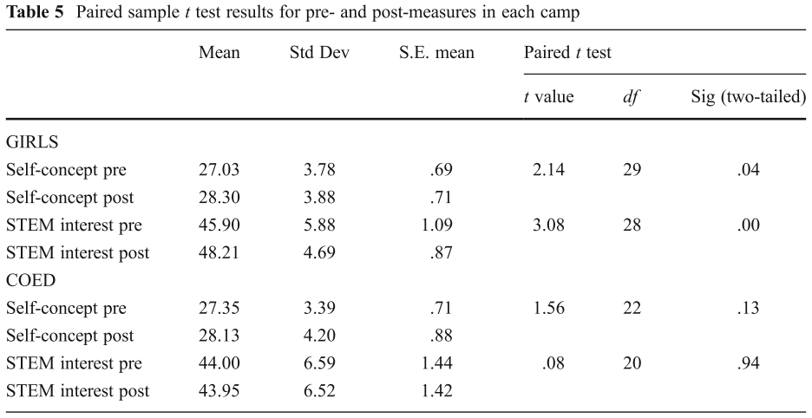

Example 2
Source: Johnson, Burke, Brinkman, & Wade (2017). Development and validation of a multifactor mindfulness scale in youth: The Comprehensive Inventory of Mindfulness Experiences–Adolescents (CHIME-A). Psychological Assessment, 29, 264–281.

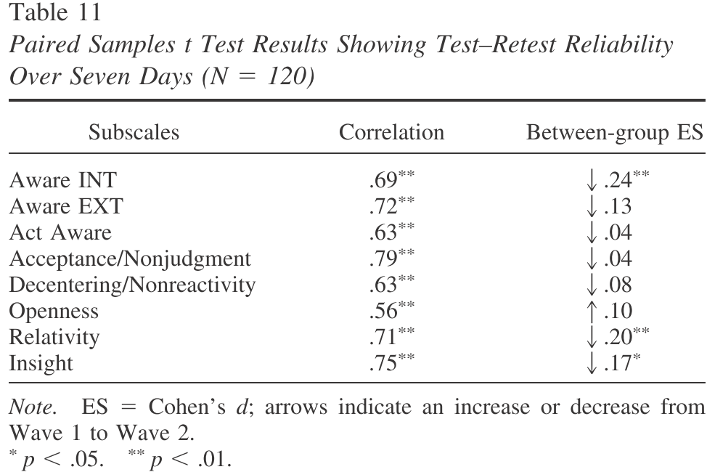

3c. Worked Example

3c1. Self-efficacy Test-retest Data

Does an instrument designed to measure academic self-efficacy administered to a group of participants twice, one week apart, show similar mean scores on academic self-efficacy? Note that the scale provides a self-efficacy score that ranges from 1 = low to 7 = high.

Student | Self-efficacy Time 1 | Self-efficacy Time 2
A | 6.00 | 6.25
B | 5.25 | 5.75
C | 3.50 | 4.50
D | 4.25 | 5.00
E | 2.75 | 2.75
F | 4.75 | 5.25
G | 5.25 | 5.00
H | 6.25 | 6.00
I | 3.75 | 4.25

http://www.bwgriffin.com/gsu/courses/edur8131/data/test-retest-selfefficacy.sav

3c2. SPSS Commands and Results

Data entry in SPSS (two columns, one for each time or data column)
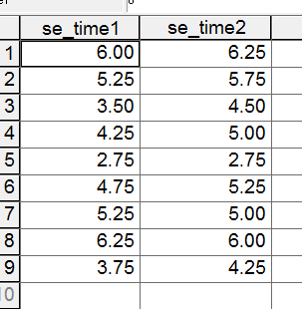

SPSS Commands
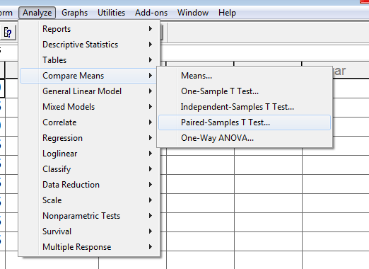

Select two columns of data to compare then move both over to paired variables box.
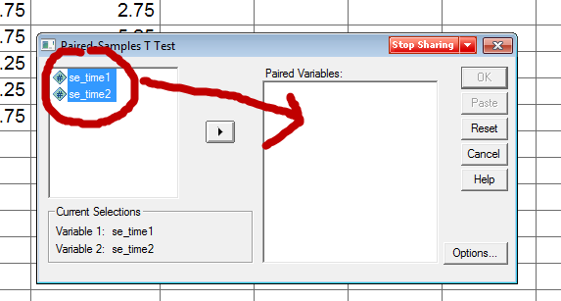

SPSS Results
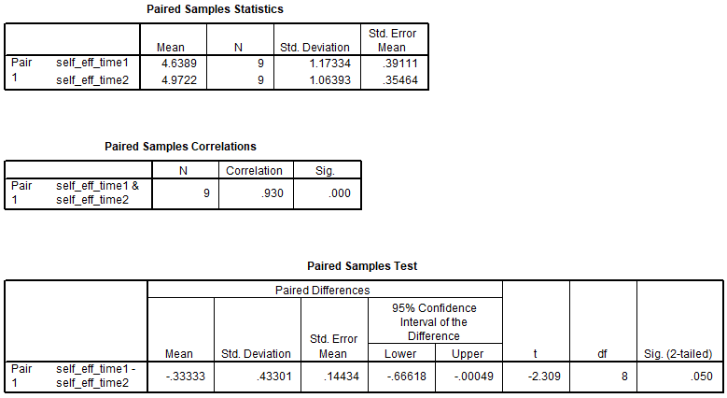

3c3. Null Hypothesis

What is the null for these data?

Written:
There is no difference in mean self-efficacy scores between the first and second administration of the self-efficacy measure.

Symbolic:
Ho: µ₁ = µ₂
or
Ho: µ₁ – µ₂ = 0.00

3c4. Reject or Fail to Reject Ho?

Would we reject or fail to reject given the SPSS output and α = .05?
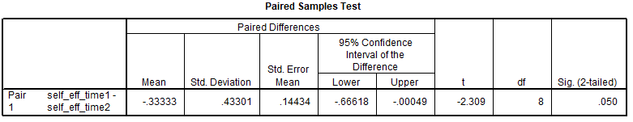

If p ≤ α reject Ho; if p > α fail to reject Ho

Since p = .05 and, would this be reject or fail to reject?

How could we use the confidence interval to test the null hypothesis of no mean difference?

Since 0.00 does not lie within the 95% CI, one would reject since 0.00 is not one of the possible values for the mean difference between groups.

3d. APA Style Presentation

Note: Show APA Word document on web page.

Table 7
Results of t-test and Descriptive Statistics for Academic Self-efficacy Over Time
 | First  Admin. |  |  | Second Admin. |  |  | 95% CI for Mean Difference
Outcome | M | SD |  | M | SD | n |  | r | t | df
Aca. Self-efficacy | 4.64 | 1.17 |  | 4.97 | 1.06 | 9 | -0.67, -0.0005 | .93* | -2.31* | 8
* p < .01.

Inference and interpretation:

Results show that there is a statistically significant mean difference, at the .05 level, between the first administration of the instrument and the second administration for academic self-efficacy. Mean academic self-efficacy appears to be greater for the second administration of the instrument.

