02b – Review of Independent Samples t-test

2. Two-samples t-test

2a. Characteristics
Two independent samples t-test
- used to compare two groups on a quantitative dependent variable
- IV = categorical (nominal) variable with two groups, DV = quantitative variable (examples, IV = sex, DV = math scores; IV = location of instruction [on-line vs on campus], DV = level of confidence in class)
- t-ratio is formed by comparing group mean differences on the dependent variable (compare mean math scores between males and females), and this mean difference is divided by a standard error of that difference
- the larger the t-ratio (in absolute value), the more evidence that groups differ

2b. Reading t-test Results

Example 1
Goodman et al. (2005). Mother expectation of bother and infant attachment behaviors as preditors of method and child communication at 24 months in children of methadone-maintained women. Infant Mental Health Journal, 26, 549-569.

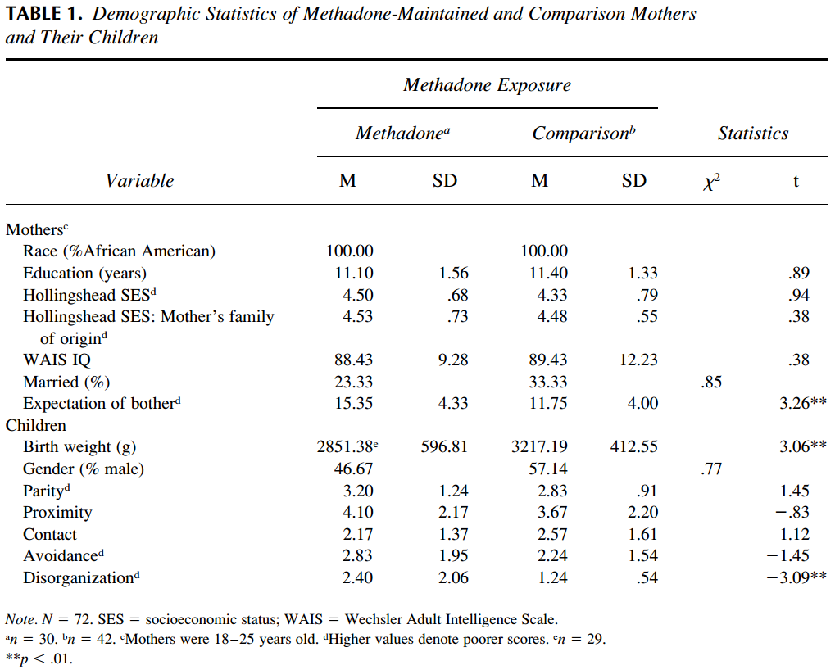

2c. Worked Example

Is there a change in mean heart rate per minute before and after taking blood pressure medication for a single individual? Below are data for this individual.

Heart Rate |  |  | Heart Rate
After |  |  | Before
50 | 62 |  | 57 | 59
50 | 57 |  | 58 | 57
48 | 49 |  | 56 | 53
49 | 47 |  | 55 | 63
44 | 54 |  | 55 | 54
49 | 48 |  | 53 | 51
45 | 44 |  | 53 | 51

2c1. SPSS Data and Results

http://www.bwgriffin.com/gsu/courses/edur8131/data/heartrate.sav

Commands
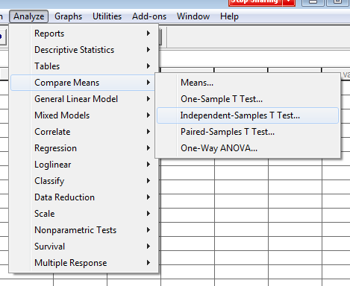

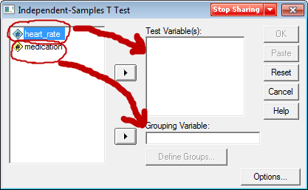
Note, Medication 1 = after medications, 0 = before medications

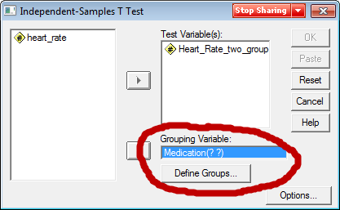

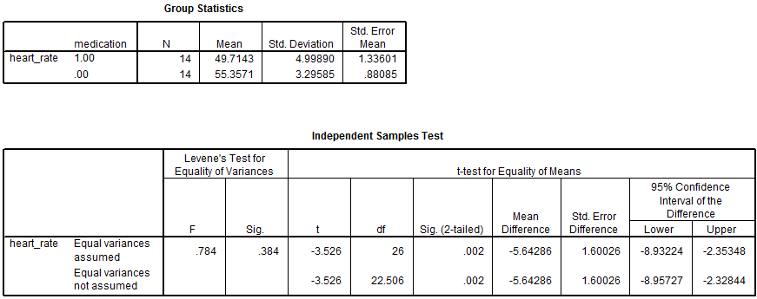

2c2. Equal vs. Unequal Variances

For EDUR 9131, we will use the row entitled “Equal Variances Assumed”

Not needed for EDUR 9131, but for those interested, use Levene’s to test group variances:
- Levene’s Test assesses this null, Ho: variance group 1 = variane group 2
- If fail to reject, we assume the two groups have similar variances; if reject, then assume group variances are not equal.
- If variances are not equal, that affects how p-values and CI are calculated for the t-test, so an adjustment is made.
- If sig. (p-value) for Levene’s is less than .10 or .05 (you pick alpha here), then variances appear to be different so use “Equal variances not assume” row,
- but if the Levene’s p-value (sig. value) is greater than .10 or .05 then use “Equal Variances Assumed” row.

2c3. Null Hypothesis
What is the written null hypothesis?

Recall that the IV is blood pressure medication use (before and after using medication) and the DV is heart rate.

There is no difference in mean heart rate before and after taking blood pressure medication.

What is the symbolic Ho?

Ho: µ_{before} = µ_{after}
or
Ho: µ_{before} – µ_{after} = 0.00 (most commonly tested by statistical software)

2c4. Reject or Fail to Reject Ho?

What information from SPSS output is used to determine whether Ho is rejected?
Also, would we reject or fail to reject Ho (setting α = .05)?
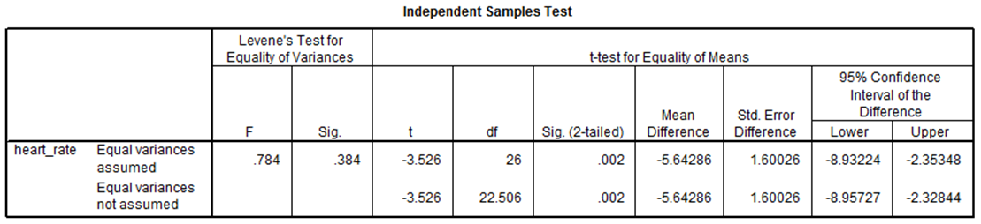

Recall decision rule for p-values:
If p ≤ α reject Ho; if p > α fail to reject Ho

p-value = t-test Sig(2-tailed) ---- this is not Levene’s sig; Levene’s only tests
whether variances of two groups are equal

Since p = .002 and since .002 < .05, reject Ho

confidence interval, if 0 is within the CI, fail to reject; if 0 is not within CI, reject Ho

2d. APA Styled Results

Note: Show APA Word document on web page.

Table 5
Results of t-test and Descriptive Statistics for Heart Rate per Minute by Medication Usage
 | Medication Usage |  |  |  |  |  |  | 95% CI for Mean Difference
 | After Usage |  |  |  | Before Usage
 | M | SD | n |  | M | SD | n |  | t | df
Heart Rate | 49.71 | 5.00 | 14 |  | 55.36 | 3.30 | 14 | -8.93, -2.35 | -3.53* | 26
* p < .05.

Two components to the written results, inference and interpretation.

There is a statistically significant mean difference in heart rate per minute before and after taking blood pressure medication. Results show that the blood pressure medication reduced heart rate by about 5.5 beats per minute.

