02a – Review of Correlation

Note: For those interested, the following table can be used to identify various statistical tests by their characteristics:

http://www.bwgriffin.com/gsu/courses/edur8131/content/WhichStatisticalTestToUse.pdf

1. Pearson Correlation

1a. Characteristics

Pearson r
- r = Pearson’s correlation coefficient
- used to assess a linear relation between two quantitative variables
- ranges from -1.00 to 1.00
- r = 0.00 means no linear relation, but there may be a non-linear relation
- the closer r to 1.00 in absolute value, the stronger the relationship, the closer to 0.00, the weaker the relationship

1b. General Interpretation

a. Found r = -.77 between car horsepower and MPG. What does this tell us; what is the interpretation of this correlation in terms of the variables examined?

Negative relationship ---- The greater the car horsepower, the lower will be expected MPG.

b. Found r = .40 between reading self-efficacy and reading test scores. What does this tell us; what is the interpretation of this correlation in terms of the variables examined?

Positive relationship --- The higher reading self-efficacy, the higher will be reading test scores, on average.

c. Found r = .00 between student weight and interest in mathematics. What does this tell us?

No linear relationship --- student weight and interest in mathematics does not appear to be linearly related; one cannot predict interest in mathematics based upon one’s weight.

1c. Reading Published Correlation Tables

Example 1
Menon, ST (2001). Employee empowerment: An integrative psychological approach. Applied psychology: An international review, 50, 153-180.

Source:
http://www.bwgriffin.com/gsu/courses/edur9131/activities/Menon_ST_2001_employee_empowerment_Applied_Psychology.pdf
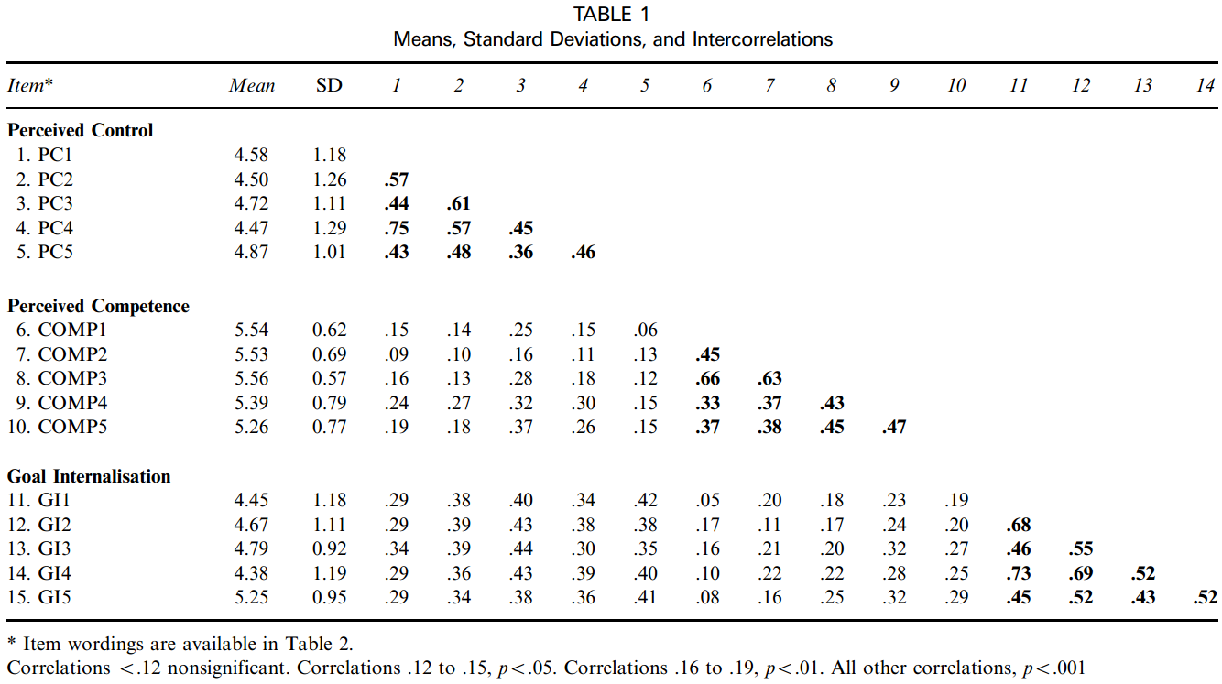

Example 2
Source: Pintrich & De Groot (1990) Motivational and Self-Regulated Learning Components of Classroom Academic Performance. Journal of Ed. Psychology, 82, 33-40.
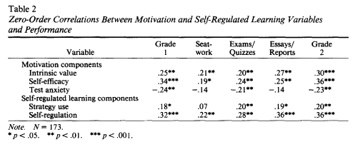
Example 3
Source: Martinez, Gudino, & Lau (2013) Problem-Specific Racial/Ethnic Disparities in Pathways from Maltreatment Exposure to Specialty Mental Health Service Use for Youth in Child Welfare. Child Maltreatment, 18, 98-107.
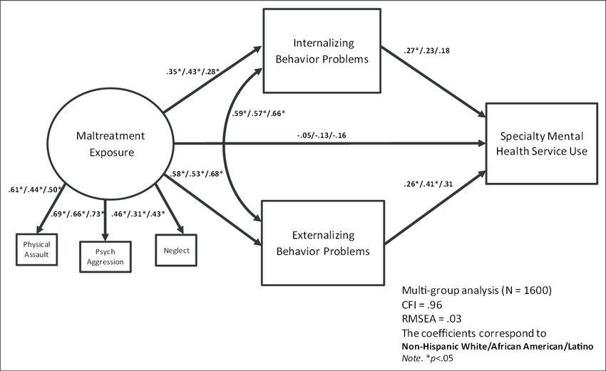

1d. Worked Example

Data file with three variables

(a) math_sat
Average mathematics SAT scores in each state.

(b) pupil_teacher_ratio
Average ratio of students to teacher in each state; a higher number indicates more students per teacher.

(c) average_teacher_salary
Average salary per teacher in each state in thousands of dollars, thus a figure of 25.000 means the average salary per teacher is $25,000 per year.

Data can be found here:
http://www.bwgriffin.com/gsu/courses/edur8132/tests/math_sat.sav

Concerning Math SAT, how might teacher salary and teacher-student ratio be related to math SAT scores?

Predicted relationships?
a. Math SAT and Teacher Salary --- how related?

Positive – as salary increases math SAT increases, but maybe no relationship. Is a negative relationship likely?

b. Math SAT and Student-Teacher Class Size/Ratio --- how related?

Negative – as class size increases math SAT declines; or maybe no relationship.

What would be the NULL hypotheses for the above predictions?

Written:
No correlation between Math SAT and Teacher Salary.
No correlation between Math SAT and Class size (Student-teacher ratio).

Symbolic:
Ho: ρ_{(SAT,Salary)} = 0.00
Ho: ρ_{(SAT,Class)} = 0.00

ρ = Greek rho, population correlation coefficient
r = English r, sample correlation coefficient

For each of the questions below, set alpha = .05

SPSS Commands
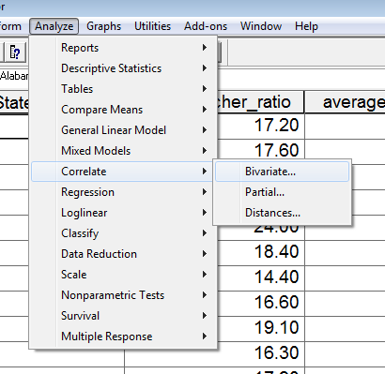

Move variables to be correlated to variables box
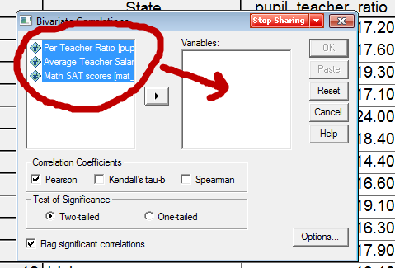

Select Options then place mark next to Means and Standard deviations to obtain descriptive statistics for each variable
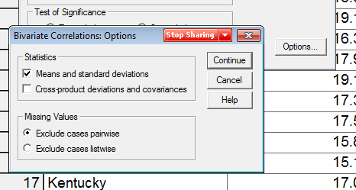

SPSS Results
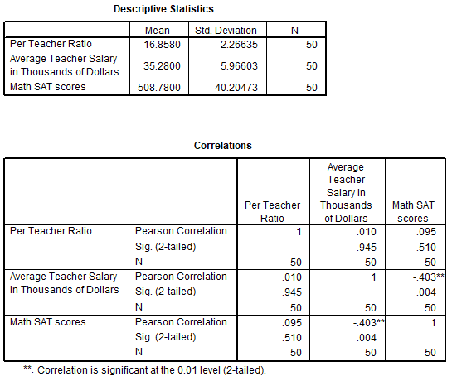

a. What is the correlation between Math SAT and student-teacher ratio (find correlation with SPSS). Do we reject or fail to reject Ho (α = .05)?

Recall decision rule for p-values:
If p ≤ α reject Ho; if p > α fail to reject Ho

r = .095 (p = .51, .51 is larger than alpha = .05 and alpha = .01, so fail to reject)

Pearson Correlation r = .095
Pearson Correlation p-value for that r is p = .51

How would this be interpreted?
There is no association between class size ratio and SAT math scores ---- on average class size does not appear to predict or be related to SAT math scores.

Scatterplot of data.
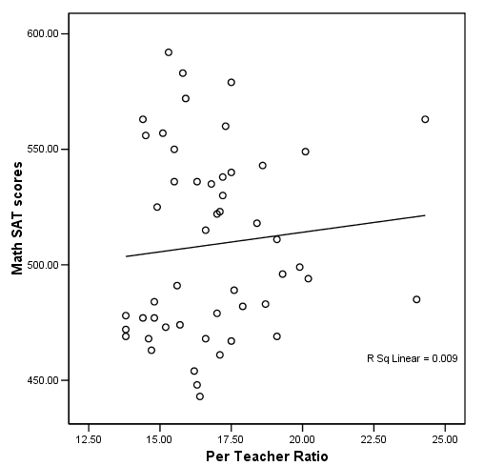

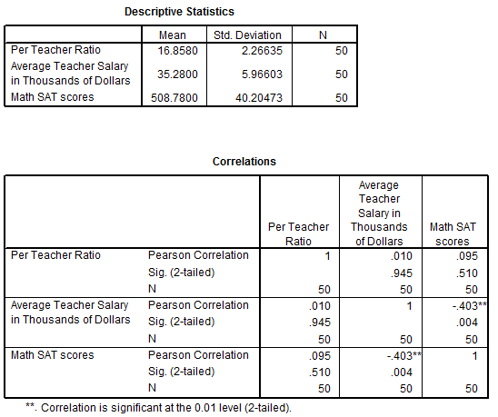

b. What is the correlation between Math SAT and teacher salary (find correlation with SPSS).

If α = .05, do we reject or fail to reject Ho?

Recall decision rule for p-values:
If p ≤ α reject Ho; if p > α fail to reject Ho

r = -.403 (p = .004, which is less than alpha = .05 and also less than alpha = .01, so reject Ho)

How would this be interpreted?
As teacher salary increases, SAT math scores decline

Scatterplot of scores.
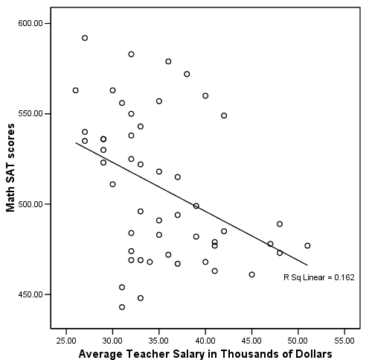

SPSS Results
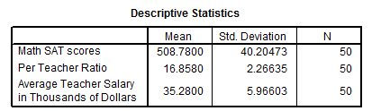

1e. APA Style Presentation

[Note location of APA styled example presentation on course website]

Table 1
Correlations and Descriptive Statistics for State-level Mean Scores for Math SAT, Student-teacher Ratio, and Teacher Salary
 | 1 | 2 | 3
1. Math SAT | ---
2. Student-Teacher Ratio | .095 | ---
3. Teacher Salary | -.403* | .010 | ---
M | 508.78 | 16.86 | 35.28
SD | 40.20 | 2.27 | 5.97
Note. n = 50.
* p < .05.

Written report has two components – inference (was Ho rejected) and interpretation (what does result mean):

There a statistically significant association between state-level mean mathematics SAT scores and teacher salary. There is not, however, an association at the .05 level between state-level mean mathematics SAT scores and student-teacher class ratio. Results show that states with higher salaried teachers tend to have lower mathematics SAT scores, while states with lower salaried teachers tend to have higher mathematics SAT scores; stated differently, there is a negative association between mathematics SAT scores and mean teacher salary. Results also show that mathematics SAT scores are unrelated to student-teacher class ratio, and this suggests that mathematics SAT scores are similar for both large and small sized classes across the states.

