01d Literature Review

Why literature reviews, who benefits who?

Two perspectives: researcher and reader.

(a) Benefit to researcher

(a) Generation of research ideas by seeing gaps or weaknesses in field

the more familiar one becomes with this literature, the better one will be at locating potential research topics because weaknesses in some studies or gaps in our understanding of certain behaviors become more apparent.

(b) Historical overview of field

Lit. review helps a researcher better understand what was done in previous studies. The review presents a history/story of past endeavors by other researchers in this area.

(c) Prior methods – learn how difficult studies executed

This can be very helpful because it shows how others solved difficult design issues and study problems.

For example:

- Academic and recreational reading interest among young readers
- How would you measure academic and recreational reading interest among kindergarten or 1st grade students who are weak readers?

Possible solutions:

Could I simply give these students statements such as the following?

"I enjoy reading recreationally from books found in the library"

1 = strongly disagree
2 = disagree
3 = somewhat agree
4 = agree
5 = strongly agree

Can children of this age handle complex statements and rating scales?

Literature review could help us find a measure of reading interest for young readers.

Use Google or Google Scholar:

https://www.google.com/

http://scholar.google.com/

Use Google Scholar - What search terms would you use?

academic and recreational reading inventory scale kindergarten students alpha

Note some search words included:

- Inventory and Scale - limits search to studies with scales
- alpha - limit search to Cronbach’s alpha, a measure of reliability, so we see studies in which reliability is reported
- kindergarten - limits to studies of young children
- students - limits studies to kids in school

Side note:
Nice features about Google Scholar:

- Cited by
- Related articles
- Versions
- PDF link
- Time search ranges
- Very thorough, includes many publications, large database
- Author pages (with scholarship, citation counts)
- Authors can add work if missing

In summary, a good literature review can help one uncover solutions to problems that may be faced by the researcher, provides a historical overview, and also helps one see potential studies and weaknesses in the field under investigation.

(b) Does the reader of your research report benefit from the literature review in any way?

- literature review is the story behind your research -- it explains the logical development of your study and places your study in the context of other studies on the same topic. After reading the review, the reader should then be able to understand why you are conducting the current study (the reader should understand the theory/logic driving your study, should see the “need” for your study);
- at the end of the literature review, readers should understand your research questions and hypotheses and see the logic, based upon the review, of why you formed the particular research questions and hypotheses you present.

(c) Boolean Logic and Search Symbols

Many search engines use AND, OR, and NOT to define searches:

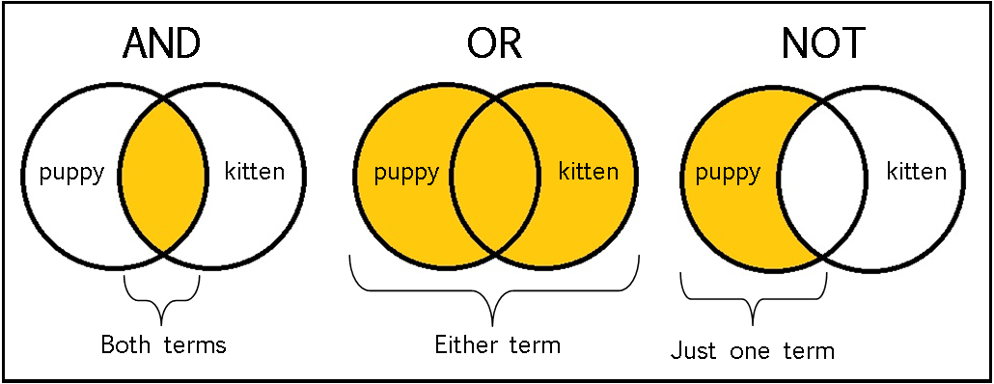
Source: https://sites.google.com/a/onalaskaschools.com/tech/boolean-search-tools

Google works a bit differently.

Google Scholar and Google

- AND = not needed, Google assumes if multiple words, AND is implied
- NOT = does not work in Google, instead, use
- - = same as NOT, excludes word, kitten -puppy
- OR = functions as expected, but must use capitalize OR, kitten OR puppy
- “ “ = exact match, “Bryan W Griffin”
- * = wildcard, “Bryan * Griffin”
- Site: = search sites, site:.edu “Bryan W Griffin”

Google, but not Google Scholar

- @ = include in front of word to search social media (e.g., twitter); currently not part of Google Scholar, @kitten
- $ = in front of number to search for price, $50 kitten
- # = hastag search, #kitten

Experiment: how many hits?

- Dropouts OR “minimum competency testing”
- Dropouts “minimum competency testing”
- Dropouts “minimum competency testing” -college

How many pages hits for each?

In summary,

- use of AND (or not including AND in Google) in the search means a filter is set in the search and finds only those articles that contain mention of “dropouts” and “minimum competency testing” (both phrases must be present),
- whereas use of OR produces a search that seeks for “dropouts” or “minimum competency testing” --- it is not necessary in this search for both terms to be present in the same article.

For research purposes, if I am interested in reading literature that reports the possible relationship between high school dropouts and results from minimum competency testing --- that is, does one’s performance on a competency test influence one’s decision to drop out of school --- which is the better to use, AND vs. OR, and why?

Yes, use of AND will provide better results because those hits obtained will be more focused on the specific search conducted, the possible link between competency testing and dropping out of school. Otherwise use of OR will result in many studies completely unrelated to that you wish to conduct.

(d) Characteristics of Written Reviews

Most of this is self-explanatory so you can read this on your own. Will focus on a few characteristics.

d1. Primary vs. secondary references – how different?

Primary references show that you have found the source firsthand. Secondary references mean that you found it in someone else's work but you didn't actually find the source yourself. Also, a primary source is one in which the author is the one who collected or observed the data (if the report is of empirical research), while a secondary is one in which the author did not collect data, but instead relied upon other’s work. In a secondary source, the author is removed from the observations -- the author did not perform the experiment, study, etc., but simply summarizes what was found by others.

If I cite a study from the author who collected and analyzed data, that is a primary source. If I cite someone who summarized others’ research, that is a secondary source.

An autobiography should be primary source, and biography secondary.

The journal “Review of Educational Research” specializes in summary literature reviews---would this be a source for primary or secondary work?

d2. Empirical studies – these are usually preferred in reviews, what is meant by empirical?

An empirical study is simply one in which data are collected to address questions or hypotheses. If no data were collected to address an issue or question, then that is not an empirical piece of work.

If I say “I believe this will work” or “Logic suggests this will work” or “Theory suggests this will work” I am making non-empirical statements. If I say, “Evidence from data suggests this will work” then I am making a statement based upon empirical support -- data driven.

How can one identify whether an article or report is empirically based --- that is, the authors collected data to address a question?

Usually identify an empirical work by the inclusion of a “Method” section; publications without some description of “Method” are usually not empirical. The “Method” section explains how data were collected (usually includes sampling or participants, measurement, and procedures).

What are data?

For the most part data are recorded bits of information. Data can range from numbers (such as ITBS scores) to words (such as transcribed conversations). Contrary to some beliefs, data do not have to be limited solely to numbers (quantitative information), data can also be words, pictures, etc. (qualitative information). This chat session, once posted on the Internet for all to view, will be a source for data.

d3. Organization - here are several options for organization of the review. Below are two common approaches.

Big v
With this approach the review should flow from general to specific. This means that the writer presents information that is only generally related to the topic of the paper first, and as the literature review progresses one should build a case for the specific research questions or hypotheses in the study, so the literature review becomes more focused on the specific questions or hypotheses of the study. Writing the review in the form of general to specific focuses on the topic of the study and helps direct the reader's attention to the importance of the questions or hypotheses addressed in the study. For example, one may be interested whether cyberbullying among college students results in negative psychological or academic effects. One could present the focus of this study in one research question: Do those who experience cyberbullying demonstrate lower psychological well-being or academic outcomes? With this review, one would first (a) introduce the concept of bullying (this represents the most general component of the review); then move to (b) comparison of cyberbullying and traditional bullying (this is the first step toward making review more specifically focused on the topic of this study). Research on cyberbullying usually focuses on K-12 students, so next the review would (c) compare and contrast research on cyberbullying for college and K-12 environments (this further focuses review on topic of study). The last component of the review introduces the specific focus of the study, a (d) discussion of the possible effects of cyberbullying on psychological well-being (e.g., life happiness, stress, anxiety) and academic outcomes (e.g., motivation, grades, academic self-efficacy). So the flow goes from most general (what is bullying) to most specific (cyberbullying relation to psychological and academic outcomes).

Variable Focused
In studies that examine relations among variables, the review may focus specifically on those variables and how they relate. For example, in a study of student ratings of teaching in college courses, the outcome or dependent variable would be student ratings. One may hypothesize that student ratings of teaching are predicted by several factors such as (a) instructor organization, (b) student interest in the subject of the course, and (c) grade discrepancy (student believes a grade will be assigned that is lower than deserved). The review for this study would first introduce student ratings as a concept, then move to current research on how student ratings relate to instructor organization. Next, the review would present research on the relation between student ratings and student interest in course, and then finish with discussion of the relation between student ratings and grade discrepancy research.

