01b Variables, Measurement, Scales of Measurement, Types of Variables

Add Latent, manifest, construct, show diagram as illustration

1. Variables

What is a variable?

A variable is anything that varies and has more than one unique category.

Examples:

Age in years = 1, 2, 3, 4, 5, 6, …, 48, 49, 50, etc.

Test Scores = SAT verbal ranges from 200 to 800; 200, 201, 202, 203, etc.

Sex: Biological distinction with Female and Male being most common categories of sex

Gender: Psychological state often measured on scale that ranges from feminine to masculine with multiple steps between these anchor points

Sometimes folks write that a variable is something that changes: Does your race change? Does your sex, based upon your chromosomes (xy or xx), change? These don’t change yet they can still be variables.

If only one category is present, then is it a variable?

For example, if everyone in this class is female, is sex a variable in this class?

If only one category present, then it is a constant.

What are the variables in these hypotheses?

1. There is no difference in Body Mass Index (BMI) between females and males?

Two variables: Sex and BMI

Why are female and male not variables?

These are categories of the variable sex. It is easy to confuse categories with variables, so watch for this when identifying variables or writing hypotheses.

2. The higher one’s level of academic self-efficacy, the lower will be one’s test anxiety.

(Note that academic self-efficacy and test anxiety are measured on a 20 point scale ranging from 1 = low to 20 = high.)

Also two variables: Academic Self-efficacy and Test Anxiety

2. Measurement

What is measurement?

Process of assigning labels to categories of a variable.

Is quantification required for measurement to occur? Must numbers be assigned in order for measurement to occur?

No, labels for variables may be non-numeric. See examples below.

Questionnaire Item:

What is your sex?
Female ____
Male ____
Etc.

What is your age in years? _____
What was your pretax income last year? _____

3. Scales of Measurement

Nominal: has only unranked categories (i.e., no inherent rank to categories)

Examples:
sex,
race,
type of flower

Ordinal: categories with inherent rank, i.e., ranked categories (i.e., this makes it easy to sort categories from high to low, more to less, etc.)

Examples:

Questionnaire Item – rate instructor on the following dimensions

(a) The instructor’s content was well organized:

Strongly disagree
Disagree
Somewhat agree
Agree
Strongly Agree

(b) The instructor presented material in a clear manner.

Use scale above

(c) The instructor was open to student questions, comments, and concerns

Use scale above

SES – socio-economic status (originally measured by three indicators: educational level, income, and occupational prestige)

High
Middle
Low

Interval: ranked categories with equal distance between measuring categories or measuring device

Rear to find variables that are truly interval since most variables with interval characteristics have zero points (beginning or ending)

Examples: time, distance (assuming no zero point)

Ratio: same as interval, but also has a true zero point (a true start or end point); allows for formation of ratios

Examples: time it takes to complete a task; number of test items answered correctly

What is the key distinction between nominal variables and all other types of variables?

The key distinction between nominal variables and all other variables is that the categories of nominal variables have no natural rank to them. So, nominal categories cannot be ranked, but the other scales of measurement, including ordinal, interval, and ratio, all have categories that can be ranked from high to low, from more to less, from best to worse, etc. For example, identify flowers by type (e.g., roses, pansies, etc.) --- most would agree there is no natural ranking to these types, just qualitative differences among flowers. However, if the variable is frequency of occurrence of certain types of flowers in one’s yard, then we take a count of types of flowers. This variable, count of flower types, does have categories that can be ranked (0, 1, 2, 3, etc.), and is therefore not nominal.

4. Types of Variables

(a) Qualitative Variable

Nominal or categorical (i.e., no inherent rank to categories), or ordinal variable with limited number of categories (e.g., SES with three categories of low, middle, high --- treat this as qualitative or nominal for convenience of statistical analysis)

Examples
Sex
Race
Types of flowers

(b) Quantitative Variable

Ranked categories (ordinal, interval, or ratio, assuming the ordinal measure contains many ranked categories)

Examples
Number of test items answered correctly
Weight in lbs.
Number of pages read over the summer
Age
Weight
Score on Test 1

(c) Practice Exercise

Example 1
If everyone buys a bag of apples, and we each count the number of whole apples in our bags, is the count of apples a qual or quan variable?

Number of apples in a bag is quantitative.

Which scale of measurement is the count of whole apples in our bags (Nominal, Ordinal, Interval, or Ratio)?

Remember the four criteria that define scales of measurement:

CATEGORIES:
Does the count of apples in a bag have distinct categories, and if yes, what are those categories?

Categories; RANK:
Does the count of apples in a bag have distinct categories that can be ranked? For example, are 7 apples more than 6 apples? Are 4 apples less than 5 apples?

Categories; rank; EQUAL INTERVALS:
Does the count of apples form equal intervals? For example, the difference between 2 apples and 1 apple is 1 apple. The difference between 15 apples and 14 apples is 1 apple. Does this 1 apple represent the same amount of difference no matter when on the scale (on the count of apples) we place this 1 apple?

Categories, rank, equal intervals; TRUE ZERO:
Is there a true zero point with the count of apples?

So what scale of measurement is count of apples?

Since count of apples has all four criteria present it is a ratio variable.

Recall that one way to determine if a variable is ratio is to consider whether one can form a RATIO between two quantities. For example, if I have 5 apples and someone else has 15 apples, then the other person has three times as many apples as I have --- 15/5 = 3. Ratios can only be formed with ratio level data.

Example 2:
What about the time it takes individuals to complete a given task, is this variable quantitative or qualitative? Also, what scale of measurement is this variable?

Quantitative and Ratio -- Since the categories of time are rank-able (i.e, 4 seconds is longer than 3 seconds, and 3 seconds is longer than 2 seconds, etc.), the time it takes one to complete a task represents a quan variable. This is also a ratio variable since differences in seconds is precise and equal (e.g., the difference between 12 and 13 seconds is 1 second, and the difference between 115 seconds and 116 seconds is 1 second, and the 1 second difference across this range is equal).

Example 3:
The classification of people into student groups in high school (such as nerds, athletes, and losers). Quan or qual variable? Also, what scale of measurement is this variable?

These groups represent categories of a qual variable and therefore nominal (no natural rank; they are simply different groups).

Example 4:
We take the classification used above (nerds, athletes, losers) and provide a different label now with numbers, like this: group 1, group 2, and group 3? Is this now a qual or quan variable? Also, what scale of measurement is this variable?

This variable represents a simple label transformation (nerds = 1, athletes = 2, losers = 3). Does changing the name of the group labels make this a quan variable now instead of a qual variable?

Despite using numbers 1, 2, and 3, this is not a quantitative variable. If there is no inherent ranking to these categories, changing the labels will not change the scale of measurement. My point here is to illustrate that use of numbers does not necessarily make a variable quan. So one should not focus on whether a number is used to decide whether a variable is qual vs. quan. Rather, one should ask whether the categories have a natural rank to them. We simply do not know what the labels group 1, group 2, etc. represent. If these groups are formed by the random assignment of students to group, then we have only a qual variable, for example.

Example 5:
What about computer chip makers – AMD, SIS, and Intel. Is this variable (computer chip maker) qual or quan?

Since these represent names of different companies, with no natural rank to the names of the companies, this would be qualitative.

(d) Independent Variable (IV) and Dependent Variable (DV)

That which precedes the dependent variable in time and is expected to predict or influence the dependent variable

That which follows the IV in time and is expected to be predicted or influenced by the independent variable

Figure 1: One possible model for Job Satisfaction.
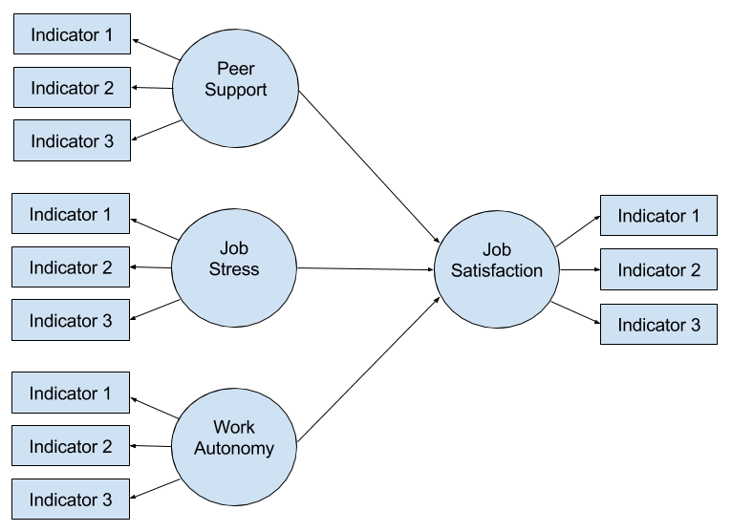

Which are IV and DV is the model above?

Examples

Find the IV and DV in these hypotheses and determine whether the variables are Quantitative or Qualitative

(a) There will be a difference in math scores between males and females.

IV = sex (categories of sex are male and female)
DV = math scores

Is sex, qual or quan?
Is math score, qual or quan

sex (categories of sex are male and female) qual
math scores quant

(b) The more time spent studying, the greater will be one’s final exam test score.

IV = time spent studying
DV = final exam scores

Time spent studying, qual or quant?
Final exam test score, qual or quant?

time spent studying (how measured – in hours) quan
final exam scores quan

(c) Students taught on-line will score at a higher level on the terminal examination than students taught in the classroom format. Which is IV and DV?

IV = format of instruction (on-line vs. classroom)
DV = terminal examination [scores]

Format of instruction, qual or quant?
Terminal examination scores, qual or quant?

Format of instruction qual
Terminal examination scores quan

(d) There is a negative association between academic self-efficacy and test anxiety.

(Academic Self-efficacy is one’s confidence in their academic ability to engage in academic activities.)

What are the variables in this hypothesis?

Two: academic self-efficacy and test anxiety

Which is IV and which is DV?

(d1) Is this possible – the more anxious one about a test, the lower will be their confidence (and hence efficacy) in doing well on the test? If yes, which is IV and DV?

(d2) Is this possible – the more confidence one has about a topic, the less anxious that person will be about upcoming tests? If yes, which is the IV and which is the DV?

This is an example where it is not clear which is IV and DV, so more information would be needed; we would need to know the theory driving the study or the study design in order to determine IV and DV.

(e) Student ratings of the instructor’s teaching and student perceptions of amount learned in the course both vary according to student level of pre-course motivation for the course and instructor presentation of the course content. Which are IV and DV?

There are four variables here: (a) ratings of the instructor’s teaching; (b) student perceptions of amount learned; (c) level of pre-course motivation; and (d) instructor presentation of the course content.

Which are IV and DV?

The IVs are: (c) level of pre-course motivation; and (d) instructor presentation of the course content, and the DVs are: (a) ratings of the instructor’s teaching; (b) student perceptions of amount learned.

