01a Testing Models, Scientific Method, Problem and Purpose Statements

1. Design Instruments/Scales to Test Models and Theories

Figure 1: One possible model for Job Satisfaction.
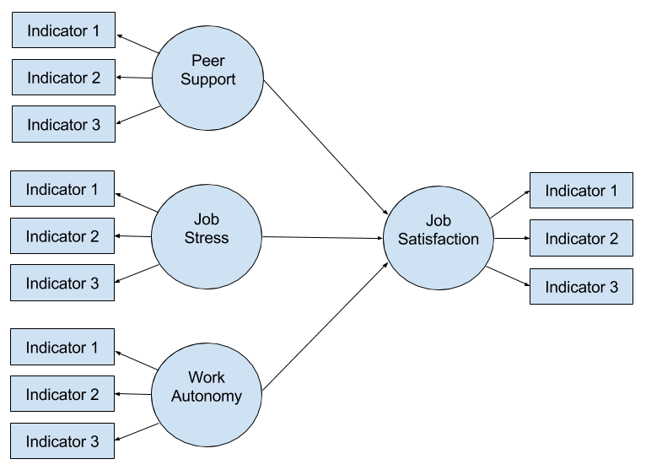

In this course we will learn skills that will allow us to collect data to empirically test such models, for example:

- Select or develop relevant scales,
- produce and assess evidence of reliability for scores from scales,
- produce and assess evidence of validity for scores from scales,
- determine appropriate sample sizes for different statistical analyses;
- analyze data to test model relations; and
- present results in an understandable, yet academic, manner.

2. Scientific Method (SM)
Follow the SM when conducting research:

(1) identify problem/issue for study
(2) expectations: form research questions or hypotheses to help direct study
(3) develop study plan in detail (allow others to replicate), collect data
(4) analyze data, report results
(5) draw conclusions

Research reports follow the format of SM, as illustrated below.

Scientific Method |  | Sections of Research Report
Identify problem/issue | = | Purpose statement/introductory section of report; literature review
Set expectations of findings | = | Hypotheses or Research Questions
Study plan, collect data | = | Method section
Analyze data | = | Analysis/Results section
Draw conclusions | = | Conclusions/discussion

(Have folks read material below on their own, skip and move to variables to save time)

3. Problem and Purpose Statements

3a. Problem Statement

Problem statements not common, except in dissertations.

It identifies for readers the problem the researcher wishes to address through the purpose of the study. For example:

"High school dropout rates are high, and there is speculation that use of minimum competency tests may be contributing the high rate of school dropout."

A more common approach to identifying problems that will be addressed in a study is to problem a brief introduction to the problem. For each example, the introductory material is several sentences or a paragraph (or two) describing the problem in some detail and why it is important to study. Once the problem is identified and explained, one typically presents the study purpose and this is often followed by study research questions or hypotheses.

3b. Purpose Statement

What role do these statements play in the report?

Purpose statements:

- sometimes can be several statements or a paragraph,
- function as the theme of the report --- they provide the reader with a brief introduction explaining the intent/purpose of the study which follows,
- and may often highlight the theoretical or practical importance of study.
- Details of the study will be revealed later in the report (e.g., methods used to execute the experiment will be provided in the Method section; findings from the study will be reported in the Results section).

Examples of Purpose Statements within Opening Sections of a Research Report

In the following examples, the PS is underlined.

Example 1

Speculation among educators and educational researchers holds that increases in academic standards may have detrimental effects on students, especially academically at-risk students (Johnson, 1994; Jones, 1993). With state mandates requiring increased standards, such as the adoption of minimum competency tests, educational researchers have argued that high school dropout rates will increase substantially once students begin experiencing difficulty passing competency tests (Adam, 1983). The purpose of this study is to investigate whether increased standards, in the form of minimum competency tests, influence students' decisions to leave school before graduation. If increased academic standards do, in fact, influence students' decisions to drop out of school, then policy makers need to reconsider both the goals for, and implementation of, such standards.

(Note. The IV in this PS is increased standards [use of minimum competency tests] and the DV is withdrawing from school.)

Example 2

Anorexia nervosa and bulimia are two eating disorders that affect females in the United States and Europe every year, and both are recognized as major medical and psychiatric problems. Anorexia is a disorder that most commonly affects females in their teenage and young adult years. Leichner and Gertler (1988) estimate that as much as 20% of women on college campuses demonstrate anorectic behaviors. Despite improved therapeutic approaches, the mortality rate of this disorder is between 5% and 20% (Zerbe, 1993). Bulimia, the other eating disorder, also affects adolescent females, and the prognosis for individuals with bulimia is often worse than those with anorexia. Because of the prevalence and severity of eating disorders, psychological researchers desire to learn of the symptoms that precede such eating disorders, how those symptoms develop, and the additional problems that accompany such symptoms.

Clinicians, in an attempt to document symptoms that precede eating disorders, are often confounded by the fact that females are usually secretive in regard to their eating disorders. Adding further to the problem is the fact that many teenagers diet, and eating disorders can sometimes be confused with dieting. Thus, as noted by Zerbe (1993), early signs of eating disorders, such as weight loss, frequently go unnoticed by family members and are ignored by physicians. Since physical and other observable warning signs are often disregarded, and since eating disorders are related to, and perhaps caused by, underlying personality characteristics, emotions, and conflicts, it seems that a method of assessment that would project these underlying tendencies would be helpful in the early diagnosis of eating disorders.

Usually eating disorders are connected to emotional conflicts, personality characteristics, and other psychological problems. Researchers have long used human figure drawings (HFD) for the assessment similar psychological problems in children and adults (Dileo, 1983; Koppitz, 1968), and, according to Klepsch and Logie (1982), such drawings can capture symbolically on paper some of an individual's thoughts, feelings, and present state of mind or attitude. Note that such states or attitudes may be governed by developmental and social-emotional conditions at any given moment (Mortensen, 1984).

Since HFDs may capture various social-emotional conditions on paper, perhaps HFDs may be used as a diagnostic tool in an attempt to differentiate among individuals with and without eating disorders. Therefore, the purpose of this investigation will be to determine whether HFDs, viewed as a diagnostic tool, can adequately identify individuals with eating disorders.

(Note. The IV is HFDs and the DV is identification of eating disorders.)

