**06 Qualitative Data Analysis of Open-ended Item Responses, Qualitative Code Sheets and Codebooks**

**(To be added: credibility of data – having participants check results)**

**1. Data Analysis of Open-ended Items**

Open-ended questionnaire items require data analysis of textual responses. Basic qualitative data analysis (QDA) is well suited to analyzing responses to open-ended items. QDA is often linked to interview data which when transcribed becomes text just like text from open-ended items. The techniques in QDA for interview data are the same applied to data from open-ended items.

To help illustrate QDA of open-ended items, several examples will be drawn from Moore and Griffin’s (2006) study of authorship name placement in education-related journals.

Moore, M. T., & Griffin, B. W. (2006). Identification of factors that influence authorship name placement and decisions to collaborate in peer-reviewed, education-related publications. Studies in Educational Evaluation, 32(2), 125-135.

<http://www.bwgriffin.com/gsu/courses/edur8331/edur8331-presentations/EDUR-8331-06-Moore-2016-authoship-study.pdf>

The questionnaire used by Moore and Griffin is linked below. Note that the questionnaire is composed of five open-ended items.

<http://www.bwgriffin.com/gsu/courses/edur8331/edur8331-presentations/EDUR-8331-06-authorship-questionnaire.pdf>

**2. Generic Steps for Qualitative Data Analysis**

LeCompte (2000) likens QDA to assembling pieces of a jigsaw puzzle.

* Many pieces to the puzzle – the raw text of responses to open-ended items
* Sort pieces into common piles – read responses and identify common responses
* Form themes of puzzle (e.g., sky, barn, water, flowers) – do the same for responses (e.g., anxiety, confidence, frustration)
* Find linking pieces of puzzle to connect themes – determine how response themes relate (e.g., when I experience frustration and I also experience anxiety)

Source:

LeCompte, M.D. (2000). Analyzing Qualitative Data. Theory into Practice, 39, 146-154.

<http://www.bwgriffin.com/gsu/courses/edur8331/edur8331-presentations/EDUR-8331-06-LeCompte-2000-Analyzing-Qualitative-Data.pdf> (also linked on course webpage)

**2a. Data Preparation**

First note that data analysis in qualitative research is often cyclical and may, perhaps should, begin once data collection commences. The cycle of collecting data and analyzing data during the data collection phase is known as interim analysis (analyzing data during the interim while data collection continues). Beginning data analysis early can help identify important themes or areas that should be explored.

At this initial stage researchers should read all their data carefully, and then re-read, then repeat again (and again). Why? The more familiar researchers are with their data, the more easily they can begin spotting or identifying important concepts in those data and see connections between concepts. With each reading researchers should record their impressions of the data, and record their thoughts and interpretation of the data. These recordings will help build one’s memory and provide insight when sorting/collecting data into broad categories and concepts.

LeCompte (2000, p. 148) suggests one use the following in preparation for QDA (if not using computer analysis systems):

* Make copies of all data so none is lost or ruined when memo-ing (adding researcher comments/notes to data)
* Put all notes and interviews in files by date of creation
* Create other files based on
  + types of data (e.g., interviews, questionnaires, field notes, artifacts),
  + participants (e.g., students, teachers, staff),
  + organizations (e.g., health agencies, foundations, schools)
  + subject or topic (e.g., recruitment of students, parent involvement);
  + do the above based upon needs and what seems reasonable.
* Catalog and store all documents and artifacts
* Label all files and boxes according to their contents.
* Create index or table for all contents for all data.
* Review research questions comparing them against data collected to ensure each question is addressed (actually, this should be addressed during questionnaire question development).
* Identify holes in data collection and address missing data so research questions can be answered (this should not occur in questionnaire development, but if it does, hopefully these holes will be identified during pilot testing).
* Collect additional data if needed (i.e., make revisions to questionnaire and start again).

**2b. Develop Initial Codes, Code Data, and Code Sheets**

At this stage the researcher will begin coding data; this means labeling relevant or important data points with unique labels to help separate data into unique and meaningful components. The researcher, when coding, is attempting to identify key ideas, behaviors, interactions, incidents, and terminology/phrases available in the data. In short, coding is labeling or naming things found in one’s data.

Codes used for labeling data may be derived in several ways:

**Deductive/A priori/Preset Codes** – Researcher develops a coding classification scheme prior to collecting data. This approach may not allow important new information to be identified; probably few qualitative researchers employ this approach although can be a useful approach is one is interested in theory testing.

**Inductive/Post hoc/Emergent Codes** – Codes for classifying data are developed while reading and coding the data. This approach allows data to speak and potentially enables the richness of the data to be revealed.

**Mixed Preset and Emergent Codes** – This approach represents a combination of the two in which researchers develop an initial classification scheme with codes but adds to these codes as new information is learned. Likely a common approach for many researchers.

Coding data and developing codes is an iterative process and requires much time and effort. When data from a many open-ended items or large samples are used, one can expect this coding process to last many hours or even days.

LeCompte (2000, p. 148) writes that researchers usually use three approaches to identifying text to code or name:

* Frequency – items are coded because they appear often (e.g., how many students expressed some form of anxiety, or how many students indicated the instructor is disorganized)
* Declaration – items are important because participants tell us they are important (e.g. students tell us the instructor’s videos were very helpful)
* Omission – something expected did not occur, why and what does this mean (e.g., students never mention being assessed or tested); this approach probably only works when using some frame of reference to set expectations

**Code Sheets**

During the code development phase, and once developed, it is useful to have code sheets that specify codes and what they mean. Below is an example of a code sheet used in the Moore and Griffin (2006) authorship study.

Authorship Code Sheet Example:

<http://www.bwgriffin.com/gsu/courses/edur8331/edur8331-presentations/EDUR-8331-06-authorship-code-sheet.pdf>

This code sheet was developed by first reading responses to the open-ended items, identifying possible codes, then forming those codes into categories, which are described below. This was an iterative process of reading responses to questionnaire items, developing codes, reviewing responses again and developing more codes and revising existing codes.

This sheet was printed twice for each returned questionnaire and used by two coders separately and independently to code responses. Once completed, both were attached to the questionnaire and then responses were compared to assess inter-coder agreement levels.

Coded Examples from Authorship Study:

<http://www.bwgriffin.com/gsu/courses/edur8331/edur8331-presentations/EDUR-8331-06-coding-example-1140.pdf>

<http://www.bwgriffin.com/gsu/courses/edur8331/edur8331-presentations/EDUR-8331-06-coding-example-420.pdf>

**2c. Organize Data into Categories**

During the process of code development and coding responses, one will begin to see commonalities among codes; these commonalities will be the formation of categories. The process of coding, code development, and category development is iterative, so new codes/categories may be identified when reviewing data, and one may find it necessary to recode already coded data to reflect changes in code and categories.

Categories are collections of codes with common elements or commonalities. When categorizing codes, one attempts to identify redundancies in codes and create subsets of codes to form broader categories of data. One approach to determine unique codes is to compare and contrast data, and to sort items (units of data) into similar and dissimilar groupings. This reduction process helps to bring meaning to data; it allows one to more succinctly grasp key ideas found in the data.

Figure 1 shows a screenshot of the authorship code sheet. Categories are underlined, and below each category are the corresponding codes that form that category. The codes were identified by first reviewing questionnaire responses and identifying rough codes, then reviewing responses again to refine codes. During this time similarities among codes were noted and category formation began. The process was repeated until final codes and categories were formed.

Figure 1: Authorship Code Sheet with Categories and Codes Identified

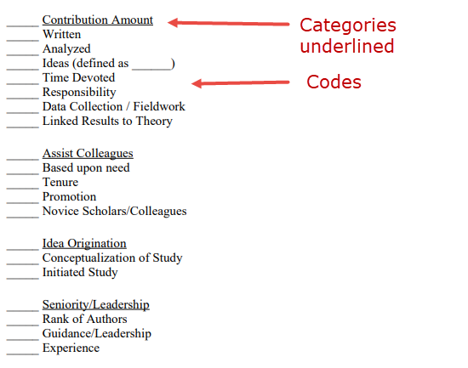

**2d. Further Refinement: Categories to Themes/Concepts/Taxonomies**

In many cases one will be able to organize categories into still boarder themes/concepts. There is not universal agreement on labeling in QDA; what many call themes are identified as concepts or taxonomies by others. The general idea here is that codes can be grouped into categories, and categories can be grouped into themes. Saldaña (2015) offers a nice graphic, shown in Figure 2, that illustrates the linkage among codes, categories, and themes.

Sometimes grouping categories into themes may not be possible or necessary, or categories may be themes/concepts (the two overlap). The notion, however, is that if there are many categories of data, it may be possible to further combine these into more general concepts that better reveal important information or meaning in the data. At this point some categories may be discarded as unimportant or because these categories provide little relevant, helpful information for telling the story of this research.

Figure 2: Levels of Codes to Categories, and Categories to Themes

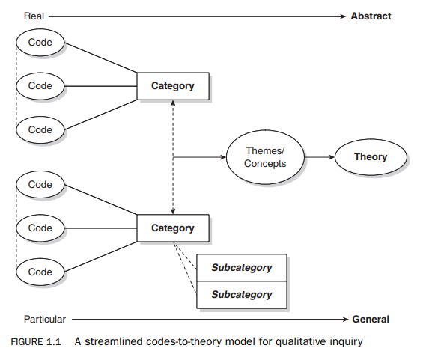

Source: Saldaña, J. (2015). The coding manual for qualitative researchers. Sage.

**2e. Find Relations among Concepts and Categories/Themes/Taxonomies**

One may be able to identify how various themes interrelate for study participants and researchers. This can lead to significant meaning and reveal important findings or lead to development of theories. However, no further detail of this analysis process will be provided here because in most cases analysis of responses to open-ended items will result in what some call content analysis – presenting frequencies of codes and categories of responses rather than attempts to find linkages among themes.

For those interested, Attride-Stirling (2001) provides a detailed discussion of thematic networks analysis. An illustration of a thematic model is given below in Figure 3.

Attride-Stirling, J. (2001). Thematic networks: an analytic tool for qualitative research. Qualitative research, 1(3), 385-405.

Figure 3: Attride-Stirling’s Structure of Thematic Network Example

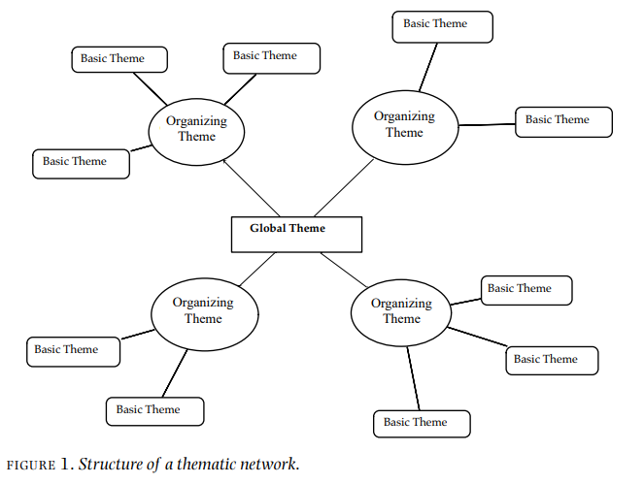

**2f. Displaying Results from Open-ended Items**

**Textual Display**

Most qualitative researchers present results in textual format; they describe the study setting, their perspectives and biases, summary of what they found, and often supplement this with quotations. I illustrate some of this below in “**3. Illustrated Example of Data Analysis**” especially in **3d** and **3e**.

**Graphical Display**

Sometimes textual results are also coupled with graphical displays. Kodish and Gittelsohn (2011) present a graphical display of data results from QDA showing linkages found in diabetes study (Figure 4 below).

In this example there are Categories which form Themes:

Categories –

* Items displayed on the outside, examples
  + Parents have diabetes
  + Exercise
  + Pills

Themes –

* Causes
* Don’t Exercise/Inactive
* Ways to Avoid
* Ways to Treat

Figure 4: Kodish and Gittelsohn’s (2011) Model of Diabetes Prevention

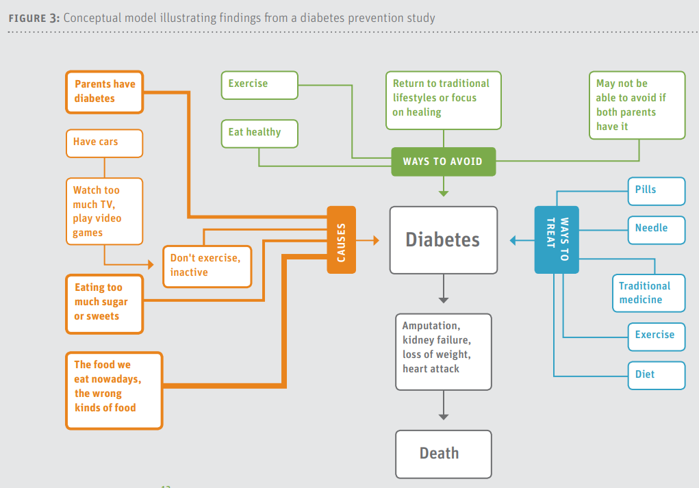

Impedovo, Ritella, and Ligorio (2013) provide the following bar chart, Figure 5, showing frequency of themes for different sections of e-portfolios examined. The X-axis contains four sections of the e-portfolio and the labels to the right are the data themes.

Figure 5: Impedovo, Ritella, and Ligorio’s (2013) Distribution of Themes Through Sections of ePortfolios

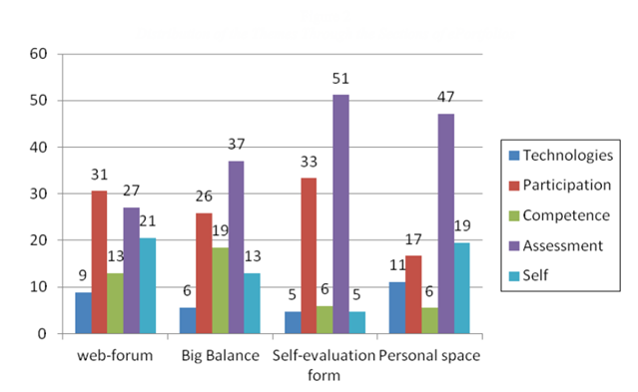

**Tabular Display**

Another approach to displaying data is in tables. Below, Figure 6, is an example from Moore and Griffin (2006) who asked participants to identify the benefits of co-authoring research.

Figure 6: Moore and Griffin’s (2006) Table 2: Perceived Benefits of Coauthored Publications

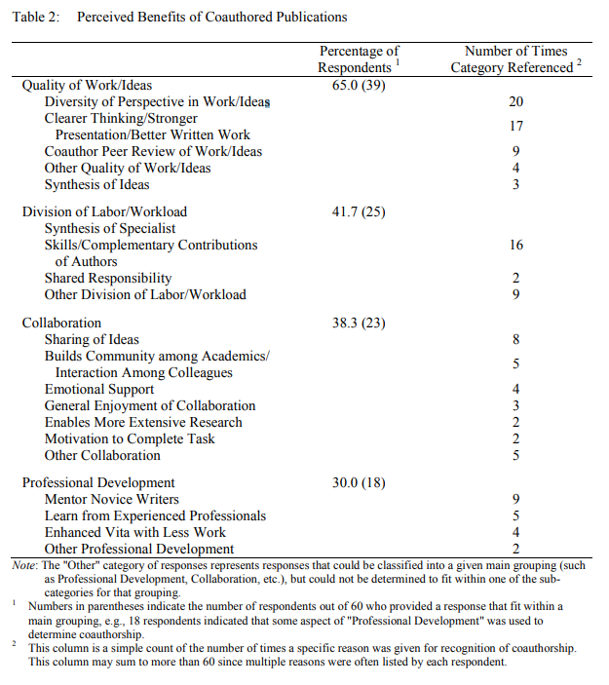

**3. Illustrated Example of Data Analysis**

Below is an example showing how data from an interview may be coded to identify important concepts.

**3a. Data Preparation**

The interview between a researcher and teacher is transcribed and presented below. While this example draws from an interview, the process for analyzing text from open-ended questionnaire items is the same.

Interviewer:

"Please tell me what it was like to work under your previous principal, and how is it different with your current principal."

Teacher:

"Wow, the difference is like night and day. Mr. Sykes* was so controlling. He had to approve . . . like everything we did. If I wanted to try something new, maybe a new computer program with my students, I had to get his permission. Uh, I remember once . . . I wanted to try a new workbook that I downloaded from the internet. One day he was observing me teach, and he asked about it in kind of a disapproving way. I don’t know, but it just seems he was so oppressive and didn’t want us to try new things. I kind of lost interest in teaching when he was here."

"Now with Mr. Rosen* things are so different. When he first arrived, he said he wanted us to explore new ways of teaching, you know, to try different things in the classroom. I wasn’t sure I believed him. So, I asked him about using some stuff I found on the web and he said ‘Sure, go for it and let me know if it works.’ So, I did and now I am constantly trying new things to help my students. It is much more exciting now to be in the classroom because I can teach the way I want."

* pseudonyms

**3b. Develop Initial Codes and Code Data**

Using an emergent design, note the following codes within brackets [ ] and highlighted in yellow were added to the teacher’s transcribed response. This is known as open-coding (reading through data and apply/develop codes).

"Wow, the difference is like night and day. Mr. Sykes* was so controlling. [authority control] He had to approve . . . like everything we did. [authority approval] If I wanted to try something new, maybe a new computer program with my students, I had to get his permission. [authority permission] Uh, I remember once . . . I wanted to try a new workbook that I downloaded from the internet. One day he was observing me teach, and he asked about it in kind of a disapproving way. [authority questioning] I don’t know, but it just seems he was so oppressive and didn’t want us to try new things. [authority oppressive] I kind of lost interest in teaching when he was here. [teacher interest lost]"

"Now with Mr. Rosen* things are so different. When he first arrived, he said he wanted us to explore new ways of teaching, [authority explore] you know, to try different things in the classroom. [classroom experiment] I wasn’t sure I believed him. [teacher disbelief] So, I asked him about using some stuff I found on the web and he said ‘Sure, go for it and let me know if it works.’ [authority approval/flexibility] So, I did and now I am constantly trying new things to help my students. [teacher explore] It is much more exciting now to be in the classroom because I can teach the way I want. [teacher excited/freedom]"

**3c. Organize Data into Categories**

Below I attempt to organize codes identified above into categories. Note there is some overlap and also one code is not used, [teacher disbelief], because it does not seem relevant to the categories that are emerging.

Control

* authority control
* authority approval
* authority permission
* authority questioning
* authority oppressive
* authority approval/flexibility

Autonomy

* teacher explore
* authority approval/flexibility
* authority control

Motivation

* teacher interest lost
* teacher excited/freedom

**3d. Further Refinement: Categories to Themes/Concepts**

As I think about this teacher’s responses and descriptions, and review those considering the codes and categories presented above, it seems there are two general concepts presented in these data:

**Teacher Autonomy Support** – In what ways does this teacher believe she is supported to be autonomous in her classroom? In what ways does she believe her level of classroom autonomy is being suppressed or controlled?

**Teacher Motivation** – While this is a category identified in the previous step, I think it also represents an important concept for this teacher. Does this teacher demonstrate motivation or de-motivation to teach in her classroom?

**3e. Find Relations among Concepts and Categories**

Given this teacher’s responses it appears that the level of autonomy support offered by the principals directly influenced her motivation to teach. As evidence, consider her statements:

"Mr. Sykes was so controlling. He had to approve . . . like everything we did."

"I kind of lost interest in teaching when he was here."

"Now with Mr. Rosen things are so different. When he first arrived, he said he wanted us to explore new ways of teaching, you know, to try different things in the classroom."

"It is much more exciting now to be in the classroom because I can teach the way I want."

**4. Codebook**

When developing codes, it is important to create a codebook to help clarify what each code represents. This book provides a memory of what you did so you can easily recall data analysis activities in the future should you need to return to your data and coding again after a long absence. The codebook should contain at least four things, and the fifth is optional:

* Code (e.g., Authority Control)
* Description of Code (e.g., Authority Control – individual in authority exerts control by …)
* Example of Code (e.g., Provide quotation from data that illustrates Authority Control)
* Parameters for Use (e.g., this explains when it should and should not be used; e.g., Authority Control is not applicable if someone who is not an authority, such as a peer teacher, attempts to control a teacher’s behavior.)
* Number or Abbreviated Letters (shorthand coding, e.g., Authority Control = AC or 3.10, etc.) – this simply makes coding large chunks of data faster compared with writing the code label repeatedly. This is not necessary, but some find this option helpful.

Such a codebook helps make clear to all involved in analyzing data the precise definition of each code, and this helps increase inter-coder agreement when multiple people are involved in the coding process.

Codebook development can be time intensive because it may involve multiple revisions since codes are often changed throughout the coding process.

Below is an example codebook description from DeCuir-Gunby, Marshall, and McCulloch (2011).

Figure 7: DeCuir-Gunby et al. (2011) “Sample Data-Driven Codes, Definitions, and Examples”

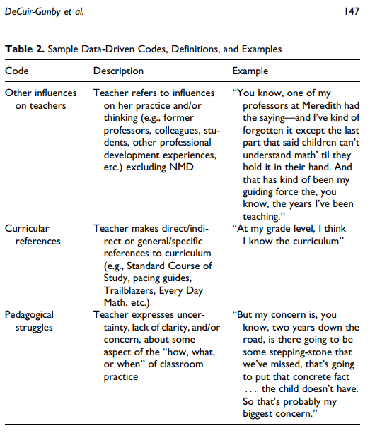

Kodish and Gittelsohn (2011) present the following example of a codebook for their study of health conditions in the Kakuma Refugee Camp, Kenya.

Kodish, S., & Gittelsohn, J. (2011). Building credible and clear findings. Systematic Data Analysis in Qualitative Health Research. Sight and Life, 25, 52-56.

<http://www.bwgriffin.com/gsu/courses/edur8331/edur8331-presentations/EDUR-8331-06-Kodish-Gittelsohn-2011-Credible-Findings.pdf>

Figure 8: Kodish and Gittelsohn’s (2011) Example Codebook of Health in a Refugee Camp

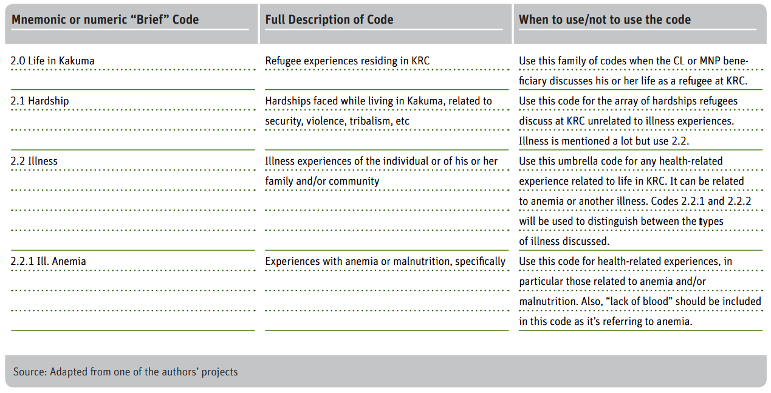

Below is a section of the codebook Kilby (2014) developed for a review of general practitioners in Norway.

Figure 9: Kilby’s (2014) Codebook Section from Patients Views of General Practitioners in Norway.

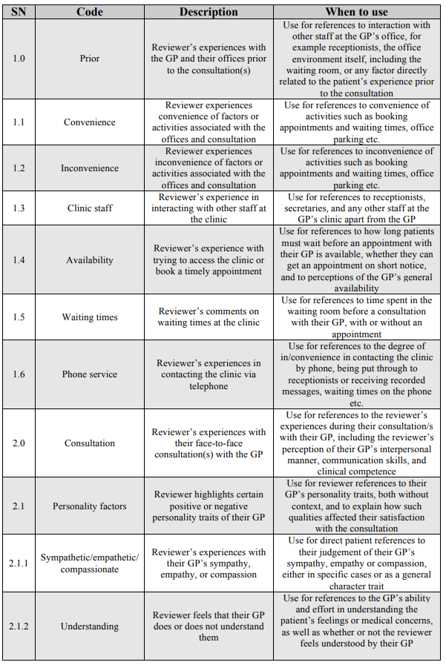

**References**

DeCuir-Gunby, J.T., P.L. Marshall, A.W. McCulloch. (2011). Developing and using a codebook

for the analysis of interview data: an example from a professional development

research project, Field Methods 23, pp. 136–155.

Impedovo, M.A., Ritella, G., & Ligorio, M.B. (2013). Developing codebooks as a new tool to analyze students’ ePortfolios. International Journal of ePortfolio, 3, 161-176.

Kilby, G. (2014). A qualitative content analysis of onlne GP reviews in Norway. Master’s Thesis, Department of Health Management and Health Economics, University of Oslo.

Kodish, S., & Gittelsohn, J. (2011). Building credible and clear findings. Systematic Data Analysis in Qualitative Health Research. Sight and Life, 25, 52-56.

LeCompte, M.D. (2000). Analyzing qualitative data. Theory Into Practice, 39(3), 146–154.

Moore, M. T., and B. W. Griffin. 2006. Identification of Factors that Influence Authorship Name Placement and Decisions to Collaborate in Peer-Reviewed, Education-Related Publications. Studies in Educational Evaluation 32 (2): 125–35.