**05c: Electronic Questionnaire with Google Docs**

This presentation contains screenshots showing how to create an electronic questionnaire in Google Docs, and also shows some item formatting options.

**1. Starting**

In GSU gmail, or your own Google account, click Google Apps icon (9 dots), then selection Google Drive.

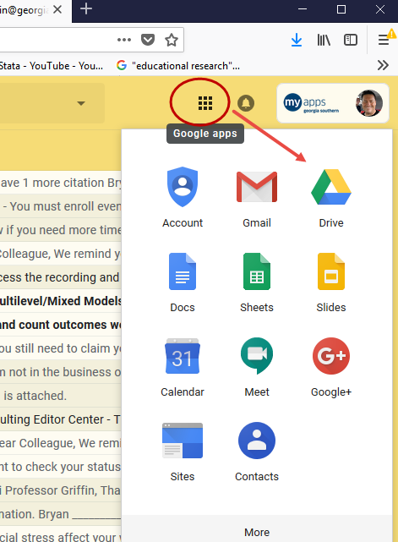

Click on New in Drive

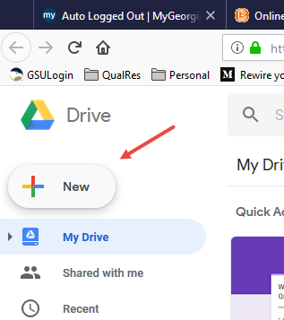

Then find and select Google Forms

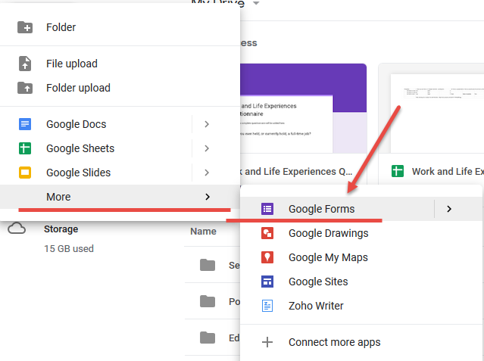

A new blank form appears as shown below. Note location for title and introduction/instructions.

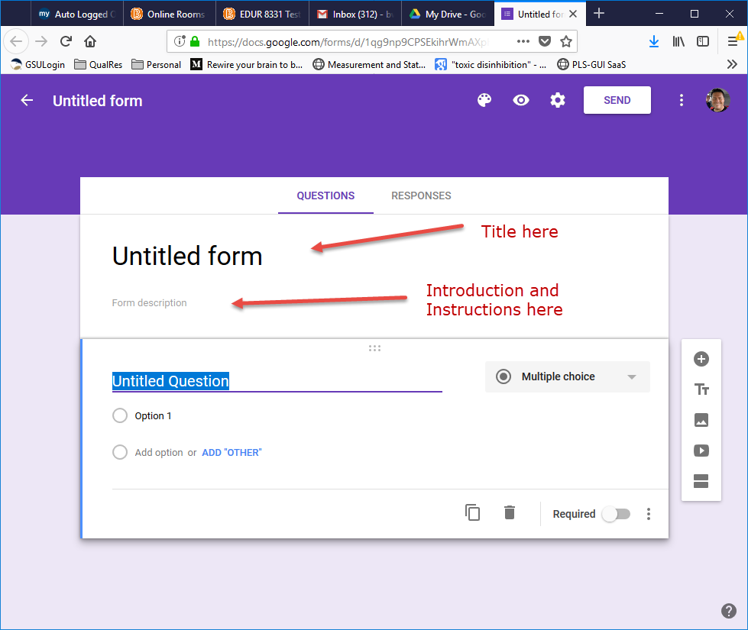

I have added a title and introduction and instructions.

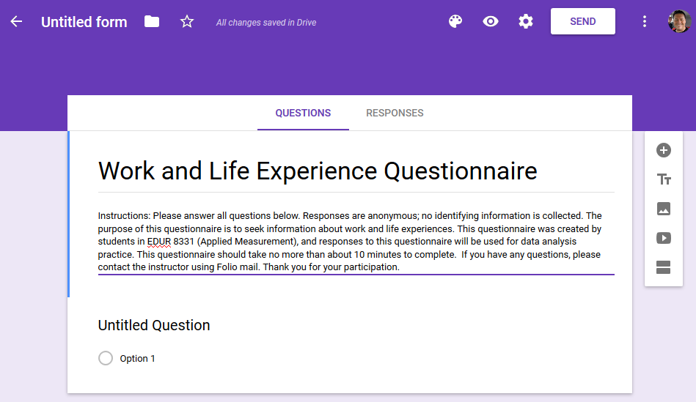

To add questions, click on the “Untitled Question” that is highlighted.

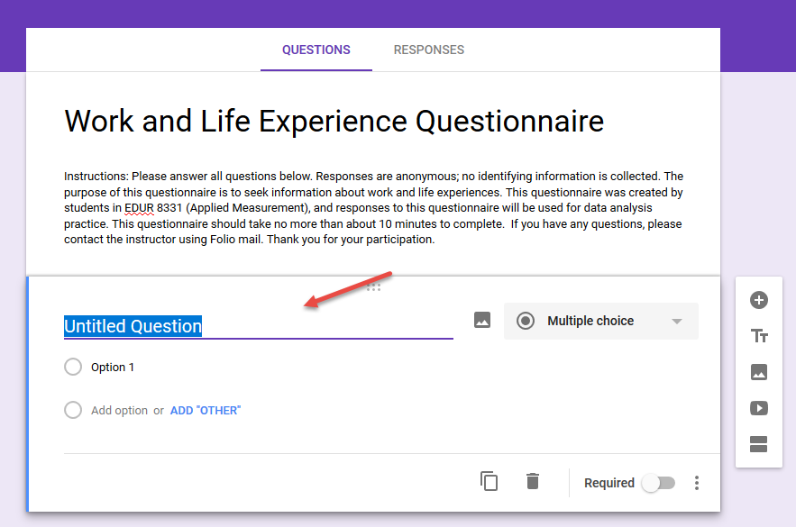

Question types can be controlled by the option bar on the right.

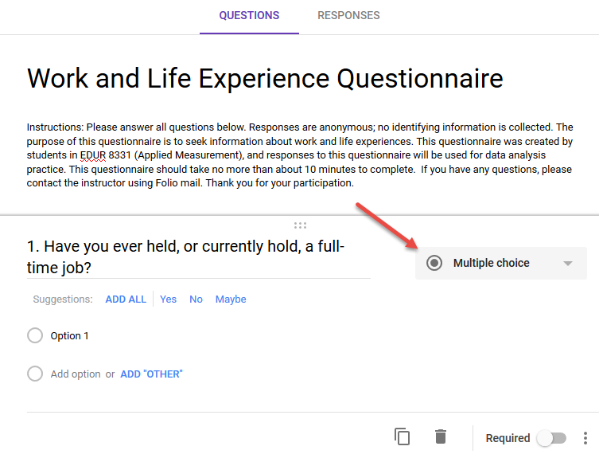

Response options are placed below for Multiple Choice type items (e.g., Likert, demographic, etc.).

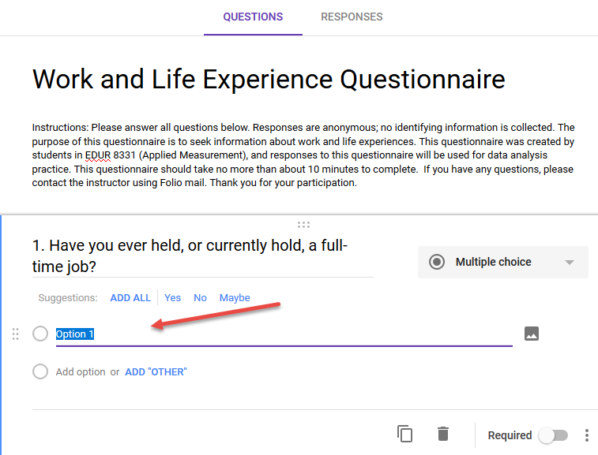

I have added several response options for Question 1. Note the question is designed to learn whether respondents have worked either full-time or part-time.

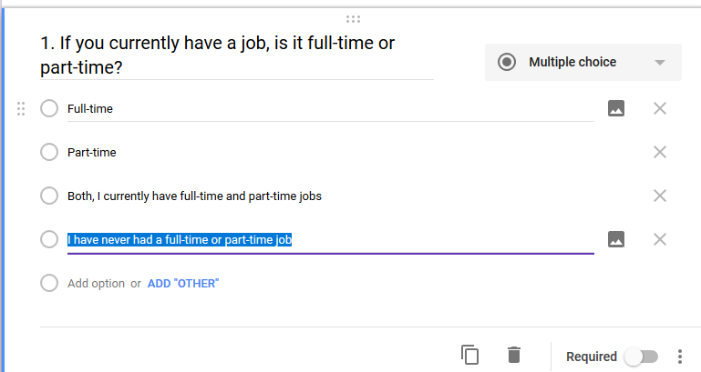

I want to create a second question, similar to the first, to learn whether those who currently do not have a job have ever held a job. I can copy Question 1 to form Question 2 using the two card-looking icons at the bottom.

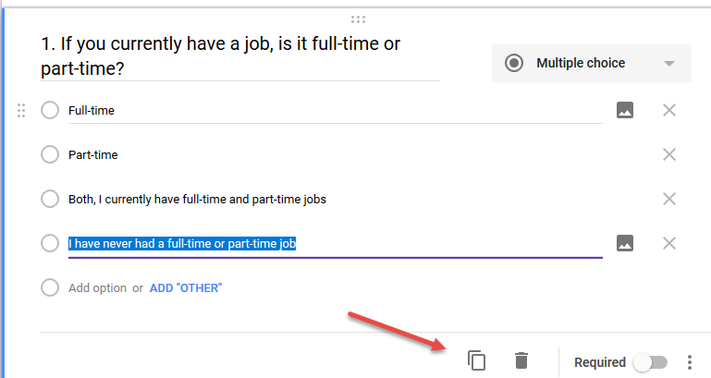

Question 2 seeks information about past employment

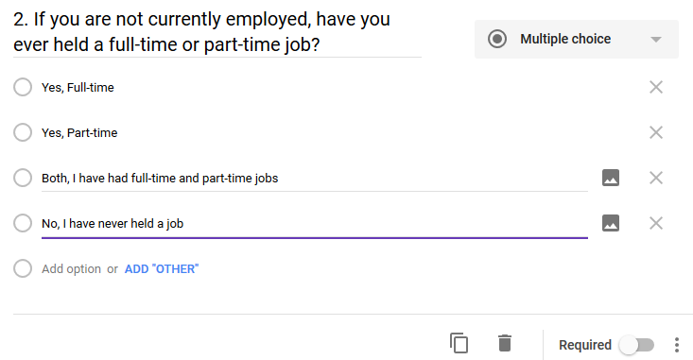

If you need to remove a response option, that can be done with the X icons on the right.

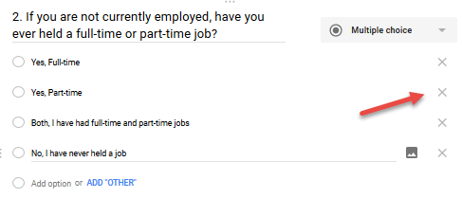

We can view the current layout of the questionnaire by clicking on the “eye” icon at the top.

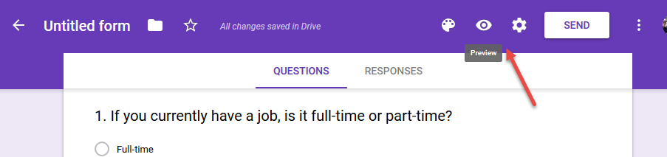

Here is the current view of the questionnaire as it would appear to respondents. Google has developed to work with small-screen devices (cell phones, tablets) so it looks big on a computer screen. Because of this design, some formatting options do not work well in Google Forms.

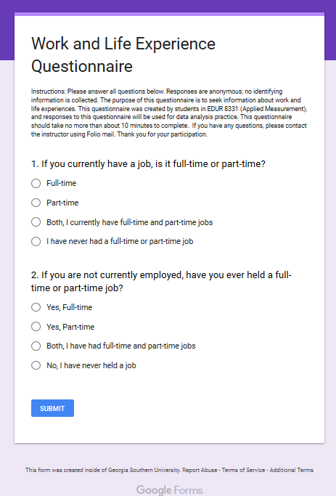

Note options on the right of items – these allow for adding additional items or other information.

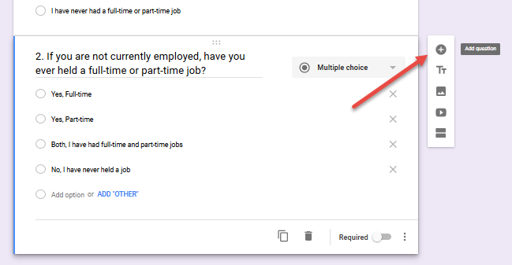

Formatting Likert-type scales.

Multiple Choice – note that all response options are labeled (Poor, Fair, etc.). Left is item building screen, right is questionnaire view screen.

|  |  |
| --- | --- |
|  |  |

Linear Scale – this option provides numbers in the spreadsheet when responses are recorded, but does not allow for response option labels except for the two anchor points.

|  |  |
| --- | --- |
|  |  |

Multiple choice Grid – works well for items with a leading stem and the items are short – only one or a few words.

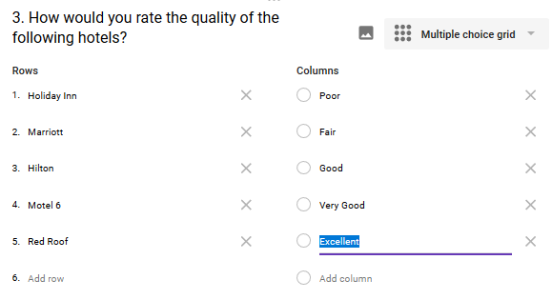

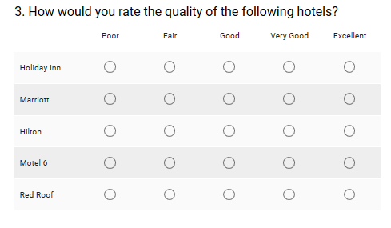

Does not work well when items are a full sentence in length because the sentence wraps in a narrow space and uses small font (see second image below).

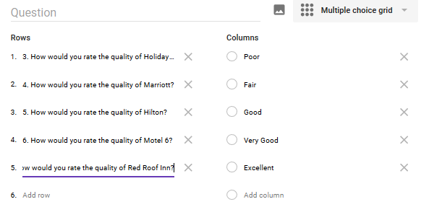

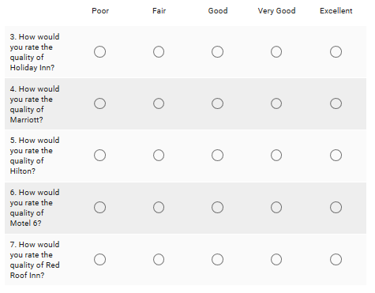

Checkbox grid option

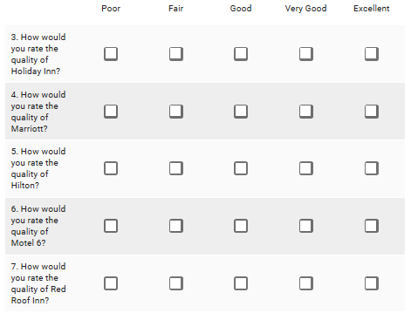

Dropdown option

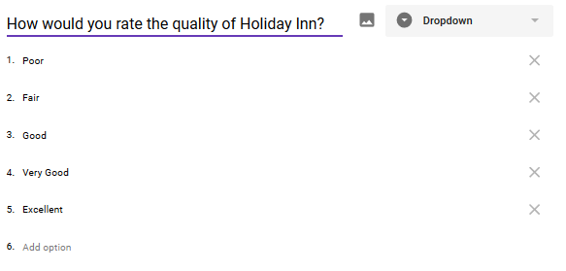

Best not to use dropdown option because it can be tedious to selection choose and also select responses. Can frustrate some respondents.

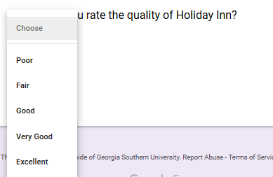

It is possible to divide questionnaire into sections. Each section may have a different title and description.

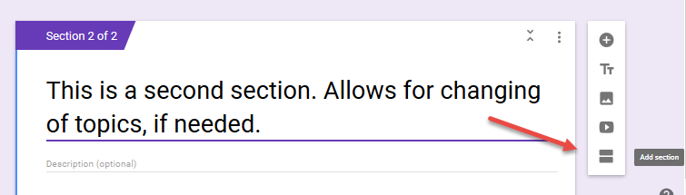

Signal a new section is available.

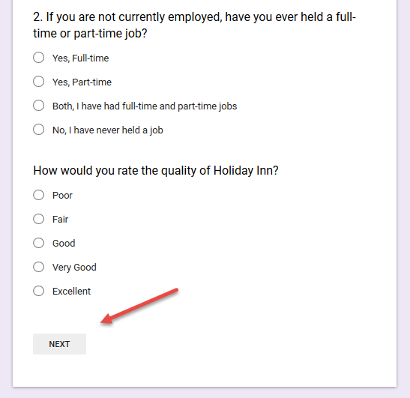

Filter, or conditional, questions can be implemented using the item options (3 dots below), then selecting “Go to section based on answer.” Google Docs does not offer the “go to item” option, but does allow one to skip sections.

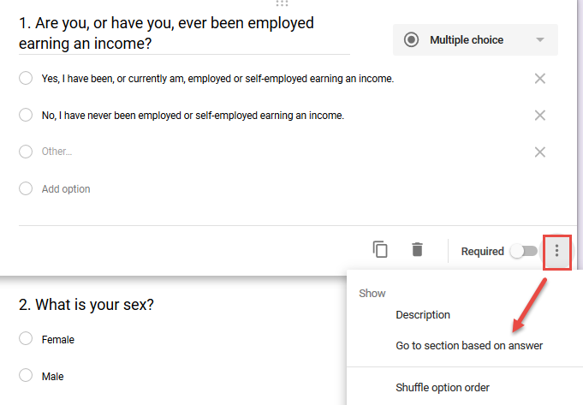

The conditional instructions for Google Docs have been set. For those who have been employed, they will answer questions in Section 2 (Employment and Life), for those who are not employed or have never been employed, they will be taken automatically to section 3 (Test Bonus Points).

