**05b: Reading Factor Analysis Results**

To add

1. failed example

<http://www.bwgriffin.com/gsu/courses/edur8331/edur8331-assessments/Test2/2011-Adelson-Math-and-Me-Scale.pdf>

good example showing that one dimension did not work twice, item revised second time but did not work, rare to see this type of example published

2. example with factor loadings displayed graphically and interpreted that way rather than table – find exampel

**1. Logic of Factor Analysis (FA)**

Suppose we designed two scales, one to measure the latent variable Life Satisfaction (**LS**), and the second designed to measure the latent variable Mathematics Self-efficacy (**MSE**). Figure 1 below shows the diagram for these two variables. Note that both variables have three indicators each and that there is no curve, or line, connecting LS to MSE. The lack of a connection between these two variables indicates that they are expected to be uncorrelated with each other.

Figure 1: Two Uncorrelated Latent Variables; Two Uncorrelated Factors

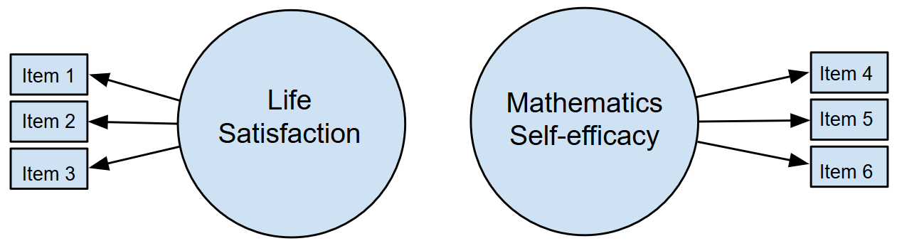

Recall that one approach to providing evidence for construct validity is an examination of the **internal structure**, or the **factor** **structure**, of scores from scales. For the variables in Figure 1, we would expect the structure to show that the three items measuring LS to correlate highly, thus demonstrating internal consistency, but to be uncorrelated, or show weak correlations, with MSE items. Similarly, the three items measuring MSE should correlate well among themselves but demonstrate weak or no correlations with the LS satisfaction items. We expect item correlations between LS and MSE to be weak since we hypothesize there is little to no correlation between LS and MSE.

Recall from discussion of scales and indexes that Figure 1 illustrates **reflective** latent variables. The figure shows that items 1 to 3 are reflective (or indicative, or indicators) of factor 1 (LS), and items 4 to 6 are reflective of factor 2 (MSE). Figure 1 indicates items 1, 2, and 3 correlate because their scores are functions of factor 1, and items 4, 5, and 6 correlate due to factor 2. When analyzing data from scales we assume participants respond to items because the construct measured leads them to respond in a consistent way. So those respondents with greater LS should respond similarly to items 1, 2, and 3 (assuming there are no reverse-scaled items), and this pattern of responses would produce moderate to strong correlations among items 1, 2, and 3. Similar logic applies to items measuring MSE.

The pattern of correlations displayed in Table 1 fits the expectation outlined above. Note correlations for LS indicators, items 1, 2, and 3, all demonstrate strong, positive correlations (in bold and highlighted in blue). Similarly, intercorrelations for items 4, 5, and 6, indicators of MSE, also demonstrate strong, positive inter-item correlations (in bold and highlighted in green). The correlations not highlighted are much weaker and near zero in value; these are the correlations of items across latent variables that were hypothesized to demonstrate weak correlations. In sum, correlations depicted in Table 1 match the expectations described above.

Table 1: Patterns of Correlations Demonstrated

|  |  |  |  |  |  |  |
| --- | --- | --- | --- | --- | --- | --- |
|  | 1 | 2 | 3 | 4 | 5 | 6 |
| Item 1 | --- |  |  |  |  |  |
| Item 2 | **.59** | --- |  |  |  |  |
| Item 3 | **.64** | **.72** | --- |  |  |  |
| Item 4 | .02 | .06 | .08 | --- |  |  |
| Item 5 | -.05 | -.14 | .12 | **.43** | --- |  |
| Item 6 | .10 | .02 | .05 | **.68** | **.55** | --- |

If FA were applied to these LS and MSE data with the correlations shown in Table 1, we would expect to see strong evidence of a two-factor solution, i.e., strong evidence that the items designed to measure LS produce one factor (latent variable) and items designed to measure MSE produce one factor (latent variable), and the inter-correlations among these items do not show any overlap between factors – they do not correlate. In short, we would expect FA to demonstrate a two-factor solution with clear indications of which items load, or correlate, on which factors, and little cross-loading (i.e., little correlation of non-indicators loading on factors for which they were not designed).

Results of FA, when provided for scales, can be useful for (a) assessing scale structure and hence provide evidence for construct validity, and (b) determining which items seem to play an important role in contributing scale measurement. Factor loadings, described below, can be a useful tool for identifying best fitting item for scale reduction (i.e., removing items and shortening scales). For long scales, reducing the number of items is often important to increase response and completion rates among participants.

**2. Formative vs Reflective Models**

Briefly explained, with **reflective models** we assume that latent variables cause questionnaire participants to respond a certain way. Someone with high levels of LS will respond to LS items affirmatively while someone with low levels of LS will respond negatively to LS items. Similarly, one with high levels of MSE will respond more positively to MSE items than someone with low levels of MSE.

**Reflective models** assume that the factor is the causal agent leading to scores obtained for indicators; the factor predicts or causes variation in the indicators, so the factor is the independent variable and the indicators are the dependent variables. With this model one assumes that the factor exists independent of the indicators; we use indicators to help us measure the factor. The factor is the causal agent and produces variation observed in the indicators. Example: The greater your math self-efficacy (factor), the (a) more time you spend on difficult problems (indicator), the (b) more interest you have in math (indicator), and the (c) more confidence you have with math problems (indicator).

Figure 2 shows this flow of causality, from Latent Variable (or factor) to indicators – the latent variable causes people to respond the way they do. FA is designed to assess reflective models.

Figure 2: Reflective Model with Two Factors (Scales rather than Indexes)

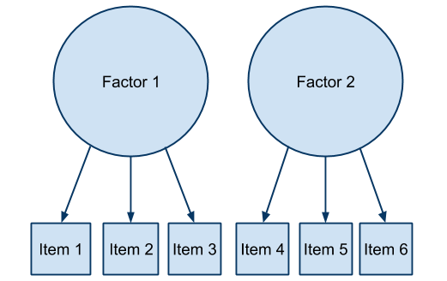

Figure 3 illustrates a **formative model** in which we assume that the items cause or build the **component**, so the direction of causality flows from item to component. Note the terms component is used instead of factor; using this terminology here helps to distinguish factors, which influence item responses, from components, which are constructed from item responses. In practice, component, factor, latent variable, and construct are often used synonymously, but for this one example I make a distinction since the direction of casualty differs between formative and reflective models.

**Formative models** represent a different causal assumption compared with reflective models. With formative models, indicators are predictors or causal agents for variation in the component. Indicators are the independent variables and the component is the dependent variable. It is also possible to view this model not as cause and effect, but simply as a mathematical structure such that the indicators are used to form a composite variable called a component. In either view, the component is formed by combining indicators; this suggests the component may not exist independent of the indicators, although that is not the case in every situation (e.g., cyber-harassment, discussed below – victims experience exists independent of the indicators). Example of a component: The greater one’s (a) wealth (indicator), (b) education (indicator), and (c) occupational prestige (indicator), the greater one’s socio-economic status (SES; component).

Figure 3: Formative Model with Two Components (Indexes rather than Scales)

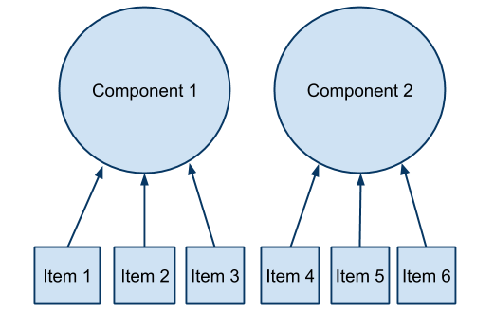

Coltman et al. (2008) explain that with reflective models we expect to see strong correlations among items and thus high internal consistency for each factor; with formative models items may be independent and uncorrelated since the component is a composite; there is no need for items to correlate (although if there are correlations, the items must correlate positively otherwise reverse scoring is needed because failure to reverse score means items are both adding and subtracting from the composite variable score). Internal consistency is expected and assessed with reflective models, but not necessary for formative models.

**Example of Reflective and Formative Models: Cyber-harassment**

Cyberbullying exists as both reflective and formative models. Suppose we ask the following three questions.

1. Visual harassment – electronically posting images or videos with the intent to embarrass, threaten, intimidate, offend, manipulate, harass, or otherwise make someone experience negative reactions.

|  |  |
| --- | --- |
| 1V. How many times has this **happened to you** in the past 3 years?  0. Never  1. 1 time  2. 2 times  3. 3 times  4. 4 or more times | 1B. How many times have **you done this to someone else** in the past 3 years?  0. Never  1. 1 time  2. 2 times  3. 3 times  4. 4 or more times |

2. Written harassment – electronically posting written message with the intent to embarrass, threaten, intimidate, offend, manipulate, harass, or otherwise make someone experience negative reactions.

|  |  |
| --- | --- |
| 2V. How many times has this **happened to you** in the past 3 years?  0. Never  1. 1 time  2. 2 times  3. 3 times  4. 4 or more times | 2B. How many times have **you done this to someone else** in the past 3 years?  0. Never  1. 1 time  2. 2 times  3. 3 times  4. 4 or more times |

3. Spoken/Verbal harassment – to speak or leave a spoken message electronically with the intent to embarrass, threaten, intimidate, offend, manipulate, harass, or otherwise make someone experience negative reactions.

|  |  |
| --- | --- |
| 3V. How many times has this **happened to you** in the past 3 years?  0. Never  1. 1 time  2. 2 times  3. 3 times  4. 4 or more times | 3B. How many times have **you done this to someone else** in the past 3 years?  0. Never  1. 1 time  2. 2 times  3. 3 times  4. 4 or more times |

Items 1V, 2V, and 3V are indicators for victims cyer-harassment, and items 1B, 2B, and 3B are indicators of cyber-harassment bullying behavior. The wording of items 1V, 2V, and 3V make clear the experience of cyber-harassment was thrust upon the vicitm, and the wording of items 1B, 2B, and 3B make clear these harassment behaviors were caused by the bully. The theoretical model for cyber-harassment is shown in Figure 4.

Figure 4: Formative and Reflective Models for Cyber-harassment

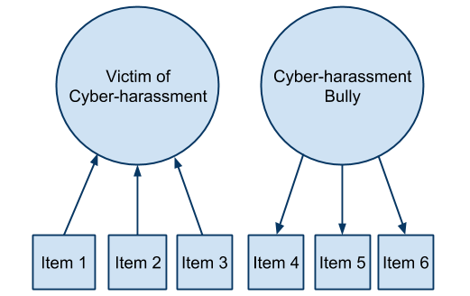

Victims are subjected to harassment activities. These experiences are directed toward them; they are not the perpetrator of these actions, so the causal links in Figure 3 must flow from item to componet. This is an example that would be suitable for principal components analysis, a reversed form of FA, could be used to create a composite a score of victim experience. In pratice researchers often use principal component analysis and FA interchangeably with often little or no material effect in results or interpretation.

Bullies, on the other hand, initiate and perpetrate cyber-harassing behaviors. These behaviors and actions emanate from the bully – the bully is the causal agent of these behaviors. Given this, the links flow from from factor to item. This is an example that would be suitable for FA – a theoretical measurment model for the bully behavior.

**3. Factor Analysis (FA) Explained**

As noted above, FA is well suited for exploring reflective models and determining number of factors that may exist among many indicators. FA should be used for ratio, interval, or ordinal data with multiple steps like typically found with Likert-scaled response items. FA is not suitable for nominal data or ordinal data with limited number of categories.

The first step in FA is to perform what is known as **factor extraction** – this is a process to determine the number of factors identified in a data file based upon item inter-correlations and other statistical indicators. Theory can also be a guide about number of factors to expect. Using the example above, we expect two factors to exist, one for LS and the othe for MSE. If the factor extraction procedures suggest there is only one factor, or more than two, this tells us the data may not support the two-factor model hypothesized for LS and MSE.

Factor extraction is a complex process that won’t be explained in this course, but be aware that presntations about factor extraction you may see in research literature refers to data analysts’ attempt to determine how many factors exist in a data file. Some common terms you may see that refer to factor extraction include scree plot, Eigenvalue, variance explained, and parallel analysis. Just recognize these terms refer to factor extraction.

**Factor rotation** is a process by which data anlysts attempt to make interpretation of FA results easier to understand. You may see words such as orthogonal or oblique rotation with methods such as varimax, oblimin, or promax. Again, these tersm refer to attempts to make FA results, specifically factor loadings, more interpretable.

**Factor loadings** represent the statistical relation between items (indicators) and factors (latent variables); in many cases factor loadings are the correlations between items and factors, so the higher factor loadings, the more strongly the item is related to the factor. It is possible to have unrotated and roated loadings. Usually rotated loadings are easier to interpret, but sometimes unrorated loadings can easily reveal the **factor** **structure** – which items load, or correlate, well with which factors.

**4. Example 1: Autonomy Support and Student Ratings of Instruction**

For a series of studies on student ratings I collected questionnaire responses from about 700 students at Georgia Southern. Two variables of interest were (a) student ratings of instructors and (b) perceived autonomy support. Scale wording for both latent variables are presented below.

Latent Variable 1: Autonomy Support

24. The instructor was willing to negotiate course requirements with students.

25. Students had some choice in course requirements or activities that would affect their grade.

26. The instructor made changes to course requirements or activities as a result of student comments or concerns.

Latent Variable 2: Student Ratings of Instructor and Course

5. The instructor presented the material in a clear and understandable manner.

6. Course materials were well prepared and organized.

8. The instructor made students feel welcome in seeking help/advice in or outside of class.

9. The content of this course is useful, worthwhile, or relevant to you.

10. Methods of evaluating student work were fair and appropriate.

13. The instructor gave students useful/helpful feedback on work.

29. Overall, how would you rate this course?

30. Overall, how would you rate this instructor?

As a construct validity check, a FA was run to assess the internal structure of these two scales. Ideally two distinct factors should emerge, one for autonomy support (only items 24, 25, and 26 should load highly on this factor), and one for student ratings (all other items should load highly on this factor). For the internal structure to be clear, we hope to see weak loadings across factors for items that were not designed to measure that construct, i.e., autonomy support items do not load highly (correlated highly) with the student ratings factor, and student ratings items should not load highly on the autonomy support factor.

Below in Table 2 are results from SPSS factor analysis of these data. The table, labeld as a Factor Matrix by SPSS, shows how each item correlates with the two factors (i.e., factor loading); the factor loadings are displayed in the two columns labeled Factor 1 and Factor 2. It seems Factor 1 is composed of the Student Ratings items (highlighted by a red box in the column labeled Factor 1), and Factor 2 is composed of three Autonomy Support items (red box in column Factor 2). Note the magnitude of the loadings. Loadings show that Factor 1 represents student ratings and Factor 2 represents autonomy support. Also note that none of the student ratings items load highly with Factor 2, and the loadings for the autonomy support items are consistently weaker for factor 1 than for Factor 2, so Factor 2 is the autonomy support factor.

Table 2: Factor Loadings for Two Latent Variables, Student Ratings of Instruction (items v5 to v10, v13, v29, and v30) and Autonomy Support (items v24, v25, and v26)

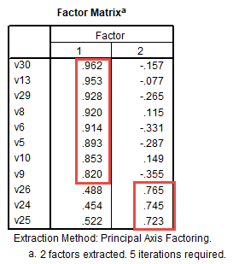

It appears that all autonomy support items load well on the autonomy support factor – all loadings are .72 or better. Similar results are shown for the student ratings items – all loadings are .82 or larger. There is some minor cross-loadings of autonomy support items with the student ratings factor (loadings of .48, .45, and .52), but this is not a problem because the loadings within and between factors seem to clearly identify which items work with which factors, and because we should expect some cross loadings since these two latent variables are correlated (research shows that autonomy support is a predictor of student ratings of instruction).

**5. Example 2: Menon’s (2001) Employee Empowerment Scales**

Menon (2001) developed and tested three scales to measure employee empowerment: (a) Perceived Control, (b) Perceived Competency, and (c) Goal Internalization. Scale responses were collected from 311 participants. While Menon expected that these three latent variables will be correlated, he also expected to find a factor structure showing three clear factors. Citation and link to Menon’s article is listed below.

Menon, S. (2001). Employee empowerment: An integrative psychological approach. Applied psychology, 50(1), 153-180.

<http://www.bwgriffin.com/gsu/courses/edur9131/2018spr-assignments/02-Menon-ST-2001.pdf>

Table 3 below presents the inter-item correlations among the 15 items forming the three scales. In this table Menon highlighted correlations within scales in bold. Items designed to measure the same latent variable should correlate more highly with like items than with items designed to measure different latent variables. The correlations demonstrate well this pattern. The within-scale correlations in bold tend to be stronger than the cross-scale correlations. This is a good sign that items are behaving as expected and should demonstrate good factor structure.

Table 4 reports Menon’s FA results. Menon placed in bold factor loadings as they apply to factors 1, 2, and 3. Results show that Goal Internalization items loaded best on Factor 1 (hence this appears to be the goal internalization factor), Perceived Control items loaded best on Factor 2 (so this is the perceived control factor), and Perceived Competence appears to be Factor 3. As one would hope to find, there seems to be a clear factor structure in which items seem to form three clusters as we would expect, and do not appear to cross-load on other factors.

Using factor loadings, we can also see that there appears to be three top items for each factor: items for Goal Internalization are 13, 1, and 2; Perceived Control items are 1, 4, and 2; and Perceived Competence items are 3, 1, and 2. Menon opted to remove the poorer fitting items and therefore used FA for scale reduction. Menon notes this by use of asterisks in Table 4 below.

Table 3: Correlations, M, and SD for Perceived Control, Perceived Competency, and Goal Internalization (p 165)

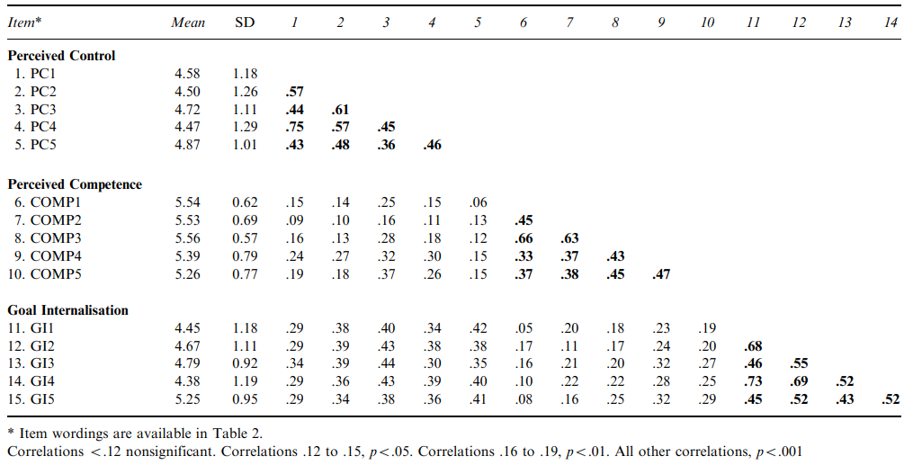

Table 4: Factor Analysis of Perceived Control, Perceived Competency, and Goal Internalization Scores (p 166)

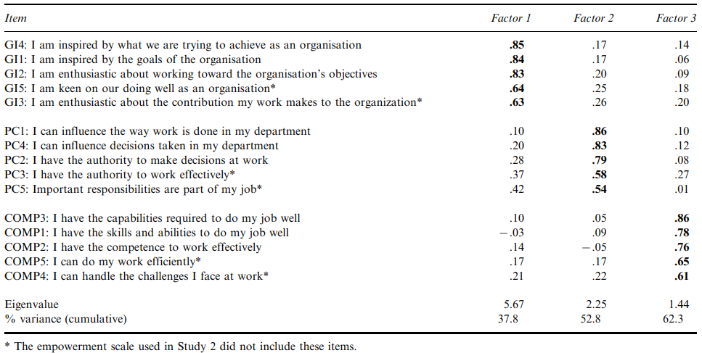

**6. Example 3: Parenting Stress and Coping in Difficult Parenting Situations**

Szymańska and Dobrenko (2017) studied parenting in difficult situations. Figure 5 shows the path diagram outlining studied variables and their hypothetical relations. Szymańska and Dobrenko made their SPSS data file publicly available at the following link.

Szymańska A, Dobrenko KA. (2017) The ways parents cope with stress in difficult parenting situations: the structural equation modeling approach. PeerJ, 5, e3384.

<https://dfzljdn9uc3pi.cloudfront.net/2017/3384/1/base_for_review_stress.sav>

Figure 5: Parenting Stress Diagram

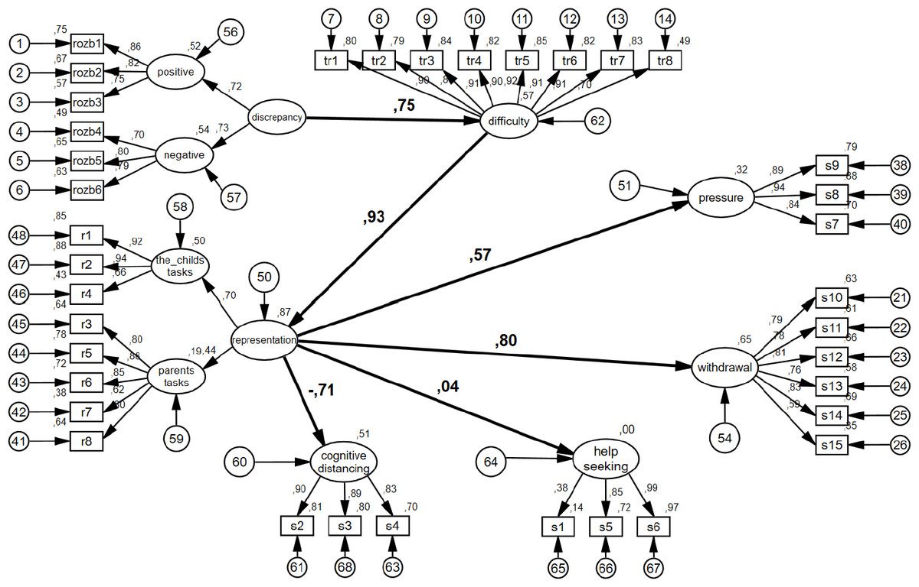

The variables used to measure each construct are identified below.

Discrepancy = rozb1 to rozb6

Representation = r1 to r8

Cognitive Distancing = s2 s3 s4

Help Seeking = s1 s5 s6

Difficulty = tr1 to tr8

Pressure = s7 s8 s9

Withdrawal = s10 to s15

According to Szymańska and Dobrenko’s (2017) model there should be 7 factors, or possibly 9 if Representation and Discrepancy both divide into 2 sub-factors as shown in the figure.

Below I present a factor analysis from SPSS showing 8 factors – I allowed SPSS to use the default extraction method to determine the number of factors (i.e., eigenvalues greater than 1.00). I used an option in SPSS to hide any factor loading less than .30 in absolute value to help make the table of result easier to read. Values less than .30 are often consider unimportant loadings. Items that do not behave as anticipated are highlighted with red circles; these items do not load on the factor expected.

Pattern Matrix – overall the results are very good (see below). In most cases each factor has loadings that are unique to that factor (simple structure) except for Difficulty which is correlated to Representation (child’s task). Given the number of items (n = 37) and the number of constructs to measure (7 or 9), this EFA did well recreating the factor structure.

Table 6: Parent Stress Study with 8 Factors

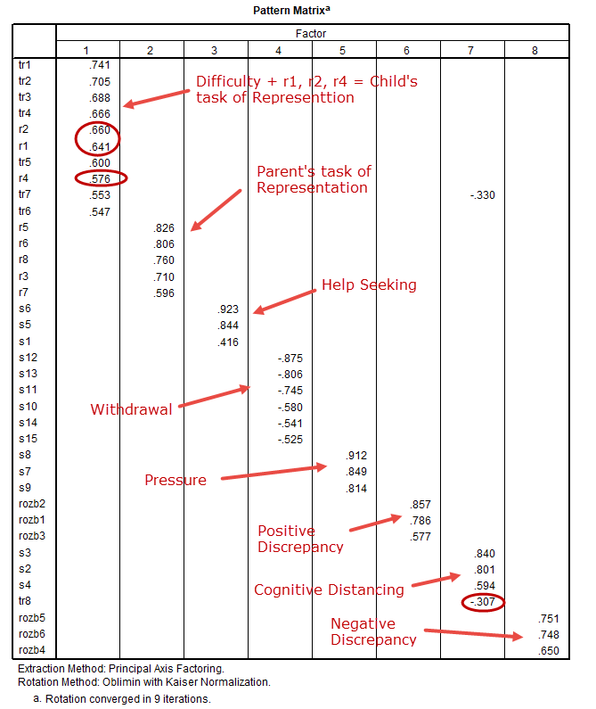

I re-ran the FA but specified 9 factors should be extracted. Results are shown below. The FA almost perfectly reproduced the factor structure expected for the questionnaire – this is a strong indication that the 9-factor extraction is the appropriate solution. Overall their measures of these 9 latent variables worked very well to independently assess these 9 constructs. Note there are no cross-loading except item s1. These are excellent results. Cross-loading means an item loads on more than one factor.

If we desired to shorten some of the longer scales, which items might be best to eliminate?

Table 7: Parent Stress Study with 9 Factors

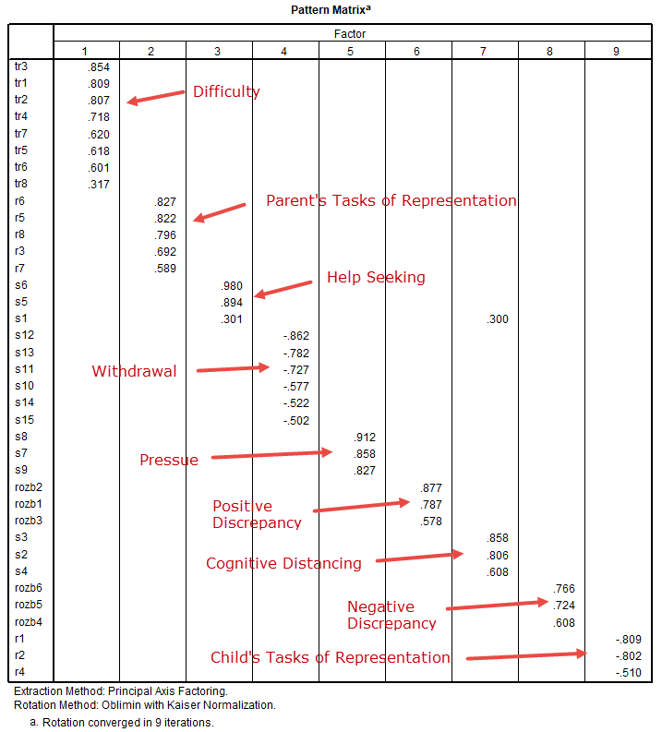

**7. Example 4: Depression Anxiety Stress Scales**

Antony et al. (1998), reference and link below, examined the factor structure of the 42-item Depression Anxiety Stress scale which was designed produce three subscales: depression, anxiety, and stress.

Antony, M. M., Bieling, P. J., Cox, B. J., Enns, M. W., & Swinson, R. P. (1998). Psychometric properties of the 42-item and 21-item versions of the Depression Anxiety Stress Scales in clinical groups and a community sample. Psychological assessment, 10(2), 176.

<http://www.bwgriffin.com/gsu/courses/edur8331/edur8331-presentations/EDUR-8331-05a-Antony-1998-Factor-Analysis-Example.pdf>

Antony et al. (1998) posted item wording and FA results for the 42-item scale. Results are shown below in Table 9.

Table 9: Factor Results for the Depression, Anxiety, and Stress Scales with 42-items

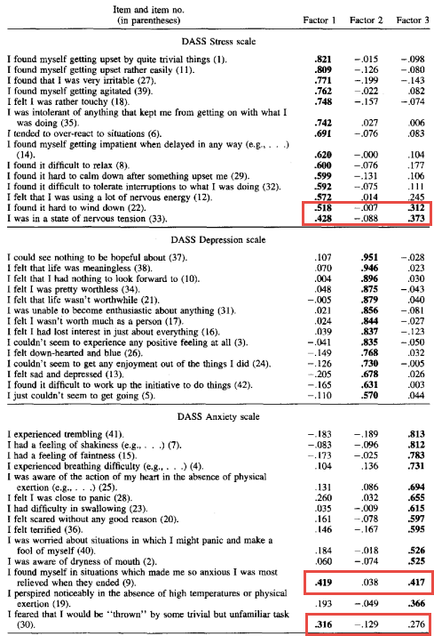

In general, the results suggest a good factor structure for these 42 items. Most items load best on the factor (latent variable) for which they were designed (e.g., anxiety items load highest on the anxiety factor).

Highlighted with red boxes are those items that demonstrate cross-loading with multiple factors. These items do not seem to fit, or do not fit well, with other items designed to measure their targeted latent variable. For example, item 22 is designed to measure stress (factor 1), but also loads on anxiety (factor 3). If item reduction were of interest, perhaps this item could be eliminated from the sub-scale.

Antony et al. (1998) also tested a shortened version of this scale that contains 21 items. Results of their FA are presented below in Table 10. This FA shows very good factor structure for the three sub-scales; all items appear to load as expected on the sub-scale for which they were designed. Comparing Tables 9 and 10, it appears the 21-item scale was developed by taking the 7 best fitting sub-scale items from the 42-item version of the scale. These two tables illustrate how one may use results from FA to reduce a scale then check the reduced scale factor structure with the same sample of participants, or better, a second sample of participants.

Table 10: Factor Results for the Depression, Anxiety, and Stress Scales with 21-items

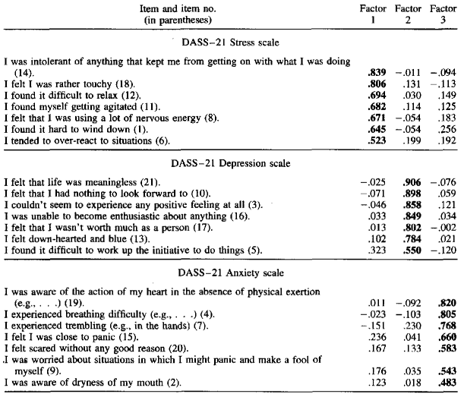

**References**

Antony, M. M., Bieling, P. J., Cox, B. J., Enns, M. W., & Swinson, R. P. (1998). Psychometric properties of the 42-item and 21-item versions of the Depression Anxiety Stress Scales in clinical groups and a community sample. Psychological assessment, 10(2), 176.

Coltman, T., Devinney, T.M., Midgley, D.F., & Venaik, S. (2008). Formative versus reflective measurement models: Two applications of formative measurement. Journal of Business Research, 61, 1250-1262,

Menon, S. (2001). Employee empowerment: An integrative psychological approach. Applied psychology, 50(1), 153-180.

Szymańska A, Dobrenko KA. (2017) The ways parents cope with stress in difficult parenting situations: the structural equation modeling approach. PeerJ, 5, e3384.