**01d: Review of Independent Samples t-test**

**1. Characteristics of Independent Samples t-test**

* used to compare two groups on a quantitative dependent variable
* IV = categorical (nominal) variable with two groups, DV = quantitative variable, examples
  + IV = sex, DV = math scores
  + IV = location of instruction [on-line vs on campus], DV = level of confidence in class
* t-ratio is formed by comparing group mean differences on the dependent variable (compare mean math scores between males and females), and this mean difference is divided by a standard error of that difference
* the larger the t-ratio (in absolute value), the more evidence that groups differ

**2. Reading t-test Results**

Below is an example of published t-test results.

Source: Goodman et al. (2005). Mother expectation of bother and infant attachment behaviors as predictors of method and child communication at 24 months in children of methadone-maintained women. Infant Mental Health Journal, 26, 549-569.

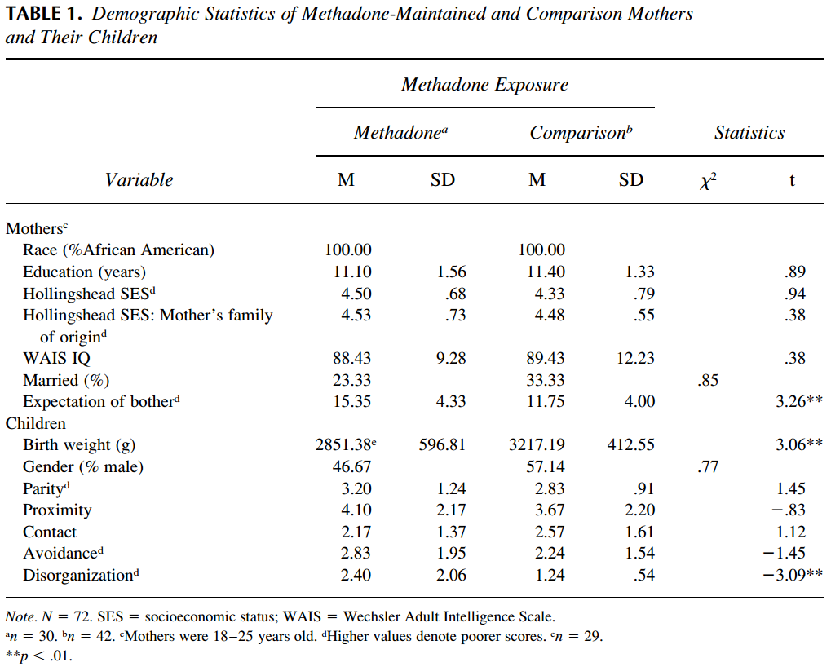

What is the mean difference in WAIS IQ between mothers on Methadone and the comparison group? Is this mean difference statistically significant? Interpret this result.

Answer:

* Mean difference: Methadone mothers WAIS IQ mean = 88.43 and the comparison group IQ mean = 89.43 for a difference of 88.43 - 89.43 = -1.
* Statistical Significance: This mean difference is not statistically significant (t-ratio = 0.38 with no asterisks indicating a significant difference).
* Interpretation: Results of the t-test indicate no statistical difference in WAIS IQ means between Methadone and comparison mothers.

What are the mean scores for expectation of bother between mothers on Methadone and the comparison group? Is this mean difference statistically significant? Interpret this result.

Answer:

* Means: Methadone mothers expectation of bother mean =15.35 and the comparison group expectation of bother mean = 11.75 for a difference of 3.6 points.
* Statistical Significance: This mean difference is statistically significant (t-ratio = 3.26* with an asterisk indicating a significant difference).
* Interpretation: Mothers on Methadone had a higher level of expectation of bother than the comparison mothers. This means those on Methadone expect their children to be more of a bother day-to-day than the comparison mothers.

**3. Worked Example**

Is there a change in mean heart rate per minute before and after taking blood pressure medication for a single individual? Below are data I recorded during four-week period, two weeks before and two weeks after taking blood pressure medication. Is there a difference in my heart rate for these two periods?

|  |  |  |  |  |
| --- | --- | --- | --- | --- |
| Heart Rate | |  | Heart Rate | |
| After | |  | Before | |
| 50 | 62 |  | 57 | 59 |
| 50 | 57 |  | 58 | 57 |
| 48 | 49 |  | 56 | 53 |
| 49 | 47 |  | 55 | 63 |
| 44 | 54 |  | 55 | 54 |
| 49 | 48 |  | 53 | 51 |
| 45 | 44 |  | 53 | 51 |

The data can also be downloaded in an SPSS file from this link.

<http://www.bwgriffin.com/gsu/courses/edur8131/data/heartrate.sav>

**Using SPSS**

Screenshot below shows data entry in SPSS.

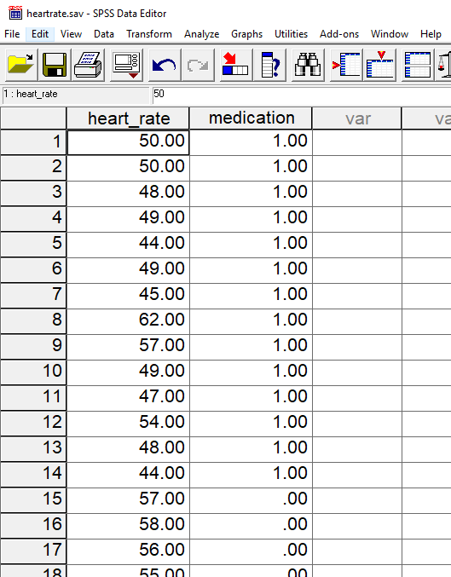

The figure above shows how data for a two-group t-test should be entered. The DV is heart_rate and the IV is medication which is scored 1 = after taking medication and 0 = before taking medication. While you can use any two numeric values desired for coding, I recommend using 0,1 coding to keep things simple. This coding of 0 and 1 informs SPSS which groups of data are to be compared.

SPSS Commands

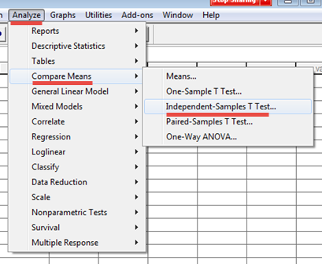

In the window that opens, move the dependent variable (heart rate) in the Test Variables box, and move the IV to the Grouping Variable box.

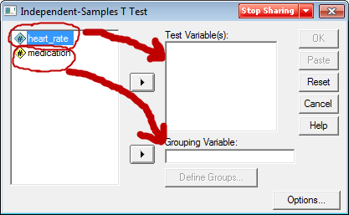

Next, inform SPSS which groups are to be compared. Recall that Medication is scored 1 = after medications, 0 = before medications, so insert these two values in the Define Groups box as shown below.

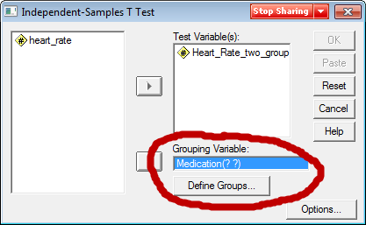

Once groups are defined select OK to obtain results.

SPSS results are shown below. The first table of results show descriptive statistics. From this table we see that before taking medication the heart rate mean = 55.36 beats per minute, but after taking blood pressure medication the heart rate slowed to mean = 49.71 beats per minute.

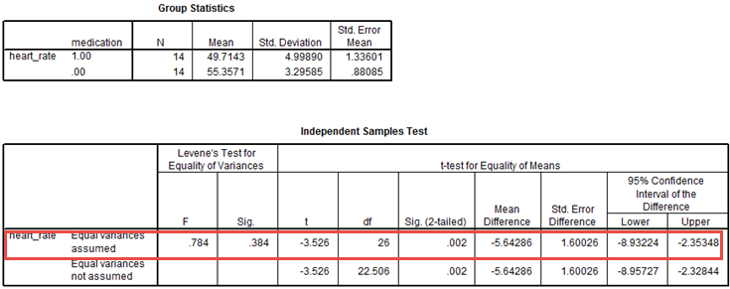

**Equal vs. Unequal Variances**

For EDUR 8331 we will use the row entitled “Equal Variances Assumed” which is marked by a red rectangle in the table above.

Not needed for EDUR 8331, but for those interested, use Levene’s to test group variances:

* Levene’s Test assesses this null, Ho: variance group 1 = variane group 2
* If fail to reject, we assume the two groups have similar variances; if reject, then assume group variances are not equal.
* If variances are not equal, that affects how p-values and CI are calculated for the t-test, so an adjustment is made.
* If sig. (p-value) for Levene’s is less than .10 or .05 (you pick alpha here), then variances appear to be different so use “Equal variances not assume” row,
* but if the Levene’s p-value (sig. value) is greater than .10 or .05 then use “Equal Variances Assumed” row.

**Reading SPSS Results**

The table below shows the t-test results with certain results highlighted.

The calculated t-ratio = -3.526, with degress of freedom = 26. The t-ratio indicates the standardized difference in the two heart rate means.

The p-value for this t-ratio is .002. Recall the decision rule for rejecting the null hypothesis of no mean difference:

If p ≤ α reject Ho; if p > α fail to reject Ho

Since the obained p-value of .002 is less than .05 (standard value for alpha), reject null and conclude there is a mean difference in heart rates before and after taking blood pressure medication.

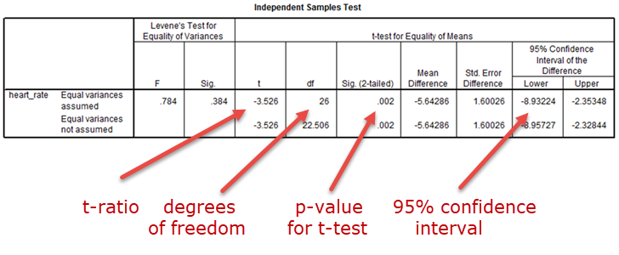

The 95% confidence interval provides a range estimate of how large the possible mean difference in heart rate means could be in the population. The population mean difference could be as low as -8.93 or as high as -2.35; so, the change in heart rate could be a decrease by as much as -8.9 beats per minute or as much as -2.3 beats per minute. Either way, this suggests blood pressure medication I take will reduce my heart rate.

**4. APA Styled Results**

Below is an example showing how to report t-test results in APA style format.

Table 5: Results of t-test and Descriptive Statistics for Heart Rate per Minute by Medication Usage

|  |  |  |  |  |  |  |  |  |  |  |
| --- | --- | --- | --- | --- | --- | --- | --- | --- | --- | --- |
|  | Medication Usage | | | | | | | 95% CI for Mean Difference |  |  |
|  | After Usage | | |  | Before Usage | | |  |  |
|  | M | SD | n |  | M | SD | n | t | df |
| Heart Rate | 49.71 | 5.00 | 14 |  | 55.36 | 3.30 | 14 | -8.93, -2.35 | -3.53* | 26 |

* p < .05.

Two components to the written results, inference and interpretation.

There is a statistically significant mean difference in heart rate per minute before and after taking blood pressure medication. Results show that the blood pressure medication reduced heart rate by about 5.5 beats per minute.