11. ANCOVA with Interaction between Factor and Covariate

Table 1
ANCOVA Results and Descriptive Statistics for Mathematics Achievement by Study Condition and Pre-Mathematics Scores
 |  |  | Mathematics Scores
 |  |  | Observed Mean |  | Adjusted Mean |  | SD |  | n
RPT |  |  | 92.88 |  | varies |  | 4.09 |  | 8
Test Only |  |  | 82.22 |  | varies |  | 8.50 |  | 9
Tutor Only |  |  | 87.43 |  | varies |  | 7.16 |  | 7
Control |  |  | 79.20 |  | varies |  | 7.39 |  | 10
Source | SS |  |  | df |  | MS |  | F
Study Condition (SC) | 341.01 |  |  | 3 |  | 113.67 |  | 5.98*
Math. Pretest (P) | 612.30 |  |  | 1 |  | 612.30 |  | 32.22*
SC × P | 222.03 |  |  | 3 |  | 74.01 |  | 3.89*
Error | 494.15 |  |  | 26 |  | 19.01
Note. R² = .80, Adj. R² = .74.
* p < .05

Table 2
Comparisons of Mean Differences in Mathematics Achievement by Study Condition (RPT vs. others)
Achievement Comparison by Study Condition for Levels of Pretest Performance | Estimated Mean Difference | Standard Error of Difference | Bonferroni Adjusted 95% CI
Math. Pretest = 39.01
RPT vs. Control | 19.27* | 3.18 | 10.18, 28.36
RPT vs. Test Only | 17.40* | 3.14 | 8.43, 26.37
RPT vs. Tutor Only | 9.87* | 3.38 | 0.22, 19.52
Math. Pretest = 47.06
RPT vs. Control | 13.96* | 2.09 | 8.00, 19.92
RPT vs. Test Only | 10.19* | 2.14 | 4.08, 16.29
RPT vs. Tutor Only | 4.42 | 2.30 | -2.15, 10.99
Math. Pretest = 55.10
RPT vs. Control | 8.66* | 2.81 | 0.64, 16.68
RPT vs. Test Only | 2.98 | 2.91 | -5.34, 11.30
RPT vs. Tutor Only | -1.03 | 3.52 | -11.09, 9.03
Note. Comparisons based upon ANCOVA adjusted means controlling for Mathematics Pretest with the scores specified within the table.
* p < .05, where p-values are adjusted using the Bonferroni method

Figure 1
Scatter Plot of Pre- and Post-Mathematics Scores by Study Condition with Points for Multiple Comparisons Indicated
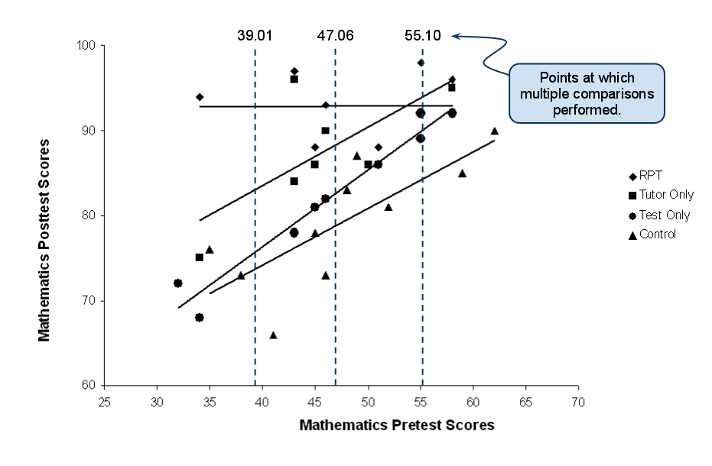

ANCOVA results, in Table 10c1, show there is a statistically significant interaction between Mathematics pretest scores and Study Condition. Figure 10c1 displays this interaction. Note that the association between pretest and posttest scores is positive and similar for the Tutor Only, Test Only, and Control groups. This means that those who performed better on the pretest also tended to perform better on the posttest; similarly, those who performed at a lower level on the pretest also tended to perform at a lower level on the posttest. The RPT group, however, displayed a different pattern—the slope between pretest and posttest mathematics scores is flat which indicates that students who scored low on the pretest tended to perform on the posttest as well as students who scored high on the pretest. Several multiple comparisons were performed to help examine these scores. Since the RPT group clearly differs from the other three groups, only the RPT vs. other group comparisons are reported. For these multiple comparisons, three points along the mathematics pretest scores range were examined, the mean (47.06), the mean + SD (55.10), and the mean – SD (39.01). Table 10c2 contains results of these comparisons. When pretest scores are low (39.01), students in the RPT group achieved higher scores than their counterparts in the other three groups. For mid-level pretest scores (47.06), students in the RPT group achieved higher mathematics scores than did students in the Control or Test Only conditions, but students in the Tutor Only condition displayed similar mean performance to those in the RPT condition. Lastly, when pretest scores are high (55.10), students in the three treatment conditions appear to display similar levels of achievement and the only statistically significant difference observed was between those in RPT and Control conditions. In summary, with RPT it appears that all students were able to perform well on the posttest despite their initial level of understanding as measured by the mathematics pretest. Overall the RPT group appears to have better performance than those in the Tutor only, Test only, or Control conditions under most ranges of initial understanding of mathematics.

