ANCOVA with Interaction: RATA Experiment (Chat Session 15)

Data from this experiment come from an EdS study dated fall 2010. RATA (Read Aloud, Think Aloud) is a reading comprehension strategy. The EdS student designed this study to learn whether RATA could be helpful to 4th grade students facing mathematics word problems. Two classes were involved – one used RATA and one did not. Below are pretest and posttest mathematics scores for the two groups.

pre | post | condition
40.7 | 39 | RATA
41.9 | 54.2 | RATA
44.7 | 51.6 | RATA
60.4 | 46.3 | RATA
45.8 | 13.1 | RATA
54.8 | 58.7 | RATA
72.8 | 93.3 | RATA
46.3 | 36.5 | RATA
67.7 | 48.9 | RATA
47.9 | 58.7 | RATA
46.3 | 50.5 | RATA
59.9 | 59.3 | RATA
71.8 | 84.6 | RATA
48.4 | 51.1 | RATA
58.7 | 73.7 | RATA
55.3 | 67 | RATA
30.7 | 45.2 | RATA
74.7 | 72.8 | control
62.9 | 71.8 | control
77 | 62.3 | control
55.9 | 65.6 | control
40.1 | 84.6 | control
46.3 | 73.7 | control
64.9 | 66.3 | control
63.5 | 47.4 | control
52.1 | 59.3 | control
71.8 | 93.3 | control
77 | 77 | control
65.6 | 93.3 | control
59.9 | 79.6 | control
84.6 | 93.3 | control
81.1 | 81.1 | control
81.1 | 81.1 | control
41.3 | 49.5 | control
71.8 | 74.7 | control
81.1 | 72.8 | control
50.5 | 70.9 | control

APA Styled Results Presentation

Table 1
ANCOVA Results and Descriptive Statistics for Mathematics Achievement by Instructional Condition and Pre-Mathematics Scores
 |  |  | Mathematics Scores
 |  |  | Observed Mean |  | Adjusted Mean |  | SD |  | n
RATA |  |  | 54.81 |  | varies |  | 18.53 |  | 17
Non-RATA |  |  | 73.52 |  | varies |  | 12.93 |  | 20
Source | SS |  |  | df |  | MS |  | F
Study Condition (SC) | 1024.92 |  |  | 1 |  | 1024.92 |  | 5.75*
Math. Pretest (P) | 2628.00 |  |  | 1 |  | 2628.00 |  | 14.75*
SC × P | 664.45 |  |  | 1 |  | 664.45 |  | 3.73*
Error | 5878.08 |  |  | 33 |  | 178.12
Note. R² = .51, Adj. R² = .46.
* p < .10

Table 2
Comparisons of Mean Differences in Mathematics Achievement by Study Condition (RATA vs. Non-RATA)
Achievement Comparison by Study Condition for Levels of Pretest Performance | Estimated Mean Difference | Standard Error of Difference | 90% CI
Math. Pretest = 73.36
RATA vs. Non-RATA | 0.23 | 7.66 | -12.73, 13.20
Math. Pretest = 59.37
RATA vs. Non-RATA | -9.58 | 4.99 | -18.02, -1.14
Math. Pretest = 45.38
RATA vs. Non-RATA | -19.42 | 6.54 | -30.49, -8.35
Note. Comparisons based upon ANCOVA adjusted means controlling for Mathematics Pretest with the scores specified within the table.
* p < .10.

Figure 1
Scatter Plot of Pre- and Post-Mathematics Scores by Study Condition with Points for Multiple Comparisons Indicated
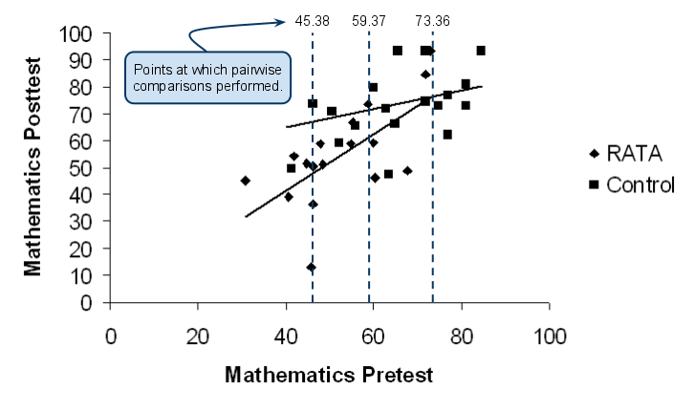

ANCOVA results show that there is a statistically significant, at the .10 level, interaction between pretest scores and type of instruction. Figure 1 provides a visual display of these results. Pretest and posttest scores from students in the RATA condition show a strong, positive association. Students in RATA condition who performed poorly on the pretest tended to perform poorly on the posttest, and those who performed well on the pretest tended to perform well on the posttest. Students in the control group, however, demonstrated a different pattern of results. In contrast to the RATA group, students in the control group who scored poorly on the pretest tended to perform better the posttest. This suggests that instruction in the control condition was more beneficial than instruction in the RATA condition. Pairwise comparisons were performed to help examine achievement differences between conditions. As shown in Table 2 and in Figure 1, students who did well on the pretest tended to perform similarly in both RATA and control conditions. However, RATA students with average performance and poor performance on the pretest showed decreasingly poorer performance on the posttest compared with students in the control condition. These results suggest that RATA failed to enhance instruction and appears to have interfered with learning.

