EDUR 8131
Chat 13: ANOVA , Part 2

1 Notes 9a: One-way ANOVA

Previous chat covered through section 6; brief review will be presented here of material presented in previous chat.

1. Purpose

Just like two-independent samples t-test, except can have more than 2 groups.

Example:

Is there a difference in overall mean MPG among country/area of origin of cars: American, European, and Japanese.

http://www.bwgriffin.com/gsu/courses/edur8131/data/cars.sav

2. Hypothesis

Overall ANOVA Hypothesis

Mean MPG will be same no matter what the origin of the car.

Ho: µ_{i} = µ_{j} (OR since three groups, Ho: µ_{American} = µ_{European} = µ_{Japanese} )

H₁: µ_{i} ≠ µ_{j}

Individual Comparison Hypothesis

Determine mean differences in MPG for each of these three possible pairwise comparisons

1. American vs. European cars,
2. American vs. Japanese, and
3. European vs. Japanese.

Covered below under multiple comparisons

1.3 Why not Separate t-tests?

The familywise, or experimentwise, error rate is higher than the nominal level of .05.

Comparison | Alpha per comparison
t-test 1 = a vs. b | .05
t-test 2 = a vs. c | .05
t-test 3 = b vs. c | .05

Taken together, these three tests lead to familywise error rate of:

1 – (1-α)^{C}

Where “c” is the number of comparison, alpha is the per comparison alpha level, so with three tests, the new Type 1 error rate is:

Familywise error rate = 1 – (1-α)^{C}
Familywise error rate = 1 – (1-.05)³
Familywise error rate = 1 – (.95)³
Familywise error rate = 1 – .857375
Familywise error rate = .142625

Familywise error rate interpretation = There is a .1426 chance that at least one hypothesis test among the three will be incorrectly rejected (at least a .1462 chance of making a Type 1 error among the three tests performed).

So we need a mechanism for controlling the possible inflation of the Type 1 error rate across a family of tests. This mechanism is discussed below under multiple comparisons.

4 Linear Model Representation

Skip

5 Logic of Testing Ho in ANOVA

Divides DV variance into components associated with group membership and error – see Table

Source | SS | df | MS (variance) | F
Between (group, regression) | SSb | df between | MSb = SSb/dfb | MSb / MSw
Within (error, residual) | SSw | df within | MSw = SSw/dfw
Total | SSt | df total | (SSt / df total =  variance of DV)

SS = sums of squares
DF = degrees of freedom
MS = mean square – ANOVA term for variance (mean square = variance)
F = F ratio
F-ratio = MS b / MS w (i.e., variance between / variance within)

F-ratio tests H₀: µ_{i} = µ_{j}

An F-ratio of 0.00 tells what about the group means?

No mean difference among groups.

F-ratio measures group mean separation, the larger the F ratio, the more group mean separation, so the larger the difference among groups.

ANOVA
Miles per Gallon
 | Sum of Squares | df | Mean Square | F | Sig.
Between Groups | 7984.957 | 2 | 3992.479 | 97.969 | .000
Within Groups | 16056.415 | 394 | 40.752
Total | 24041.372 | 396

Variance of MPG based upon the ANOVA results would be

(SS total / df total) = 24041.372 / 396 = 60.712

What this shows is that SS / DF = variance of the DV (mpg in this example)

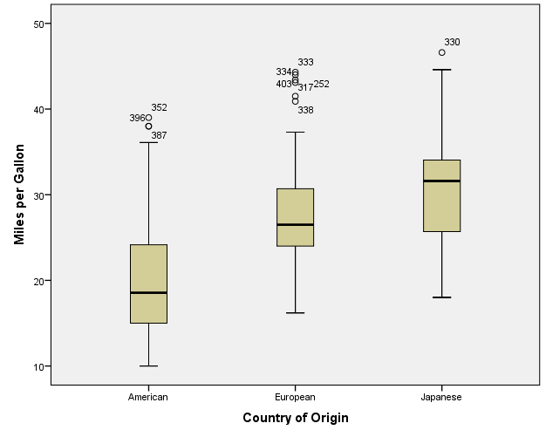

6 One-way ANOVA in SPSS
SPSS Results of One-way ANOVA (both oneway and general linear model commands)

Analyze -> Compare means -> One-way ANOVA
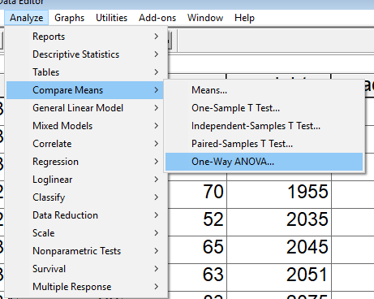

Move the DV, MPG, to the DV box
Move the IV, Origins, to the Factor box (factor is the anova term for categorical, nominal IV)

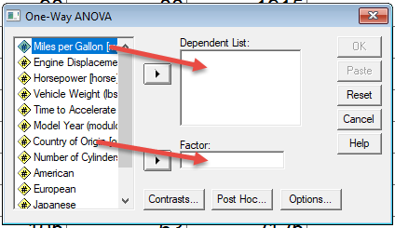

Click on Options and mark Describes to get M, SD, and n for each group.
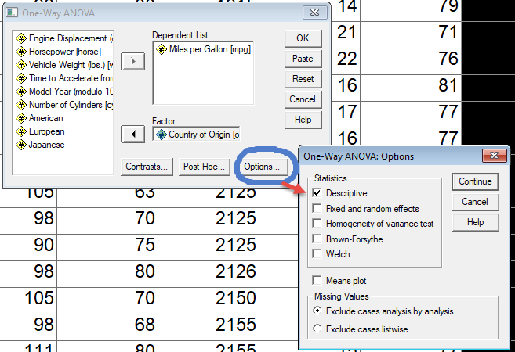

Results of Oneway command in SPSS

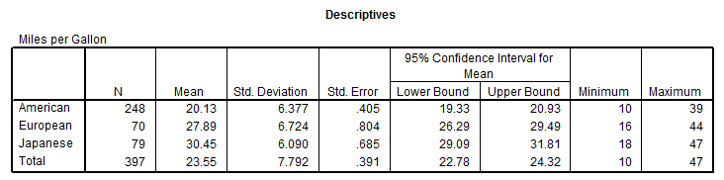
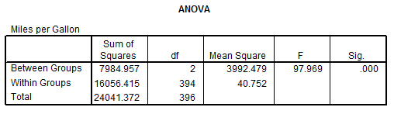

Results of General Linear Model Command in SPSS
1. Analyze, General Linear Model, Univariate
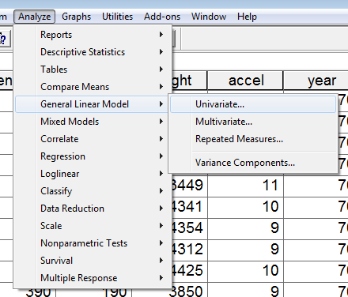

2. Move DV to DV box, move grouping variable into fixed factor box (see below)
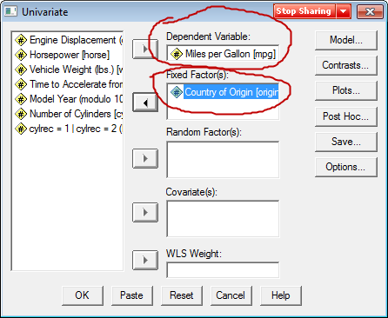

3. To get descriptive statistics (M, SD, n) per group, click on Options then place mark next to Descriptive Statistics
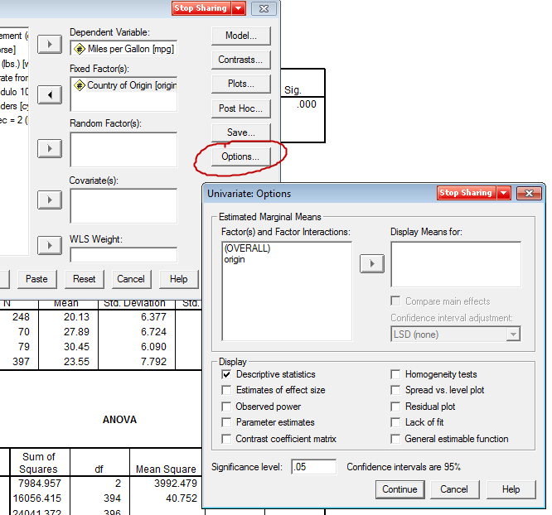

Results
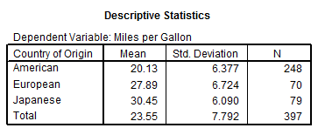
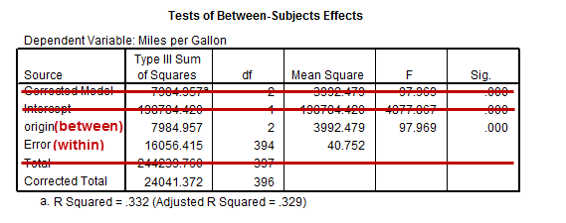

One benefit from the General Linear Model command is the calculation of R² and Adjusted R² values (see table above).

Both R² and Adjusted R² have the same interpretation as with regression—the proportion of variance in the DV that can be predicted by the ANOVA model (country of origin in this example).

If you used the One-way command and wanted to calculate the R2 value yourself, here’s how:
R² = SS between / SS total = 7984.957/ 24041.372 = 0.3321

7. Multiple Comparisons

Problem – ANOVA results above show that there is a statistically significant mean difference in MPG based upon origin of vehicle, but the ANOVA does not indicate which groups (which countries of origin) are different.

Many possible – see, for example, post hoc options in oneway command in SPSS.

From Oneway SPSS command:
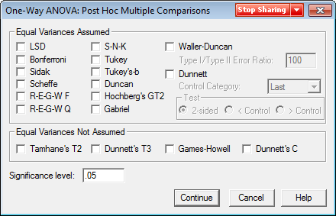

a. Bonferroni Adjustment for Multiple Comparisons

Control familywise error rate at a set level such as .05 or .01, divide nominal alpha for familywise error rate by number of comparisons performed and use resulting adjusted alpha as the new per comparison alpha.

Bonferroni adjusted α for pairwise comparisons = $\frac{(familywise α) }{(number of comparisons)}$

Divide familywise alpha (e.g., .05) by the number of comparisons and use the result as the new alpha for each pairwise comparison.

Example
Compare car MPG by area of origin (American, Japanese, European).

Three possible pairwise comparisons:

Comparison 1 = American vs. Japanese
Comparison 2 = American vs. European
Comparison 3 = Japanese vs. European

Familywise Error Rate to be set at alpha = .05

Bonferroni adjusted comparison alpha for each pairwise comparison

Bonferroni adjusted α = .05 / 3 =
.0167

Decision rule

If p ≤ alpha (or Bonferroni alpha) reject Ho, but if p > alpha fail to reject

Comparison | Old Alpha | Bonferroni Adjusted Alpha | P-value (fictional values given)
1 = American vs. Japanese | .05 | .0167 | .002
2 = American vs. European | .05 | .0167 | .018
3 = Japanese vs. European | .05 | .0167 | .042
Familywise Error Rate (1-(1-α)^{C})= | 0.14263 | Value =?
 |  | .049267

If .018 ≤ .05 reject Ho, but if p > alpha fail to reject
If .018 ≤ .0167 reject Ho, but if p > alpha fail to reject

--+----------------------------+-------------------------------+------------ Number Line
0.00 .0167 .05

What would be the Bonferroni alpha per comparison if we want an overall familywise error rate of .05 and we have 6 comparisons (4 groups means 6 possible pairwise comparisons)?

1. a vs. b
2. a vs. c
3. a vs. d
4. b vs. c
5. b vs. d
6. c vs. d

What would be the Bonferroni adjusted alpha for these 6 comparisons?

Bonferroni alpha = (familywise error rate) / number of comparisons =

Bonferroni alpha = (familywise error rate) / number of comparisons = .05 / 6 = .008333

For 6 comparisons with per comparison unadjusted α = .05, what would be the familywise error rate?

Familywise Error Rate (1-(1-α)^{C}) =
.2649

For 6 comparisons with per comparison Bonferroni adjusted α = .008333, what would be the familywise error rate?

Familywise Error Rate (1-(1-α)^{C})=
.0489

Table showing Bonferroni Pairwise Adjusted Alpha per comparison
Number of Comparisons |  | α = .05 | α = .01 | Familywise Error Rate (Familywise Alpha)
1 |  | 0.0500000 | 0.0100000 | Pairwise Error Rate (adjusted alpha)
2 |  | 0.0250000 | 0.0050000
3 |  | 0.0166667 | 0.0033333
4 |  | 0.0125000 | 0.0025000
5 |  | 0.0100000 | 0.0020000
6 |  | 0.0083333 | 0.0016667
7 |  | 0.0071429 | 0.0014286
8 |  | 0.0062500 | 0.0012500
9 |  | 0.0055556 | 0.0011111
10 |  | 0.0050000 | 0.0010000

Question
What is the potential drawback to such small per comparison, Bonferroni adjusted α when the number of comparisons increases?

Answer
As the probability of a Type 1 error decreases, the probability of a Type 2 error increases. Recall that a Type 2 is failing to reject a false Ho (failing to detect group differences if they exist). As α becomes smaller, it becomes more and more difficult to reject Ho, so therefore it becomes more difficult to find real differences if they exist. In short, as α becomes smaller the test loses power (1-β) to detect differences if they exist.

b. Scheffé Adjustment for Multiple Comparisons

- Too complex to cover here, but the logic is similar to Bonferroni
- More conservative (less likely to reject Ho, less power) unless there are a large number of comparisons
- Once calculated it is good for all pairwise and more complex comparisons or contrasts (e.g., ([a+b]/2 vs. c), no need to recalculate adjusted α once other comparisons are added
- Use if more than 5 to 7 comparisons it should be better than Bonferroni (i.e., give more power), but calculate and compare CI with Bonferroni to determine which is more powerful, Scheffe or Bonferroni
- Based upon critical F-ratio

Example (with SPSS)

Test mean differences in mean MPG among three groups (use SPSS)

Am. Vs. Eu
Am. Vs Jap.
Eur vs. Jap.

Recall the mean MPG for each of the three origins:

American = 20.13
European = 27.89
Japanese = 30.45
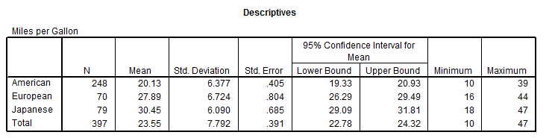

Ho: µ_{American} = µ_{European}

OR

Ho: µ_{American} - µ_{European} = 0.00

So what are the mean differences for each of these comparisons?

American = 20.13
European = 27.89
Japanese = 30.45

Am. Vs. Eur. = 20.13 – 27.89 = ?
Am. Vs. Eur. = 20.13 – 27.89 = -7.76

Am. Vs Jap. = ?
Am. Vs Jap. = 20.13 – 30.45 = -10.32

Eur. vs. Jap. = ?
Eur. vs. Jap. = -2.56

Show SPSS Bonferroni and Scheffe

Using oneway command in SPSS

Select “Post Hoc” to obtain Bonferroni and Scheffe corrections and confidence intervals.

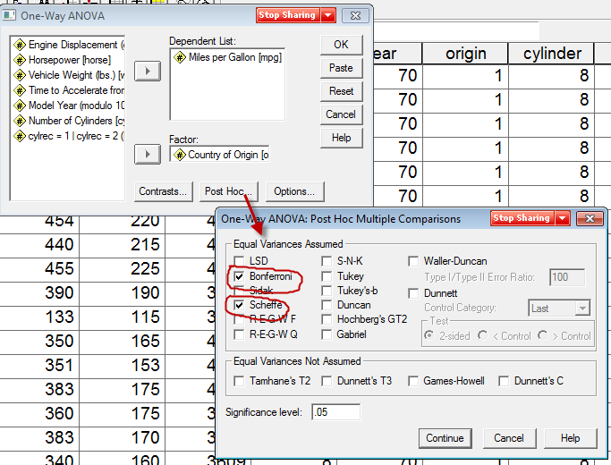

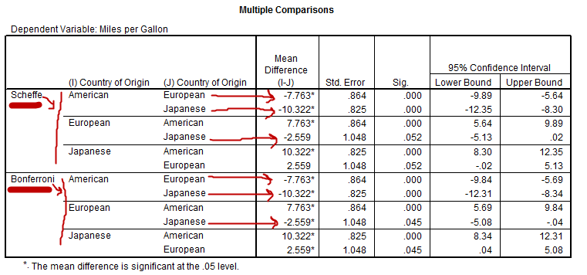

Question
Do the Bonferroni and Scheffe produce different inferences for the above data?

Answer
Note difference inference result for European vs. Japanese comparisons. FTR for Scheffé, but reject for Bonferroni (thus, Bonferroni has slightly more power than Scheffe)

APA Style for Car Data

Table 1
ANOVA Results and Descriptive Statistics for Number of Inquiries by Days of the Week
Days |  | Mean |  | SD |  | n
American |  | 20.13 |  | 6.38 |  | 248
European |  | 27.89 |  | 6.72 |  | 70
Japanese |  | 30.45 |  | 6.09 |  | 79
Source | SS |  | df |  | MS |  | F
Origin | 7984.96 |  | 2 |  | 3992.48 |  | 97.97*
Error | 16056.42 |  | 394 |  | 40.75
Note. R² = .33
* p < .05

[If we wished to report R² value, it would be (SS between)/ (SS total) = 7984.96/24041.38 = .33]

Table 2
Multiple Comparisons and Mean Differences in Ad Inquiries by Week Days
Comparisons | Mean Difference | s.e. | Scheffé Adjusted 95% CI
A vs. E | -7.76* | .86 | -9.89, -5.64
A vs. J | -10.32* | .83 | -12.35, -8.30
J vs. E | 2.56 | 1.05 | -.02, 5.13
Note. A = American, E = European, and J = Japanese.
* p < .05, where p-values are adjusted using the Scheffé method.

There are statistically significant mean differences in MPG among areas of origin. Both European and Japanese cars obtain statistically higher MPG than their American counterparts. However, there is not a statistically significant mean difference in MPG between Japanese and European cars; cars from both origins appear to obtain similar MPG.

Additional ANOVA Examples (with APA)
Example Data
http://www.bwgriffin.com/gsu/courses/edur8132/data/Newspaper_Ad_Inquiries.sav

Excel Version
http://www.bwgriffin.com/gsu/courses/edur8131/data/Newspaper_Ad_Inquiries.xls

Example 1
IV = section of newspaper (1 = news, 2 = business, 3 = sports)
DV = inquiries – number of contacts received about an ad placed in newspaper

Run ANOVA with the above IV and DV. Determine if multiple comparisons are needed, if yes, perform multiple comparisons. Set alpha = .05

When the ANOVA is completed, post the value of the obtained F ratio in the chat box.

F = 4.235
p-value (called Sig. in SPSS) = .019

Decision rule for p-values:
If p-value is ≤ alpha reject Ho, otherwise fail to reject Ho

Question
Do we reject or fail to reject Ho of no difference in inquiries based upon sections of the newspaper.

Answer
Reject Ho.

Question
Since we reject the overall null (all means are equal), what is the next step in the ANOVA analysis?

Perform multiple comparisons to pinpoint which sections of the newspaper differ in mean inquiries.

Question
Recall that the p-value for the F ratio was = .019
If we had set α = .01 instead, then would we reject overall null based upon F test?

Since p = .019 since it is larger than α = .01, so Fail To Reject (FTR) null (Ho: no differences in mean number of inquiries across the three sections of newspaper).

Question
Since we FTR, what does this result tell us?

No difference in inquires across sections of the newspaper – no difference in mean number of inquiries

Question
Since we failed to reject the overall null (all means are equal), what is the next step in the ANOVA analysis?

Since the overall null of no difference among the three groups was not rejected, and since the null says means are the same, we stop analysis here and report results – there is no need to perform multiple comparisons to pinpoint group differences since the null tells us the means are the same (they don’t differ).

Analysis
Run analysis in SPSS and find Bonferroni and Scheffe confidence intervals (run multiple comparison procedures).

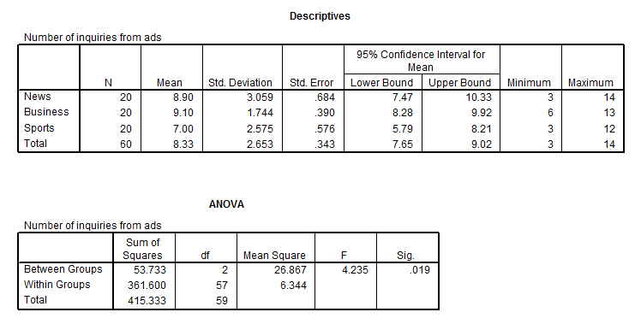
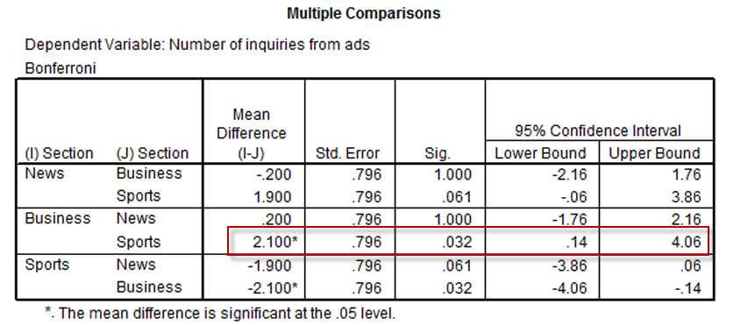

With both Bonferroni and Scheffe conducted
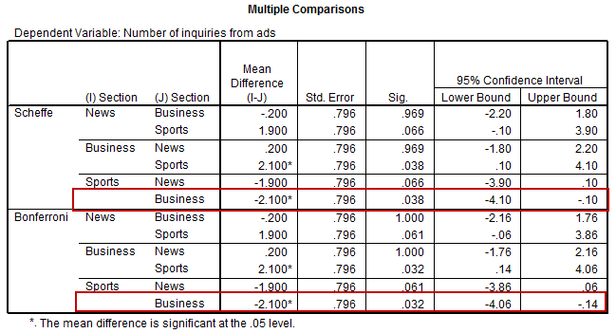

Example 2
IV = days --- days of the week
DV = inquiries

Run ANOVA with the above IV and DV. Determine if multiple comparisons are needed, if yes, perform multiple comparisons. Set alpha = .05

When the ANOVA is completed, post the value of the obtained F ratio in the chat box.

F = 7.519

Recall this F ratio tests Ho: no difference in # of inquiries across days of the week,
i.e., mean number of inquires should be same each day of week

p-value (called Sig. in SPSS) = .000

Decision rule for p-values:

If p-value is ≤ alpha reject Ho, otherwise fail to reject Ho

Question
Reject or fail to reject?

Reject

Question
What is next step in analysis?

Since we rejected Ho (no difference in inquiries across days of the week), and found that number of inquires does appear to differ based upon which day ad was placed, next step is to perform multiple comparisons (pairwise comparisons with corrections using Bonferroni or Scheffe) to pinpoint which days are better for generating inquiries.

Question
Given that we have 5 days to compare, which method should give us better results (tighter confidence intervals), Scheffe or Bonferroni?

How many comparisons are possible with 5 groups?

Possible comparisons:

1. Monday vs. Tuesday,
2. Monday vs. Wed.,
3. Mon. vs. Thurs.,
4. Mon. vs. Fri.
5. Tues. vs. Wed.,
6. Tues vs. Thursday
7. Tues. vs. Friday
8. Wed. vs. Thurs.,
9. Wed. vs. Fri.
10. Thurs. vs. Fri.

Since there are 10 comparisons, Scheffe should provide tighter confidence intervals.

Number of pairwise comparisons ignoring order:

n(n-1)/2 = number of pairwise comparisons

where n = number of groups.
5(5-1)/2 =
5(4)/2 =
20/2 = 10

SPSS Results (using One-way ANOVA)

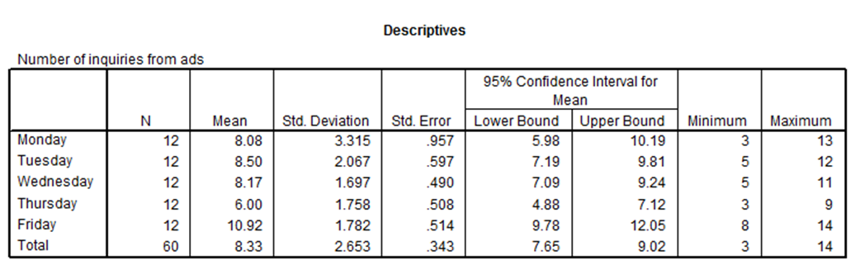

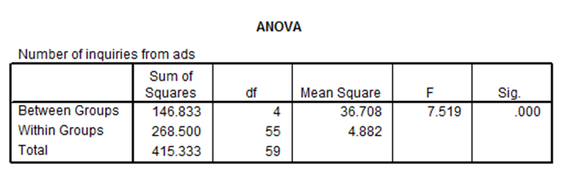
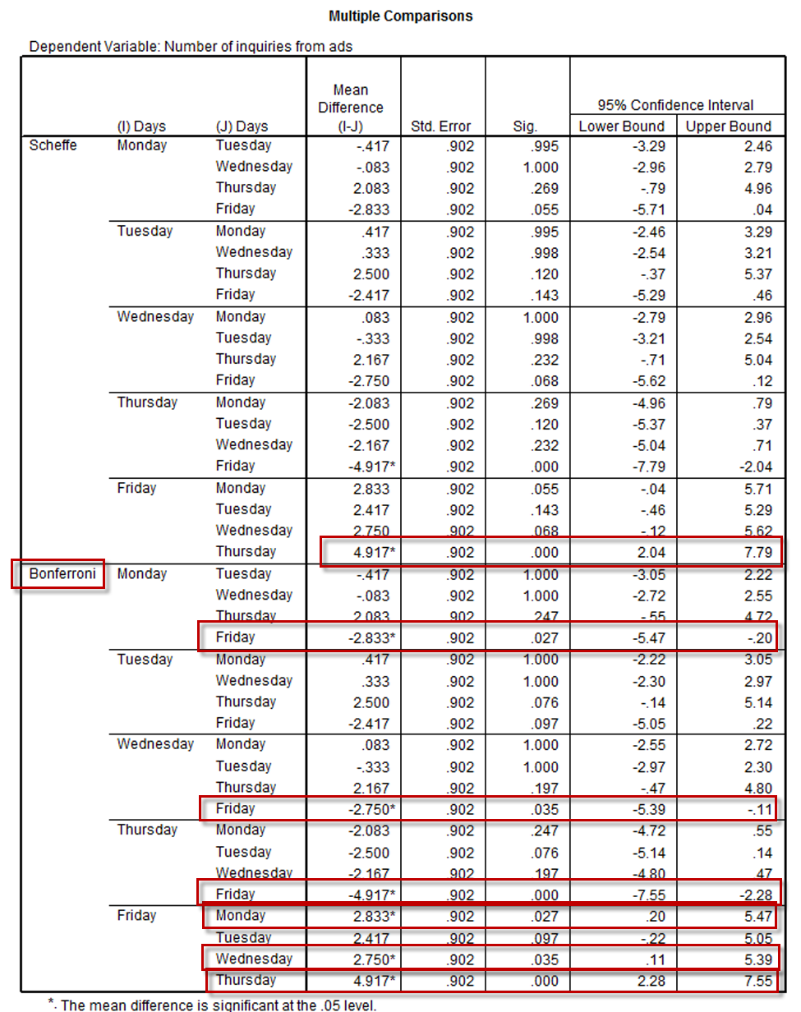

9. APA Style Results

APA Style with Days of Week and Ad Inquiries.

Table 1
ANOVA Results and Descriptive Statistics for Number of Inquiries by Days of the Week
Days |  | Mean |  | SD |  | n
Monday |  | 8.08 |  | 3.32 |  | 12
Tuesday |  | 8.50 |  | 2.07 |  | 12
Wednesday |  | 8.17 |  | 1.70 |  | 12
Thursday |  | 6.00 |  | 1.76 |  | 12
Friday |  | 10.92 |  | 1.78 |  | 12
Source | SS |  | df |  | MS |  | F
Days | 146.83 |  | 4 |  | 36.71 |  | 7.52*
Error | 268.50 |  | 55 |  | 4.88
Note. R² = .35
* p < .05

[If we wished to report R² value, it would be (SS between)/ (SS total) = 146.833/415.333 = .35]

Table 2
Multiple Comparisons and Mean Differences in Ad Inquiries by Week Days
Comparisons | Mean Difference | s.e. | Scheffé Adjusted 95% CI
M vs. T | -0.42 | .902 | -3.29, 2.46
M vs. W | -0.08 | .902 | -2.96, 2.79
M vs. Th | 2.08 | .902 | -0.79, 4.96
M vs. F | -2.83 | .902 | -5.71, 0.04
T vs. W | 0.33 | .902 | -2.54, 3.21
T vs. Th | 2.50 | .902 | -0.37, 5.37
T vs. F | -2.42 | .902 | -5.29, 0.46
W vs. Th | 2.17 | .902 | -0.71, 5.04
W vs. F | -2.75 | .902 | -5.62, 0.12
Th vs. F | -4.92* | .902 | -7.79, -2.04
Note. M = Monday, T = Tuesday, W = Wednesday, Th = Thursday, and F = Friday.
* p < .05, where p-values are adjusted using the Scheffé method.

ANOVA results show there is a statistically significant mean difference in number of advertisement inquiries across weekdays. As shown in Table 2, the only significant pairwise comparison is between inquiries for Thusday and Friday, with the number of inquiries on Fridays averaging about 10.92 and the number on Thursdays averaging 6.00, so it seems there are more inquiries on Friday than on Thursday. Inquiries on other days of the week were between these two means, and were not statistically different from either Thursday or Friday. In summary, it seems the day with the greatest number of inquiries is Friday, but this number was not statistically greater than the number of inquiries received on Mondays, Tuesdays, or Wednesday.

Note – if using Bonferroni, the results differ somewhat. Here is how I would reword that:

As shown in Table 2, Friday has more inquiries than either Monday, Wednesday, or Thursday. On average the number of inquiries on Friday is about 2.5 to 5 more than the other days of the week except Tuesday. … etc.

