EDUR 8131
Chat 12: ANOVA, Part 1

1. Notes 9a: One-way ANOVA

One-way means only one IV. Two-way means two IVs, three-way means three IVs, etc.

1 Purpose

Just like two-independent samples t-test, except can have more than 2 groups.

Example
Is there a difference in overall mean MPG among country/area of origin of cars: American, European, and Japanese.

http://www.bwgriffin.com/gsu/courses/edur8131/data/cars.sav

2 Hypothesis

2.1 Overall ANOVA Hypothesis

MPG will be same no matter what the origin of the car.

Symbolic
Ho: µ_{i} = µ_{j} (or since three groups, Ho: µ_{American} = µ_{European} = µ_{Japanese})

H₁: µ_{i} ≠ µ_{j}

Written
Ho: There will be no difference in mean MPG among American, European, or Japanese cars.

Hi: There will be difference in mean MPG among American, European, or Japanese cars.

2.2 Individual Comparison Hypothesis

Pairwise comparisons among groups:

Is there a difference in MPG between

1. American vs. European cars,
2. American vs. Japanese, and
3. European vs. Japanese.

Covered below under multiple comparisons

3 Why not Separate t-tests?

Three groups, a, b, and c; does DV differ across these three groups?

t-test 1 = a vs. b
t-test 2 = a vs. c
t-test 3 = b vs. c

or

1. American vs. European cars,
2. American vs. Japanese, and
3. European vs. Japanese.

This analysis requires three separate tests. Combined these three tests are known as a family of pairwise tests.

Since there are multiple tests performed in this family, this leads to inflation of Type 1 error rate.

The familywise, or experimentwise, error rate is higher than the nominal level of .05.

Comparison | Type 1 Error Rate (Alpha, α) per comparison
t-test 1 = American vs. European | .05
t-test 2 = American vs. Japanese | .05
t-test 3 = European vs. Japanese | .05

Taken together, these three tests lead to familywise error rate of:

1 – (1-α)^{C}

Where “c” is the number of comparison, alpha is the per comparison alpha level, so with three tests, the new Type 1 error rate is:

Familywise error rate = 1 – (1-α)^{C}
Familywise error rate = 1 – (1-.05)³
Familywise error rate = 1 – (.95)³
Familywise error rate = 1 – .857375
Familywise error rate = .142625

So we need a mechanism for controlling the possible inflation of the Type 1 error rate across a family of tests. This mechanism is discussed below under multiple comparisons.

Questions (illustrate in Excel)
1. How many pairwise comparisons possible if we add a fourth auto maker category of other?

a b c d

a vs b
a vs c
a vs d
b vs c
b vs d
c vs d

2. What is the familywise error rate for these comparisons if alpha = .05?

Familywise error rate = 1 – (1-α)^{C}
Familywise error rate = 1 – (1-.05)⁶
Familywise error rate = 1 – (.95)⁶
Familywise error rate = 1 – .73509
Familywise error rate = .26491

Excel formula = =1-(1-D2)^D3 (where D2 is alpha and D3 is number of comparisons

What would be the familywise error rate for these 6 tests if alpha = .01?

fw error rate = .0585

3. Illustrate logic of single coin flip (pairwise alpha) vs. series of flips for obtaining heads vs. tails.

4 Linear Model Representation
Skip

5 Logic of Testing Ho in ANOVA

ANOVA used to test Ho:

Ho: µ_{i} = µ_{j} (or since three groups, Ho: µ_{American} = µ_{European} = µ_{Japanese} )

Divides DV variance into components associated with group membership and error – see ANOVA Summary Table below

Source | SS | df | MS (variance) | F
Between (group, regression) | SSb | df between | MSb = SSb/dfb | MSb / MSw
Within (error, residual) | SSw | df within | MSw = SSw/dfw
Total | SSt | df total | (SSt / df total =  variance of DV)

Note: Present quick reminder of SS, df, and variance in Excel for a simple set of data

SS = sums of squares
DF = degrees of freedom
MS = mean square – ANOVA term for variance (mean square = variance)
F = F ratio, a measure of group separation relative to amount of variation among groups

Distribution Overlap and F ratios (see course site, link to 4 of these under ANOVA)

https://docs.google.com/a/georgiasouthern.edu/drawings/d/17eS69paOqp3G6Ejl8L4wj1YjX-NS50jiqjjx20z6mUc/edit

http://www.buseco.monash.edu.au/mkt/resources/applets/one-way-anova.html

SPSS Results for MPG

Descriptive Statistics
 | N | Minimum | Maximum | Mean | Std. Deviation
Miles per Gallon | 398 | 9 | 47 | 23.51 | 7.816
Valid N (listwise) | 398

Statistics
Miles per Gallon
N | Valid | 398
 | Missing | 8
Std. Deviation |  | 7.816
Variance |  | 61.090

VAR = SD²
SD = $\sqrt{VAR}$

To run one-way ANOVA in SPSS, option 1 is

(a) Analyze, Compare Means, One-way ANOVA
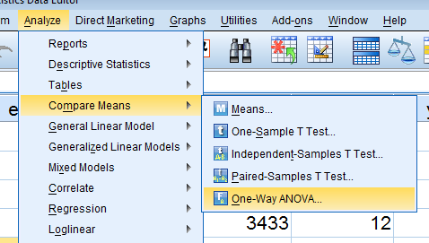

(b) Move DV to DV box, more IV to Factor box
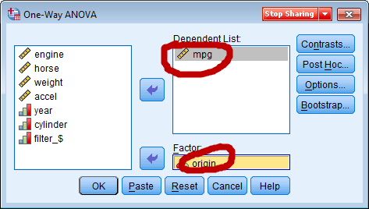

(c) Select Options, then choose Descriptive

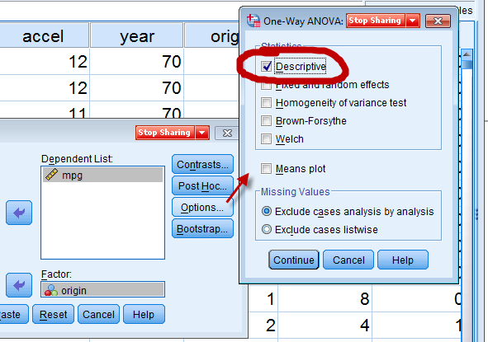

(d) Continue, OK

SPSS ANOVA Summary Table

ANOVA
Miles per Gallon
 | Sum of Squares | df | Mean Square | F | Sig.
Between Groups | 7984.957 | 2 | 3992.479 | 97.969 | .000
Within Groups | 16056.415 | 394 | 40.752
Total | 24041.372 | 396

Variance of MPG based upon the ANOVA results would be

(SS total / df total) = 24041.372 / 396 = 60.712

What this shows is that SS / DF = variance of the DV (mpg in this example)

To obtain plot below, use these commands = Analyze, Descriptive Statistics, Explore (place check mark next to plots)
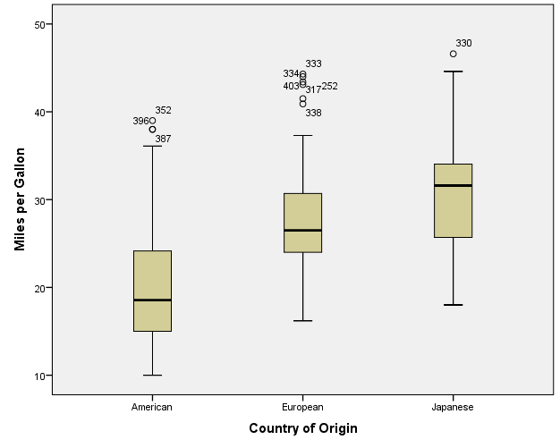
Question – why don’t the middle thick lines shown by the box plot above agree with the means below?
Because bloxplot shows medians.

Miles per Gallon
 | N | Mean | Std. Deviation | Std. Error | 95% Confidence Interval for Mean |  | Minimum | Maximum
 |  |  |  |  | Lower Bound | Upper Bound
American | 248 | 20.13 | 6.377 | .405 | 19.33 | 20.93 | 10 | 39
European | 70 | 27.89 | 6.724 | .804 | 26.29 | 29.49 | 16 | 44
Japanese | 79 | 30.45 | 6.090 | .685 | 29.09 | 31.81 | 18 | 47
Total | 397 | 23.55 | 7.792 | .391 | 22.78 | 24.32 | 10 | 47

F-ratio = MS b / MS w (i.e., variance between / variance within)

F-ratio tests H₀: µ_{i} = µ_{j}

If rejected the test indicates at least one mean differs from the other group means.

F ratio does not pinpoint where the groups differ, rather only that there are differences. There is one exception to this, however.

Example
Use ANOVA to determine if there is a mean difference in achievement between boys and girls. If the F ratio is significant, then we know the mean difference is between boys and girls since these are the only groups present.

If we 4 groups, a b c d, we have the following pairwise comparisons:

1 = a v b
2 = a v c
3 = a v d
4 = b v c
5 = b v d
6 = c v d

--- total of 6 possible pairwise comparisons.

F ratio would not indicate which of the above differ, only that there is one difference at least.

Exception, if we have two groups, such as males vs. females, if the F ratio is significant, what does this tell us about the two groups?

6 One-way ANOVA in SPSS

Copied and pasted SPSS commands listed above.

SPSS Results of One-way ANOVA (both oneway and general linear model commands)

Results of Oneway command in SPSS

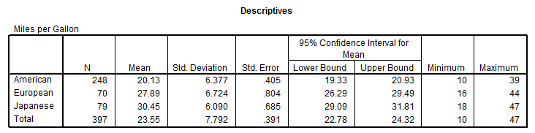
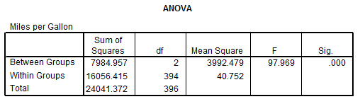

Results of General Linear Model Command in SPSS

1. Analyze, General Linear Model, Univariate
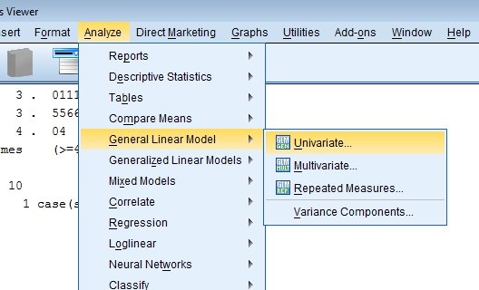

2. Move DV to DV box, move IV to fixed Factor box
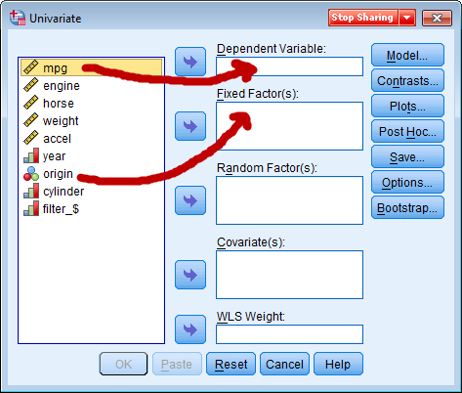

3. To get descriptive stats:
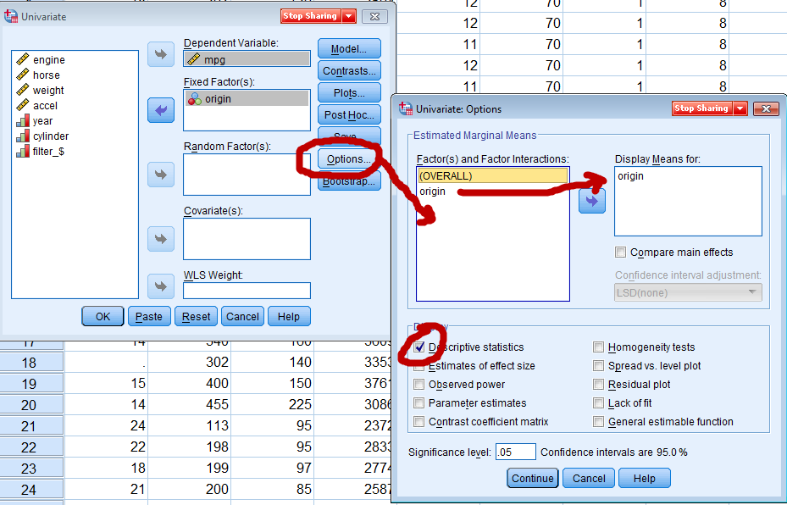

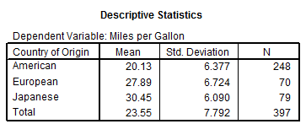

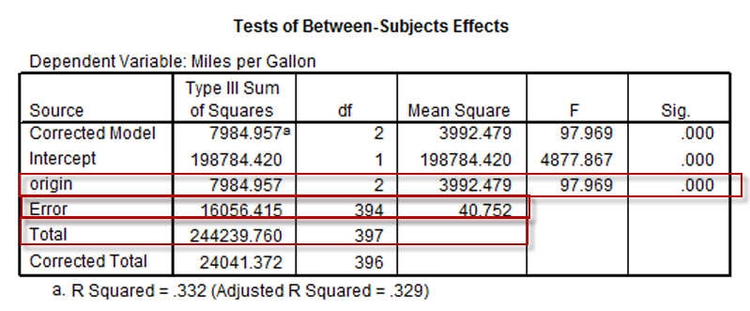

Hypothesis Testing with Critical F ratios
Compare calculated F to critical F
Decision Rule

If F ≥ F_{critical} then reject Ho, otherwise fail to reject Ho

To find Critical F, use critical F table with appropriate degrees of freedom

df1 (df between) = J -1 = 3 – 1 = 2

J is the number if groups

df2 (df within ) = n – J = 397 – 3 = 394

F_{critical} = 3.00

If 97.969 ≥ 3.00 then reject Ho, otherwise fail to reject Ho

