**EDUR 8131**

**Chat 8**

**1. Notes 7a Chi-square Goodness of Fit**

**2. Notes 7b Chi-square Test of Association**

**3. Review: Which Statistical Test to Use?**

**1. Notes 7a: Chi-square Goodness-of-fit**

Used for one qualitative variable. Correlation requires at least two variables, two-group t-test and paired-samples t-test both require two variables or two sets of scores.

Can be used to address questions about whether the distribution of categories (counts of categories within one variable) follows some expected pattern (e.g., Does enrollment in this class follow a 50-50 sex distribution for males and females? Does a die appear to fairly show all six sides?).

We will use the following two web pages to calculate Goodness-of-fit statistics. SPSS can be tedious to use if data must be entered by hand.

<http://vassarstats.net/csfit.html>

<http://www.quantpsy.org/chisq/chisq.htm>

**Example 1**

Given a choice, what is the distribution of stairs vs. elevator when ascending to the second floor of the college of education? A sample of 100 people was observed and their choice of stairs or elevator was recorded.

If we are unsure about what to expect, the safest expected distribution is one that is evenly split among the categories. Therefore, what would be the expected probabilities and expected counts below?

|  |  |  |  |
| --- | --- | --- | --- |
|  | Ascension Choice | |  |
|  | Stairs | Elevator | Total |
| Observed Counts | 85 | 15 | 100 |
| Expected probabilities | ? | ? |  |
| Expected Counts | ? | ? |  |

Answers

|  |  |  |  |
| --- | --- | --- | --- |
|  | Ascension Choice | |  |
|  | Stairs | Elevator | Total |
| Observed Counts | 85 | 15 | 100 |
| Expected probabilities | .5 | .5 |  |
| Expected Counts | .5 * 100 = 50 | .5 * 100 = 50 |  |

What would be an appropriate null hypothesis for this study?

Symbolic

Ho: freq(stairs) = freq(elevator)

Written

Ascension choice is equally divided between stairs and elevator.

What results are obtained for the above data using one of the on-line calculators?

χ2 = , df = , p = . ; Yate’s corrected χ2 = , df = , p < . .

Answer

χ2 =49.00, df = 1, p < .0001; Yate’s corrected χ2 =47.61, df = 1, p < .0001.

http://vassarstats.net/csfit.html

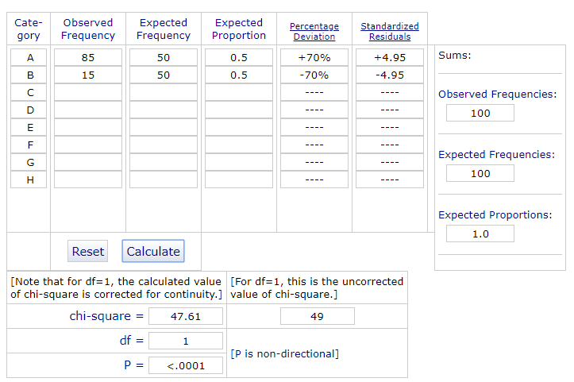

http://www.quantpsy.org/chisq/chisq.htm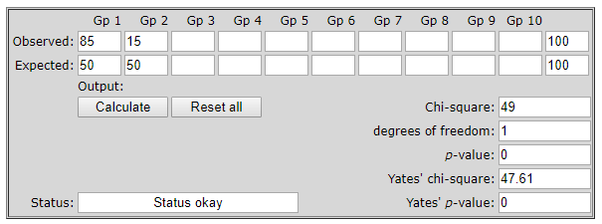

P-value

(a) Decision Rule:

If p is less than alpha (e.g., .05 or .01 is typical for alpha), then reject Ho. If p is larger than alpha then fail to reject Ho

**If p ≤ α reject Ho. If p > α fail to reject Ho.**

**If .0001 ≤ .05 reject Ho.** If .0001 > .05 fail to reject Ho.

(b) Interpretation:

What does p mean here? For this example, using the chi-square goodness-of-fit, the p represents the probability of obtaining a random sample of 100 people that would display a distribution of results that deviate from the expected 50/50 split by this much, or more, at random, assuming Ho is true in the population. (P value is the probability of obtaining through a random sample results that deviate by the amount observed, or deviate more, assuming Ho is true.)

**APA Style Presentation**

Table 3

*Frequencies of Ascension Choice within the College of Education*

|  |  |  |  |
| --- | --- | --- | --- |
|  | Ascension Choice | | |
|  | Stairs |  | Elevator |
| Observed Freq. | 85 |  | 15 |
| Expected Freq. (prop.) | 50 (.50) |  | 50 (.50) |

*Note*. χ2 = 49.00*, df =1. Numbers in parentheses, (), are expected proportions.

Freq. = frequency and prop. = proportion.

*p < .05

Recall that for the written component of an APA style presentation there are two parts, the **inference** (did we reject Ho?) and **interpretation** (what did we find in simple language?).

Results of the chi-square goodness-of-fit test show a statistically significant difference in ascension choice to the second floor of the COE. Among those observed, a disproportionate number opted to take stairs rather than elevator when ascending to the second floor; 85 of 100 observed opted to take the stairs rather than an elevator.

If reporting the Yate’s corrected χ2 (corrected for continuity), use a format like this:

*Note*. χ2 = 47.61* (Yate’s corrected χ2), df =1.

**Example 2**

Ascension Among Faculty in the COE

Assume from prior research that 65% of people will choose an elevator, so we use this prior knowledge to set expected proportions. How does this change the goodness-of-fit calculation? What are the new expected probabilities and counts? To frame these data, the question of interest is whether the observed choice of the 30 participants differ from prior research?

|  |  |  |  |
| --- | --- | --- | --- |
|  | Ascension Choice | |  |
|  | Stairs | Elevator | Total |
| Observed Counts | 6 | 24 | 30 |
| Expected probabilities |  |  |  |
| Expected Counts |  |  |  |

Answer

|  |  |  |  |
| --- | --- | --- | --- |
|  | Ascension Choice | |  |
|  | Stairs | Elevator | Total |
| Observed Counts | 6 | 24 | 30 |
| Expected probabilities | .35 | .65 |  |
| Expected Counts | .35 * 30 = 10.5 | .65 * 30 = 19.5 |  |

What results are obtained for the above data using one of the on-line calculators?

χ2 = , df = , p = . ; Yate’s corrected χ2 = , df = , p < . .

Answer

χ2 = 2.97, df = 1, p=.085; Yate’s corrected χ2 =2.34, df = 1, p=.1261

http://vassarstats.net/csfit.html

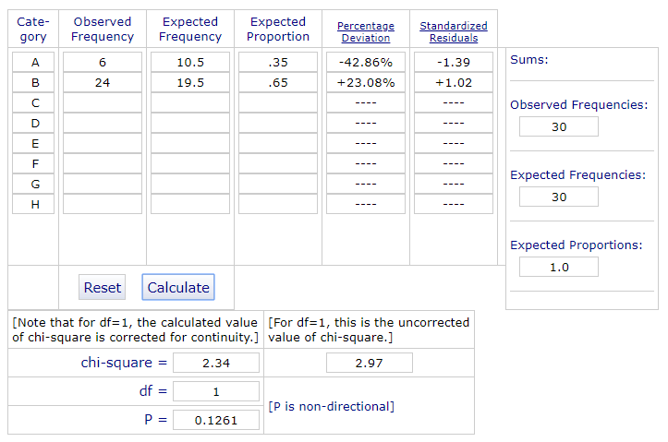

http://www.quantpsy.org/chisq/chisq.htm

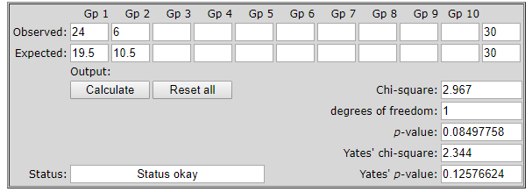

Do we reject or fail to reject Ho with α = .05?

FTR since p is greater than alpha of .05

What would be the written results here (inference and interpretation)?

|  |  |  |  |
| --- | --- | --- | --- |
|  | Ascension Choice | |  |
|  | Stairs | Elevator | Total |
| Observed Counts | 6 | 24 | 30 |
| Expected probabilities | .35 | .65 |  |
| Expected Counts | .35 * 30 = 10.5 | .65 * 30 = 19.5 |  |

χ2 = 2.97, df = 1, p=.085; Yate’s corrected χ2 =2.34, df = 1, p=.1261

Answer (provide **inference** and **interpretation** separately for class participation; in actual research report both together)

Inference:

Results of the chi-square goodness-of-fit show that there is not a statistically significant difference in ascension choice from the proportions found in prior research (i.e, 65% favor elevator and 35% favor stairs).

Interpretation:

Results of the chi-square goodness-of-fit show that there is not a statistically significant difference in ascension choice from the proportions found in prior research (i.e, 65% favor elevator and 35% favor stairs). Prior research shows that about 65% of observed individuals will take an elevator rather than the stairs when ascending to the second floor. Results of this study show a similar pattern with 24 of 30 individuals selecting elevator rather than stairs.

Alternative Written Example

There is not a statistically significant difference in ascension choice between observed behavior and expected behavior. Prior research suggests that about 65% of people will choose an elevator over stairs when considering ascension to the second floor, and results of the college of education study are similar with more people opting for elevator than stairs.

**Example 3**

Below are vehicle sales data as reported in Oct. 2012. We wish to know whether vehicles appear to be evenly bought in terms of frequency – do folks tend to select each type of vehicle equally frequently?

We are completely ignorant and don’t know what to expect in terms of preference for auto type. Thus, we assume an equal distribution of sales. What would be the expected probabilities?

|  |  |  |  |  |  |
| --- | --- | --- | --- | --- | --- |
|  | Cars | Regular Trucks | SUV | Crossover | Minivan |
| Observed Count of Sales | 600,956 | 165,695 | 104,930 | 250,133 | 64,151 |
| Expected probabilities | ? | ? | ? | ? | ? |
| Expected Counts | ? | ? | ? | ? | ? |

Answers

|  |  |  |  |  |  |
| --- | --- | --- | --- | --- | --- |
|  | Cars | Regular Trucks | SUV | Crossover | Minivan |
| Observed Count of Sales | 600,956 | 165,695 | 104,930 | 250,133 | 64,151 |
| Expected probabilities | .2 | .2 | .2 | .2 | .2 |
| Expected Counts |  |  |  |  |  |

What values do you get?

χ2 = , df = , p = .

χ2 = 780189, df = 4, p <.0001.

**2. Chi-square Test of Association**

Used to determine whether two qualitative variables are associated. The variables may also be ordinal with few categories such as SES (low, middle, high).

We will use the following page to calculate chi-square test of association:

<http://vassarstats.net/newcs.html>

<http://www.quantpsy.org/chisq/chisq.htm>

**Worked Example**

Do vacation plans vary according to family composition (presence and age of children)?

Folks were polled and asked the following:

a. What do you typically do during family vacations?

* Visit relatives
* Visit beach, mountains, adventure park, or similar outdoor oriented trips
* Visit urban areas for sightseeing
* Stay home

b. Which best describes your current family composition?

* No children at home
* Children aged 0 to 10
* Children aged 11 to 18

Respondents indicated the following:

No children at home, n = 60:

* 10% visit relatives,
* 15% visit beach etc.,
* 35% visit urban,
* 40% stay home

Children aged 0 to 10, n = 100:

* 38% visit relatives,
* 39% visit beach etc.,
* 9% visit urban,
* 14% stay home

Children aged 11 to 18, n = 80:

* 20% visit relatives,
* 50% visit beach etc.,
* 20% visit urban,
* 10% stay home

**Convert Information Above into a Contingency Table**

|  |  |  |  |  |
| --- | --- | --- | --- | --- |
|  |  | Family Composition | | |
| Vacation Activities |  | No Children at Home | Child. Aged 0 to 10 | Child. Aged 11 to 18 |
| Visit Relatives |  | n =? | n =? | n =? |
| Visit beach, etc. |  | n =? | n =? | n =? |
| Visit Urban, etc. |  | n =? | n =? | n =? |
| Stay Home |  | n =? | n =? | n =? |
| TOTALS |  | n =? | n =? | n =? |

Answers

|  |  |  |  |  |
| --- | --- | --- | --- | --- |
|  |  | Family Composition | | |
| Vacation  Activities |  | No Children at Home | Children Aged  0 to 10 | Children Aged  11 to 18 |
| Visit Relatives |  | 6 | 38 | 16 |
| Visit beach, etc. |  | 9 | 39 | 40 |
| Visit Urban, etc. |  | 21 | 9 | 16 |
| Stay Home |  | 24 | 14 | 8 |
| TOTALS |  | 60 | 100 | 80 |

What values do you get for χ2 = , df = , p = ?

χ2 = , df = , p = .

<http://vassarstats.net/newcs.html>

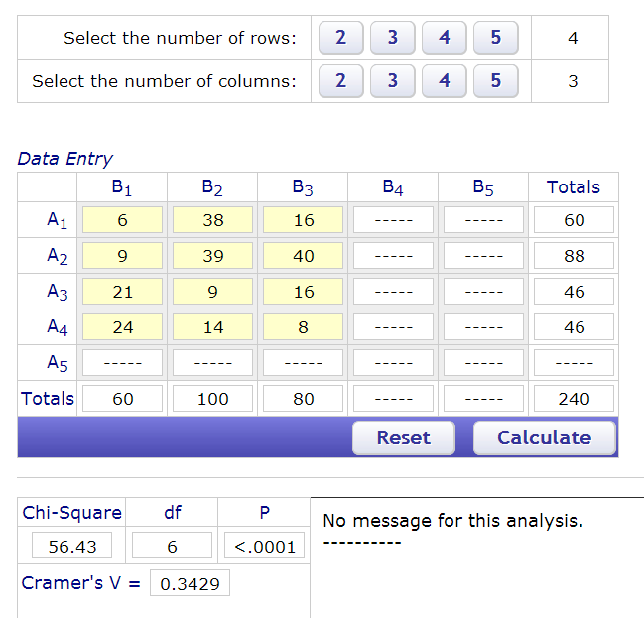

http://www.quantpsy.org/chisq/chisq.htm

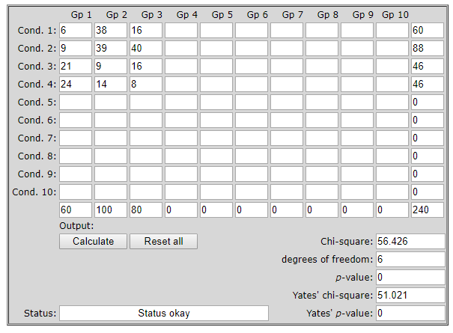

Decision Rule for P-values:

**If p ≤ α reject Ho. If p > α fail to reject Ho.**

Do we reject or fail to reject Ho here with α = .05?

Answer

Recall that α is normally set to either .05 (for small samples) and .01 (for larger samples).

In this example reject because p = .0001 and α = .05, so p is less than alpha.

Reject Ho

What is Ho and Ha for this example?

|  |  |  |  |  |
| --- | --- | --- | --- | --- |
|  |  | Family Composition | | |
| Vacation  Activities |  | No Children at Home | Children Aged  0 to 10 | Children Aged  11 to 18 |
| Visit Relatives |  | 6 | 38 | 16 |
| Visit beach, etc. |  | 9 | 39 | 40 |
| Visit Urban, etc. |  | 21 | 9 | 16 |
| Stay Home |  | 24 | 14 | 8 |
| TOTALS |  | 60 | 100 | 80 |

Ho: type of family vacation is independent of family composition

Ha: type of family vacation is associated with family composition

Why not use term “significant” in a hypothesis?

Step 1: Form the hypothesis –

There will be no difference in math between females and males

Step 2: Test the hypothesis --

Collect data, calculate test statistics, find p-value, compare against alpha

Step 3: Draw conclusion --

Make decision about Ho, either reject (significant) or fail to reject (not significant), interpret results

Don’t include a decision we make about Ho or Ha in the hypothesis itself.

**APA Style**

*Results of Chi-square Test and Descriptive Statistics for Vacation Plans by Family Composition*

|  |  |  |  |  |
| --- | --- | --- | --- | --- |
|  |  | Family Composition | | |
| Vacation  Activities |  | No Children at Home | Children Aged  0 to 10 | Children Aged  11 to 18 |
| Visit Relatives |  | 6 (10%) | 38 (38%) | 16 (20%) |
| Visit beach, etc. |  | 9 (15%) | 39 (39%) | 40 (50%) |
| Visit Urban, etc. |  | 21 (35%) | 9 (9%) | 16 (20%) |
| Stay Home |  | 24 (40%) | 14 (14%) | 8 (10%) |

*Note*. χ2 = 56.43*, df = 6. Numbers in parentheses indicate column percentages.

*p < .05

Important – ALWAYS place the IV categories as columns and DV categories as rows (assuming and IV and DV can be identified).

There is a statistically significant association between family composition and vacation activities. Results show that families with no children at home tend to visit urban areas or stay home during vacation, while those with younger children prefer to visit relatives or go on outdoor type vacations, and those with older children tend to focus more on outdoor type vacations.

How to find percentages for each column. Example for first column:

No children at home **total** = 6 + 9 +21 + 24 = 60

Cell 1,1 **visit relatives** and **no children at home** = 6, so the % would be: 6 / 60 = .10 * 100 = 10%

Cell 1,2 **visit beach** and **no children at home** = 9 %? 9/60 = .15*100 = 15%

**3. Review: Which Analysis to Use?**

Statistical tests that may appear on Test 2

(a) One sample Z test

(b) One sample t-test

(c) Two independent sample t-test

(d) Correlated samples t-test (paired samples t-test)

(e) Pearson’s Correlation, r

(f) Chi-square goodness of fit

(g) Chi-square test of association

Steps to Decide

[use table from course web page:

13. Types of Statistical Procedures and Their Characteristics: [PDF Table](http://www.bwgriffin.com/gsu/courses/edur8131/content/WhichStatisticalTestToUse.pdf)  ]

1. How many variables involved?

* One or two? If only one variable, then three options:

(a) One sample Z test

(b) One sample t-test

(f) Chi-square goodness of fit

* If the one variable is categorical, which test?

Chi-square goodness-of-fit designed for categorical (nominal) variable or sometimes ordinal if limited number of categories involved (e.g. 2, 3, or 4).

* If the one variable is quantitative, which test?

(a) One sample Z test

(b) One sample t-test

* How distinguish between the two above?

One sample Z test uses population SD (σ) while one-sample t-test uses sample SD (sd or s)

🡪 to use, MUST have population SD

Vs.

🡪 to use t, need only the sample SD

If two variables involved, that leaves the following tests:

(c) Two independent sample t-test

(d) Correlated samples t-test (paired samples t-test)

(e) Pearson’s Correlation, r

(g) Chi-square test of association

2. Next, identify the IV and DV, and determine if the IV is qualitative or quantitative

a. if both IV and DV are quantitative, which test?

Pearson’s correlation, r

b. if IV is qualitative and DV is qualitative, which test?

Chi square test of association

c. If the IV is a group (qualitative and has only 2 groups) and the DV is quantitative, and if data are linked in some way by participants – matched samples or pre-post scores for same individual – which test to use?

Correlated samples (paired samples) t-test

d. If the IV is qualitative (with only 2 groups) and the DV quantitative, and groups are not matched or linked, then use which test?

Two independent samples t-test

[Use sample test 2 examples to identify types of tests. Sample test 2 found on course web site:

7. [Sample Test 2](http://www.bwgriffin.com/gsu/courses/edur8131/tests/edur_8131_sample_test_2.pdf) (shows examples of data analysis section of Test 2 with t-tests, correlation, and chi-square; ]