EDUR 8131
Chat 6

Notes 5a One-sample t-test
Notes 5b Two-independent Samples t-test

Notes 5a: One-sample t-test

1. One-sample t-test worked example
Is there any evidence that my heart rate has changed since taking blood pressure medication? Before medication my heart rate was 55.36 beats per minute after arising each morning. Below are 14 observations of my heart rate after taking the blood pressure medication. Set alpha (α) to .05 for hypothesis testing.
50 | 62
50 | 57
48 | 49
49 | 47
44 | 54
49 | 48
45 | 44

Formula for one-sample t-test vs. z-test

$Z_{\overline{x}}=\frac{\overline{X}-μ}{σ/{\sqrt{n}}}$ to use, MUST have population SD
Vs.

$t=\frac{\overline{X}-μ}{s/{\sqrt{n}}}$ to use t, need only the sample SD

Note: Work in Excel to show calculations, then in SPSS

SPSS results for one-sample t-test

Commands (below)

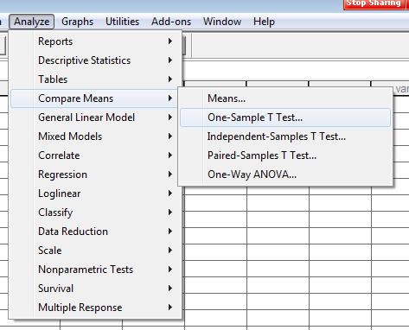

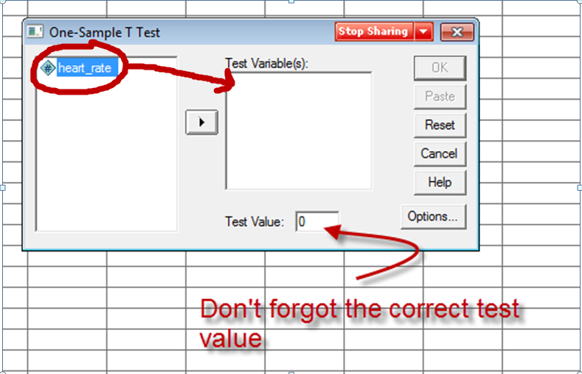

SPSS Results
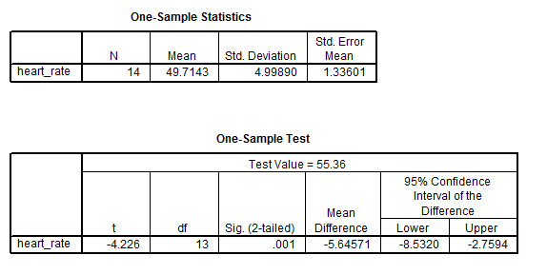
What do these results tell us?

Decision Rule with p and α: If p ≤ α reject Ho, if p > α fail to reject Ho

Decision Rule with p and α: If .001 ≤ .05 reject Ho, if .001 > .05 fail to reject Ho
So reject Ho

Since p (= .001) is less than alpha = .05, one would reject Ho and conclude there is a difference in heart rates per minute between the comparison value of 55.36 beats per minute and the mean number of beats observed after taking the medication.

APA Styled Results
Note: Show location of APA Word document on course web site.

Table 1
Results of One-sample t-test and Descriptive Statistics for Heart Rate Per Minute
Outcome |  | M | SD | n |  | Comparison Value | 95% CI for Mean Difference | t | df
Heart Rate |  | 49.71 | 4.99 | 14 |  | 55.36 | -8.53, -2.76 | -4.23* | 13
* p < .05.

Note:
* p < .05. this must be present to inform reader that hypothesis testing was performed and at what level of significance that test was performed (i.e., what was the alpha level, probability of Type 1 error, in this example it is .05)

Written Results –
Written results always contain two bits in information --
- Inference – did we reject Ho?
- Interpretation – what do the result mean in simple language?
There is a statistically significant mean difference in heart rate before and after taking blood pressure medication. Results show that the medication reduces the mean heart rate by about 5.5 beats per minute on average.

Use CI for Hypothesis testing

(a) Ho:$\overline{X}=μ$ ----------------> Does µ lie within CI, if yes, fail to reject Ho

Vs.

(b) Ho:$\overline{X}-μ=0.00$ ------> Does 0.00 lie within CI, if yes, fail to reject Ho

Both can be used, but our focus will be on the second Ho:$\overline{X}-μ=0.00$ , for presentation I will skip to section (b) below, but I include (a) for those interested.

(a) If Ho:$\overline{X}=μ$

CI = $\overline{X}±(critical t)(standard error of mean)$

The formula above provides a confidence interval about the sample mean.

Example:
95% CI
Step 1: Calculate df = n-1

df = 14 -1 = 13

Step 2: Find Critical t-value given α (=.05) and df

Critical t = ± 2.16

Step 3: Calculate standard error of mean $s/{\sqrt{n}}$
S = 4.999
N = 14

SEM = $s/{\sqrt{n}}$ = ${4.999}/{\sqrt{14}}$ = 1.336

Step 4: Plug numbers into CI formula and find Upper and Lower Limits
CI = $\overline{X}±(critical t)(standard error of mean)$
(Recall that $\overline{X}=49.71$)

CI = $49.71±(2.16)(1.336)$

Upper Limit = $49.71+(2.16)(1.336)$ = 52.59
Lower Limit = $49.71-(2.16)(1.336)$ = 46.82

Recall that µ = 55.36
Interpretation

One may be X% confident that the interval LL to UL includes the population mean.

One may be 95% confident that the interval 46.82 to 52.59 includes the population mean from which this sample was drawn.

Hypothesis Testing
Ho:$\overline{X}=μ$ ----------------> Does µ lie within CI, if yes, fail to reject Ho; if no, then reject Ho

Do we reject or fail to reject Ho?

Ho: µ = 55.36 (mean heart rate before taking medications)
95% CI = 46.82, 52.59

Yes, reject Ho (because 55.36 is not within the 95% CI), our sample has a heart rate that differs from the value of 55.36; the new heart rate is lower by about 5.6 beats per minute.

We believe that the population heart rate, after taking the BP medication, is somewhere between 46.82 and 52.59, and our single best estimate of heart rate is the sample mean at 49.71.

If reject, what does this tell us? If we fail to reject, what does this tell us?

If reject Ho – our sample produces a mean heart rate that differs from the specified value of 55.36

If fail to reject Ho – our sample heart rates appear to be consistent with the specified value of 55.36

SPSS Results
Note: Illustrate how to obtain the above CI with SPSS – use Explore command:
Analyze -> Descriptive Statistics -> Explore (then click on Statistics and set CI to level desired)
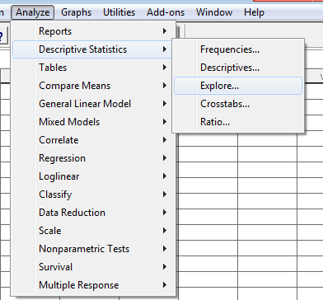

Explore command
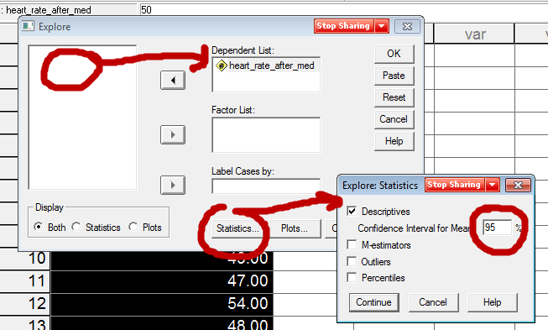

95%CI limits are 46.828 to 52.6006 (similar to that presented above 46.82, 52.59 – within rounding error, also, SPSS uses a more precise critical t-value than our table provides)
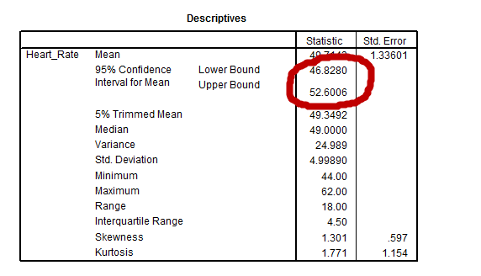

(b) If Ho: $\overline{X}-μ=0.00$
CI = $(\overline{X}-µ)±(critical t)(standard error of mean)$

The formula above provides a confidence interval about the mean difference.

Example: 95% CI
Critical t = 2.16 (df = 13)

Repeat the same steps outlined above except use $(\overline{X}-µ)$ rather than $\overline{X}$ in the CI formula:

From this CI = $(\overline{X})±(critical t)(standard error of mean)$
To this CI = $(\overline{X}-µ)±(critical t)(standard error of mean)$

Step 1: Calculate df = n-1

df = 14 -1 = 13

Step 2: Find Critical t-value given α (= .05) and df

Critical t = 2.16

Step 3: Calculate standard error of mean $s/{\sqrt{n}}$

SEM = $s/{\sqrt{n}}$ = ${4.999}/{\sqrt{14}}$ = 1.336

Step 4: Plug numbers into CI formula and find Upper and Lower Limits

CI = $(\overline{X}-µ)±(critical t)(standard error of mean)$

Mean difference is 49.71 – 55.36 = -5.65

What are the CIs for $(\overline{X}-µ)$?

CI = $(49.71-55.36)±(2.16)(1.336)$
CI = $(-5.646)±(2.16)(1.336)$

Upper Limit =$\left(-5.646\right)+\left(2.16\right)\left(1.336\right)$ = -2.764
Lower Limit =$\left(-5.646\right)-(2.16)(1.336)$ = -8.535

What is the interpretation for the 95% CI?
Recall Ho:$\overline{X}-μ=0.00$

We can be 95% confidence that the real difference in heart rates before and after taking BP medication lies somewhere between -8.5 to -2.7 beats per minute.

99% CI
Same as above but use different critical value
CI = $(\overline{X}-µ)±(critical t)(standard error of mean)$
What is the critical value for α = .01 and df = 13?
Critical t = ±3.01

Recall the mean difference is -5.646 and the standard error of the mean (SEM) is 1.336.
What is the 99% CI for $(\overline{X}-µ)$?

CI = $(49.71-55.36)±(3.01)(1.336)$
CI = $(-5.646)±(3.01)(1.336)$

Upper Limit =$\left(-5.646\right)+\left(3.01\right)\left(1.336\right)$ = -1.628
Lower Limit =$\left(-5.646\right)-(3.01)(1.336)$ = -9.67

Compare this 99% CI to SPSS results for one-sample t-test specifying 99% CI:
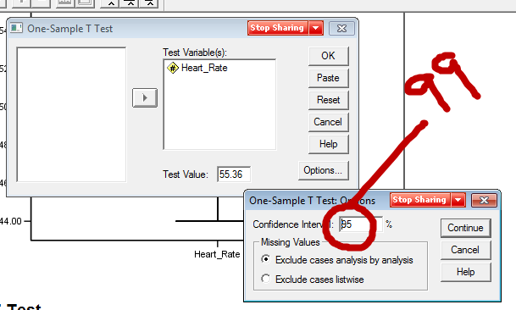
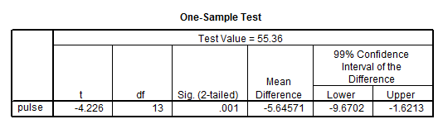
Interpretation:

One may be 99% confident that the true population mean difference between sample mean of 49.71 and prior-medication heart rate of 55.36 is between -9.67 and -1.62.

For hypothesis testing purposes, if 0 does NOT lie within this CI, then reject Ho; but if 0 lies within the CI then fail to reject Ho

Ho: $\overline{X}-μ=0.00$

So, if 0 is within the CI, that means 0 is one of the possible values for the true mean difference, but if 0 is not within the CI that tells us that 0 is not likely to be one of the values representing the true mean difference.

Notes 5b: Two Independent Samples t-test
2. Two-samples t-test worked example.

Is there a change in mean heart rate per minute before and after taking blood pressure medication for a single individual? Below are data for this individual.

Heart Rate |  |  | Heart Rate
After |  |  | Before
50 | 62 |  | 57 | 59
50 | 57 |  | 58 | 57
48 | 49 |  | 56 | 53
49 | 47 |  | 55 | 63
44 | 54 |  | 55 | 54
49 | 48 |  | 53 | 51
45 | 44 |  | 53 | 51

First, why is this not a correlated samples t-test since it appears we have before and after data?

Data are not linked – scores are not aligned or correlated specifically with other scores. These scores are taken from one individual and do not represent a matched set from multiple participants or even a matched set for one participant.

Compare these data to one in which correlated scores are present:

Does heart rate change after blood medication for these individuals?

 | After |  | Before
John | 55 | <-> | 51
Bill | 59 | <-> | 56
Sue | 67 | <-> | 53
Pam | 48 | <-> | 47
Jon | 41 | <-> | 42
Paul | 71 | <-> | 68
Fred | 55 | <-> | 51

SPSS Data and Results

http://www.bwgriffin.com/gsu/courses/edur8131/data/heartrate.sav

Commands
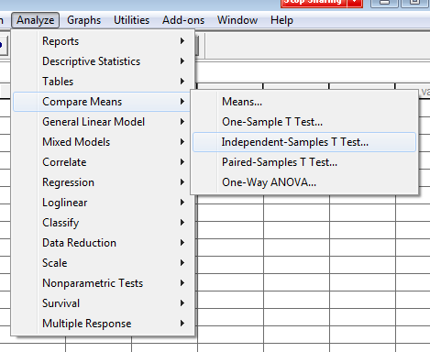

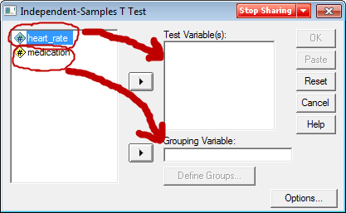
Note, Medication 1 = after medications, 0 = before medications
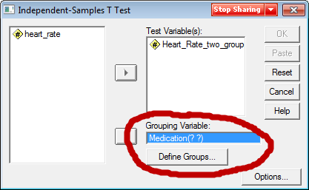

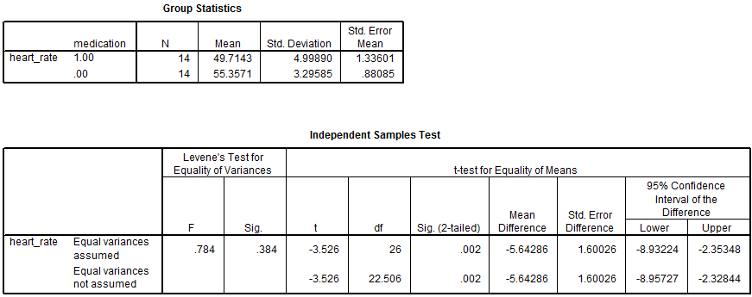

Equal vs. Unequal Variances

Use Levene’s test to determine which row to use for t-test results.
- Levene’s Test assesses this null, Ho: variance group 1 = variance group 2
- If fail to reject, we assume the two groups have similar variances; if reject, then assume group variances are not equal.
- If variances are not equal, that affects how p-values and CI are calculated for the t-test, so an adjustment is made.
- If sig. (p-value) for Levene’s is less than .10 or .05 (you pick alpha here), then variances appear to be different so use “Equal variances not assume” row,
- but if the Levene’s p-value (sig. value) is greater than .10 or .05 then use “Equal Variances Assumed” row.

Null Hypothesis
What is the written null hypothesis?

Recall that the IV is blood pressure medication use (before and after using medication) and the DV is heart rate.

There is no difference in mean heart rate before and after taking blood pressure medication.

What is the symbolic Ho?

Ho: µ_{before} = µ_{after}

or

Ho: µ_{before} – µ_{after} = 0.00 (most commonly tested by statistical software)

Reject or Fail to Reject Ho?

What information from SPSS output is used to determine whether Ho is rejected?
Also, would we reject or fail to reject Ho?

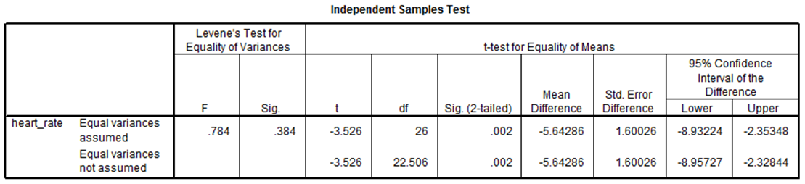

p-value = t-test Sig(2-tailed) = .002

Note - this is not the p-value for the Levene’s test; Levene’s sig is the p-value for the Levene’s only test. Recall that Levene’s tests whether variances of two groups are equal

confidence interval, if 0 is within the CI, fail to reject; if 0 is not within CI, reject Ho

APA Styled Results

Note: Show APA Word document on web page.

Table 5
Results of t-test and Descriptive Statistics for Heart Rate per Minute by Medication Usage
 | Medication Usage |  |  |  |  |  |  | 95% CI for Mean Difference
 | After Usage |  |  |  | Before Usage
 | M | SD | n |  | M | SD | n |  | t | df
Heart Rate | 49.71 | 5.00 | 14 |  | 55.36 | 3.30 | 14 | -8.93, -2.35 | -3.53* | 26
* p < .05.

Recall there must be two components to the written results, inference and interpretation.

What might be the written results for the results reported above?

(Recall that Ho states no differences in heart rate before and after taking blood pressure medication.)

First, what would be the inference statement?

There is a statistically significant mean difference in heart rate per minute before and after taking blood pressure medication.

Next, what would be the interpretation offered for readers?

There is a statistically significant mean difference in heart rate per minute before and after taking blood pressure medication. Results show that the blood pressure medication reduced heart rate by about 5.5 beats per minute.

Use CI for Hypothesis testing
Ho:$µ_{1}-µ_{2}=0.00$ --------> Does 0.00 lie within CI, if yes, fail to reject Ho

CI = $({\overline{X}}_{1}-{\overline{X}}_{2})±(critical t)(standard error of mean difference)$

Example:

See SPSS output, also, show how to obtain 99% CI in SPSS

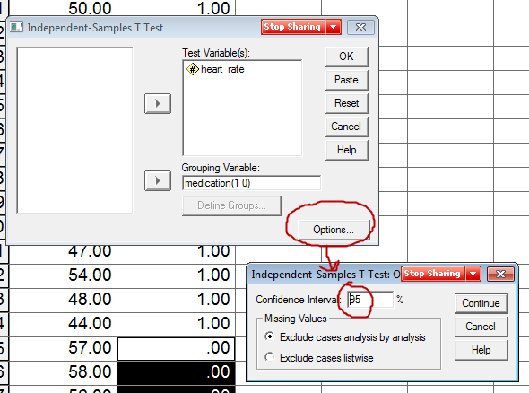

99% CI Results
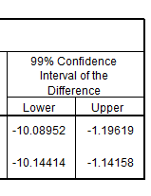
Is 0 within the 99% CI? Does this mean we can reject or fail to reject Ho?

The value of 0 is not within the 99% CI, therefore we can reject Ho and conclude that the population mean difference in heart rate must be different from 0, therefore the two means, heart rate before and after, appear to be different.

Interpretation of either 95% or 99% CI:

One may be X% confident that the interval LL to UL includes the population mean difference of DV between group 1 and group 2.

One may be 95% confident that the interval -8.93 to -2.35 includes the population mean difference in heart rate per minute between the two sets of scores (before and after taking blood pressure medication).

Or

One may be 99% confident that the interval -10.09 to -1.20 includes the population mean difference in heart rate per minute between the two sets of scores (before and after taking blood pressure medication).

