Chat 5
Notes 4 Hypothesis Testing

1. Hypothesis Testing Logic
Summarized:
- Form null hypothesis, e.g., there will be no difference in math scores between males and females;
Ho: µ_{males} = µ_{females}
- Collect relevant data from random sample taken defined population
- Test data relative to null hypothesis – calculate probability of randomly selecting data like those obtained if the null hypothesis is true, i.e., check the probability of selected data deviating from what was specified by the null hypothesis assuming the null is true
- If probability is small, reject Ho; if probability is large fail to reject Ho
- Provide inference (was Ho rejected) and interpretation (what findings tell us) of results.

2. One Sample Z-test with p-values
One sample Z-test is designed to test whether a sample mean deviates from some hypothesized value.

Note – one sample Z-test is different from Z scores.
- Z scores show have far a raw score deviates from a sample mean in SD units;
- Z-test is used to determine whether a sample mean appears to be different from some set value, and shows how far the sample mean deviates from this value in Standard Error units.

a. Hypotheses

Null

Symbolic Ho: µ = “some value” (e.g., Ho: µ = 16 oz)
Written There will be no difference between the sample mean and “some value”

Example Null
Mean number of auto accidents during past 10 years is the same as the mean number of auto accident during the previous 20 years (µ = 24.5) in Statesboro.

Symbolic null Ho: µ = 24.5
Written null There will be no difference in mean number of auto accidents between past 10 years and previous 20 years in Statesboro (µ = 24.5, σ = 7.6).

Alternative, Non-directional

Symbolic Ha: µ ≠ “some value” (e.g., Ha: µ ≠ 16 oz)
Written There will be a difference between the sample mean and “some value”

Example Non-directional

Symbolic null Ha: µ ≠ 24.5
Written null There will be a difference in mean number of auto accidents between past 10 years and previous 20 years in Statesboro (µ = 24.5, σ = 7.6).

Ho: µ = 24.5
H1: µ ≠ 24.5

b. Formula (one sample z-test)

$$Z test= Z_{\overline{x}}=\frac{\overline{X}-μ}{σ/{\sqrt{n}}}$$

Note, do not confuse the above with a Z score

$$Z score=\frac{X-\overline{X}}{SD}$$

1. Find mean for sample of number of auto accidents in Statesboro during the past 10 years:

35, 41, 22, 51, 29,
16, 55, 61, 29, 43

M = 38.2

2. Find standard error of mean

Pop SD / SQRT(n)

Mean number of auto accidents in Statesboro during past 10 years = 38.2
Population Number of accidents during previous 20 years = 24.5
Population SD for accidents = 7.6
Sample size of 10 for previous ten years of data

$$Z_{\overline{x}}=\frac{\overline{X}-μ}{σ/{\sqrt{n}}}= ?$$

Pop SD = 7.6
N = 10

SE of mean = 7.6 / SQRT(10) = 2.403

[To obtain the square root when no square root function is available, raise value to .5, e.g., 7.6^.5]

3. Calculate Z score for sample vs population (or comparison) value

Pop M = 24.5
Sample M = 38.2
SE of Mean = 2.403

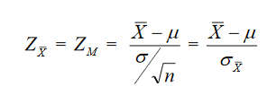

Zm =

Zm = (38.2 – 24.5) / 2.403 =

Zm = 5.701

4. Determine whether this Zm is extreme – beyond what would be expected by random chance. How is this done?

One option is to calculate the p-value – probability of obtaining a sample mean that deviates this far, or further, from the population mean assuming Ho is true.

Use Z table to find the p-value for

Zm ≥ 5.70 or Zm ≤ -5.70

alternatively,

Zm ≥ |5.70|

So,

p($Z_{\overline{x}}≥\left|calculated Z_{\overline{x}}\right|)=2×probabilty from one tail of Z table$

is the same as:

p(Zm ≥ 5.70 or Zm ≤ -5.70) =

p ≥ 5.7 = .0001
p ≤ -5.7 = .0001

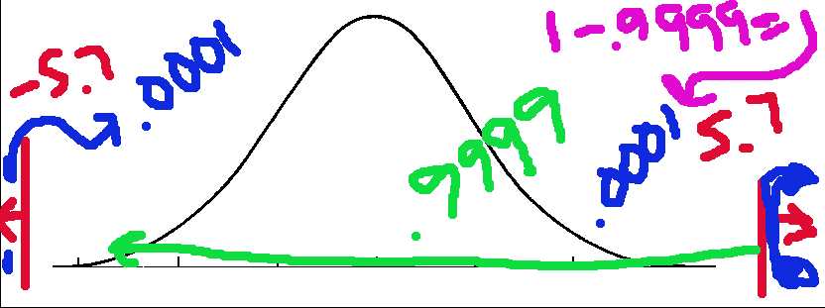

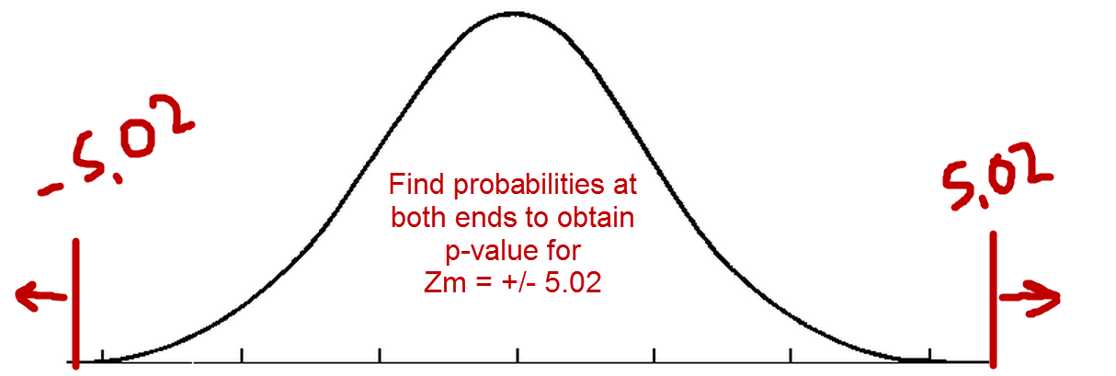

p value for this test = .0002

How use this p value to determine whether Ho should be rejected?

Decision rule assuming α = .05

If p ≤ α reject Ho; if p > α fail to reject Ho
If p ≤ .05 reject Ho; if p > .05 fail to reject Ho

Decision rule more generally,

If p ≤ α reject Ho; if p > α fail to reject Ho

Plugging in the numbers:

If .0002 ≤ .05 reject Ho; if .0002 > .05 fail to reject Ho?

Reject Ho: µ = 24.5 and adopt H1 as descriptive of what was found.

Chart below shows how to interpret p-value when alpha = .05

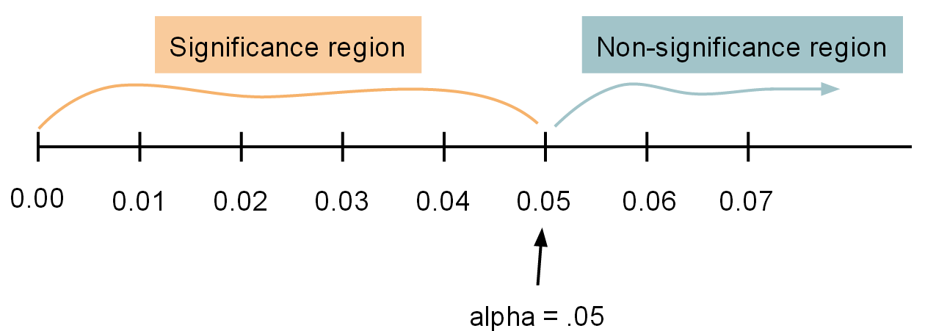

Recall that significant means Ho was rejected

5. Inference and interpretation

Inference – tell reader whether Ho was rejected
Interpretation – tell reader what was found in simple language

Pop M = 24.5 (auto accidents previous 20 years)
Sample M = 38.2 (auto accidents past 10 years)
SE of Mean = 2.403
Zm = 5.7
p-value = .0002

Ho rejected? Use phrases like this:

“…found a statistically significant difference…”

Failed to reject Ho? Use phrasing like this:”

“...there was not a statistically significant difference…”
“...difference was not significant…”

Inference for current example:

“Analysis of the data revealed a statistically significant difference in mean number of auto accidents during the past 10 years when compared to number of accidents in the previous 20 years.”

Remember, significant means only that Ho was rejected. It DOES NOT mean something important was found.

Example that Significant ≠ Important

Girl readings M = 85.3331313
Boys reading M = 85.3331312

This minor reading difference of 0.0000001 could be statistically significant if the sample size is large enough, but we all would agree this difference in reading scores is not important.

Interpretation for current one-sample Z test example:

“Data show that over the past 10 years the number of auto accidents in Statesboro appears to have increased from a mean number per year of 24.5 during the previous 20 years to a mean number of accidents of 38.2 for the past 10 years. “

Pop M = 24.5 (auto accidents previous 20 years)
Sample M = 38.2 (auto accidents past 10 years)

So the written result for the Z test would combine both the Inference and Interpretation statements, like this:

Analysis of the data revealed a statistically significant difference in mean number of auto accidents during the past 10 years when compared to number of accidents in the previous 20 years. Data show that over the past 10 years the number of auto accidents in Statesboro appears to have increased from a mean number per year of 24.5 during the previous 20 years to a mean number of accidents of 38.2 for the past 10 years.

In summary, for hypothesis testing using p-values, one compares p-value against alpha and if p is less than (or equal to) alpha, then reject Ho. This is true for any statistical test using p-values.

If p-value ≤ α reject Ho, but if p> α fail to reject Ho

Example 2 of Z-test

Reported ages
Student | Age
1 | 28
2 | 33
3 | 22
4 | 25
5 | 28
6 | 29
7 | 28
8 | 28
9 | 37
10 | 31
11 | 27
13 | 25
Mean Age for Students in Course = 28.4167

Population Age for GSU students = 24.5
Population SD for Age at GSU = 9.8
Sample size of 13 students from this course

$$Z_{\overline{x}}=\frac{\overline{X}-μ}{σ/{\sqrt{n}}}= ?$$

$$Z_{\overline{x}}=\frac{\overline{X}-μ}{σ/{\sqrt{n}}}= \frac{28.4167-24.5}{{9.8}/{\sqrt{13}}}= \frac{3.9167}{2.718}= 1.44$$

So what is the p-value for this Z-test score?

p($Z_{\overline{x}}≥1.44)$ = 1 - .9251 = .0749
p($Z_{\overline{x}}≤-1.44)$ = .0749

Combined p = .0749+.0749 = .1498

p($Z_{\overline{x}}≥\left|-1.68\right|)=2×.0749= .1498$

If α = .05, do we reject or fail to reject Ho?

Since .1498 is larger than .05, we fail to reject

If p-value ≤ α reject Ho, but if p> α fail to reject Ho
If .1498 ≤ .05 reject Ho, but if .1498> .05 fail to reject Ho

So what conclusion do we draw now about students in this course regarding their age relative to all students at GSU?

There is not a statistically significant mean difference between the sample mean and the population mean of 24.5. It appears that students in EDUR 8131 have an average age that is consist with GSU students overall.

3. One Sample Z-test with Critical Z

Critical Z values:

Alpha = .05
Z = ±1.96

Alpha = .01
Z ≈ ±2.58

Compare calculated Z against these critical Z values for hypothesis testing.

If $\left|Calculated Z\right|$≥ $\left|Critical Z\right|$ reject Ho otherwise fail to reject

Example:

Mean Age for Students in Course = 40.89
Ho: µ = 24.5

Population Age for GSU students = 24.5
Population SD for Age at GSU = 9.8
Sample size of 9 students from this course

$$Z_{\overline{x}}=\frac{\overline{X}-μ}{σ/{\sqrt{n}}}= \frac{40.89-24.5}{{9.8}/{\sqrt{9}}}= \frac{16.39}{3.267}= 5.02$$

Set alpha = .05, so critical Z scores are ±1.96

If $\left|Calculated Z\right|$≥ $\left|Critical Z\right|$ reject Ho otherwise fail to reject
If $\left|5.02\right|$≥ $\left|1.96\right|$ reject Ho otherwise fail to reject

Since 5.02 is larger than 1.96 we can reject Ho and draw the conclusion noted above.

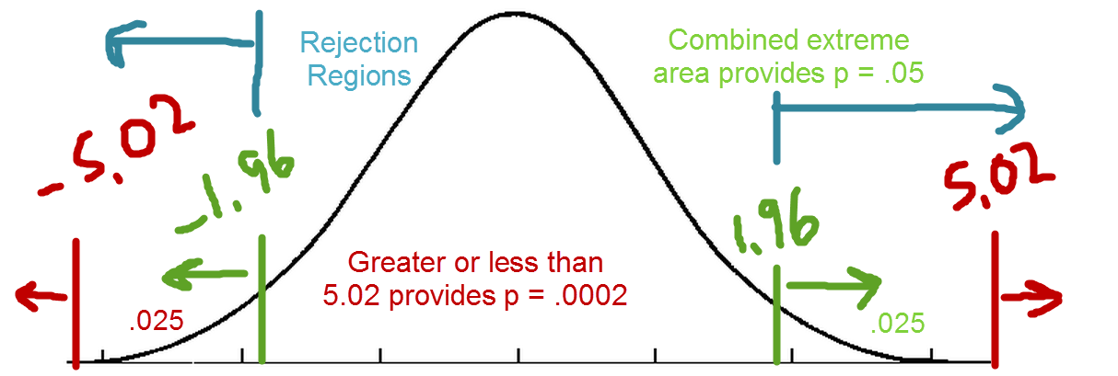

Set alpha = .01, so critical Z scores are ±2.58

Would we reject or fail to reject Ho if the critical Z value is ±2.58?

If $\left|5.02\right|$≥ $\left|2.58\right|$ reject Ho, otherwise fail to reject

So reject Ho since 5.02 is larger than critical value of 2.58

Example 2 of Z-test with Critical Values

Reported ages
Student | Age
1 | 28
2 | 33
3 | 22
4 | 25
5 | 28
6 | 29
7 | 28
8 | 28
9 | 37
10 | 31
11 | 27
13 | 25
Mean Age for Students in Course = 28.4167

Population Age for GSU students = 24.5
Population SD for Age at GSU = 9.8
Sample size of 13 students from this course

$$Z_{\overline{x}}=\frac{\overline{X}-μ}{σ/{\sqrt{n}}}= ?$$

$$Z_{\overline{x}}=\frac{\overline{X}-μ}{σ/{\sqrt{n}}}= \frac{28.4167-24.5}{{9.8}/{\sqrt{13}}}= \frac{3.9167}{2.718}= 1.44$$

If α = .01, this provides critical Z values of ±2.58. Do we reject or fail to reject Ho?

If $\left|1.44\right|$≥ $\left|2.58\right|$ reject Ho, otherwise fail to reject
So fail to reject Ho since 1.44 is smaller than critical value of 2.58

If α = .05, this provides critical Z values of ±1.96. Do we reject or fail to reject Ho?

If $\left|1.44\right|$≥ $\left|1.96\right|$ reject Ho, otherwise fail to reject
So fail to reject Ho since 1.44 is smaller than critical value of 1.96

So what conclusion/interpretation do we draw now about students in this course regarding their age relative to all students at GSU?

Since Ho was not rejected, we can conclude that students in EDUR 8131 have an average age that is consistent with GSU students overall.

4. Assumptions of Z test

Normality and independence – see notes and video for presentation.

5. Errors in Hypothesis Testing

Type 1 error – we reject a true null (i.e., claim there is an effect based upon the sample selected when there is not an effect in the population); false positive

α = probability of a Type 1 error.

Type 2 error – failure to reject a false null (i.e., failing to find a difference or relationship in the sample when one actually exists in the population); false negative

β = probability of a Type 2 error.

Power – probability of rejecting a false null; power is the probability of finding an effect, finding a difference or relationship, if there is one in the population.

Power = 1 - β

Reading the table of hypothesis testing decisions

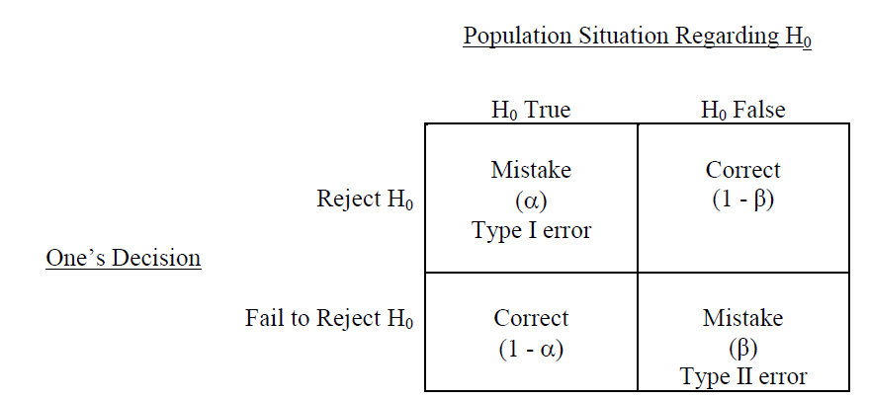

a. DV = math scores, IV = computer program usage. Experiment, half of 5th grade class uses computer program and other half does not. In the population of 5th grade students, the computer program results in a 20% increase in achievement based upon test scores. In your class you find evidence of achievement benefit in math scores due to the computer program so you reject Ho.

Null hypothesis states computer program has no benefit (i.e., math scores will not differ between those who use or do not use computer program).

Was this a correct decision or an error? If error, which type of error? Also, what is the probability of this decision?

Correct decision (probability is 1 – beta, which is called power)

b. DV = math scores, IV = computer program usage. Experiment, half of 5th grade class uses computer program and other half does not. In the population of 5th grade students, the computer program results in a 0% increase in achievement based upon test scores. In your class you find evidence of achievement benefit in math scores due to the computer program so you reject Ho.

Null hypothesis states computer program has no benefit (i.e., math scores will not differ between those who use or do not use computer program).
Was this a correct decision or an error? If error, which type of error? Also, what is the probability of this decision?

Type 1 error (probability is alpha)

c. DV = math scores, IV = computer program usage. Experiment, half of 5th grade class uses computer program and other half does not. In the population of 5th grade students, the computer program results in a 0% increase in achievement based upon test scores. In your class you find no evidence of achievement benefit in math scores due to computer program so you fail to reject Ho.

Null hypothesis states computer program has no benefit (i.e., math scores will not differ between those who use or do not use computer program).

Was this a correct decision or an error? If error, which type of error? Also, what is the probability of this decision?

Correct decision, and probability of this decision is 1-alpha

d. DV = math scores, IV = computer program usage. Experiment, half of 5th grade class uses computer program and other half does not. In the population of 5th grade students, the computer program results in a 10% increase in achievement based upon test scores. In your class, however, you find no evidence of achievement benefit in math scores due to computer program so you fail to reject Ho.

Null hypothesis states computer program has no benefit (i.e., math scores will not differ between those who use or do not use computer program).

Was this a correct decision or an error? If error, which type of error? Also, what is the probability of this decision?

Type 2 error (probability of this decision is beta)

The table below shows the hypothesis situations described above, but this table shows the situation in terms of symbolic hypotheses and numbers. Recall two groups compared, one with software and one without. Comparing mean achievement between the two groups.

Null – mean difference between groups is equal | Actual Mean Difference in Population | Researcher’s decision based upon sample | Correct, Type 1, or Type 2 Error? | Probability of this outcome?
Ho: µ-µ= 0.00 | 100 – 100 = 0 | Reject | Type 1 | alpha
Ho: µ-µ= 0.00 | 120 – 100 = 20 | Reject | Correct | 1-beta
Ho: µ-µ= 0.00 | 100 – 100 = 0 | Fail to Reject | Correct | 1-alpha
Ho: µ-µ= 0.00 | 110 – 100 = 10 | Fail to Reject | Type 2 | beta
Ho: µ-µ= 20.00 | 120 – 100 = 20 | Reject | Type 1 | alpha
Ho: µ-µ= 20.00 | 100 – 100 = 0 | Reject | Correct | 1-beta
Ho: µ-µ= 20.00 | 120 – 100 = 20 | Fail to Reject | Correct | 1-alpha
Ho: µ-µ= 20.00 | 100 – 100 = 0 | Fail to Reject | Type 2 | beta

What if we do not know population values, can we determine whether a Type 1 or Type 2 occurred or is possible?

Answer: We cannot determine whether a Type 1 or 2 error occurred, but we can determine which type may have occurred.

Null – mean difference between groups is equal | Actual Mean Difference in Population | Researcher’s decision based upon sample | What type of Error is possible? | What is the probability of this error?
Ho: µ-µ= 0.00 | Not known | Reject | Only type possible is Type 1 | alpha
Ho: µ-µ= 0.00 | Not known | Fail to Reject | Only type possible is Type 2 | beta

Power
See above; 1-β, probability of correctly rejecting a false null.

