EDUR 8131
Chat 4
Notes 3 Statistical Inference

Questions?

1 and 2. Inference, and Population vs. Sample

Population – Example: Graduate Class in Statistics with 10 students
Sample – Subset of population (less than entire population selected)

Recall Parameter vs. Statistic Comparison

Mean age of everyone in this course is µ = 41.30
µ is the parameter, mean for population

Mean age for a sample of five students in this class is M (or $\overline{X}$)= 39.30
M (or $\overline{X}$) is the statistics, mean for sample, and used to estimate parameter

Statistics are used to make inferences about parameters, so samples are used to make inferences about populations.

Hypothesis testing is the process used for statistical inference --- to infer from sample to population. What we learn in the sample we hope tells us about the population.

What does the term significant mean in research and statistics?

In statistics, significant

- does not mean important (despite what is implied in news broadcasts, reports, or newspapers)
- significant or statistically significant = Ho rejected
- statistically insignificant (or not significant) = Ho is not rejected
- Both significant and non-significant results could be important

So the word significant only means that the null hypothesis, Ho, has been rejected.

Decisions in Hypothesis testing:

Either reject or fail to reject the null (Ho)

If the null is not rejected (not significant) we then believe the null to be a correct description of the population.

If the null is rejected (is statistically significant), then we believe the alternative hypothesis, Ha, to be a correct description of the population.

Neither rejection nor failure to reject the null alone determines importance.

3. Randomness and Sampling

Discrepancy between a statistic and the parameter it estimates is either due to sampling error or bias

Statistic – parameter = deviation of statistic from parameter
Example
M - µ = deviation could be due to either sampling error or bias
Recall example above: µ = 41.30, M (or $\overline{X}$)= 39.30
39.30 – 41.30 = -2 deviation score

Sampling error = random, chance deviations between statistic and parameter

Bias = systematic difference due to non-random factors such as study design, sampling plan, etc.; systematically and consistently over estimates or under-estimates the parameter

4. Point and Interval Estimates

Statistics are estimates of population parameters, and statistics usually have error (i.e., some deviation between statistic and parameter due to sampling error or perhaps bias)

M vs. M ± (margin of error)

Figure 1 (Image stolen from this site: http://voyager.dvc.edu/~ghorner/solutions15.htm )
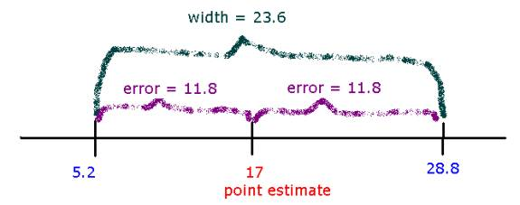

5. Population Distribution, Sample Distribution, and Sampling Distribution

Population – raw scores in population (census)
Sample – raw scores in sample taken from population
Sampling – distribution of a statistic taken from multiple samples

Sample 1 Mean Age = 31.2
Sample 2 Mean Age = 35.69
Sample 3 Mean Age = 27.89

*Illustrate each in Excel file from webpage, i.e.,
Excel file showing 95% CI and Standard Error of the Mean for 100 Random Samples

6. Sampling Distribution of the Sample Mean (M or $\overline{X}$)

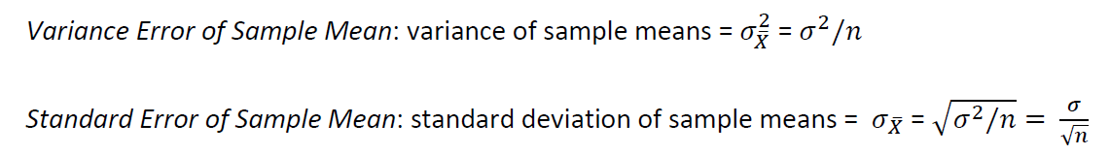

Why are estimates noted above referred to as error?

Statistics are estimates of parameters and have error (due to sampling error or bias). The variance error and standard error are estimates of how much error exists in the estimate.

7. Central Limit Theorem

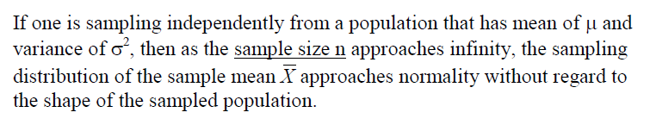

In short, as the sample size increases one may expect the sampling distribution of the mean to become normal in shape.

*Review illustration of central limit theorem from course web site

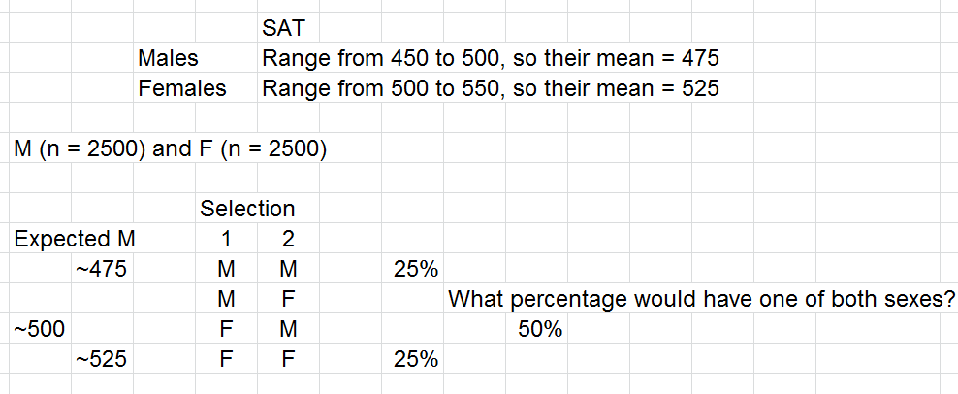

*Not done -- Show CLT using Excel file above, (a) create bimodal population data, (b) take 500 samples of size 3 and compare 500 samples of size 12 from Excel to SPSS (use transform compute [ COMPUTE y=Rnd(variable, .1). ] to make histogram bins more consistent in size

8. Confidence Intervals
Using the Z table we may form a 95% confidence interval for the sample mean:

So this can be separated into two formulas:
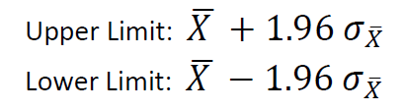

A 99% confidence interval has this formula when using the Z table:

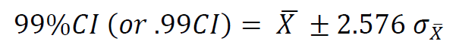
Example 1: 95%CI for Mean SAT
A sample of 100 undergraduate students at GSU reported a mean verbal SAT score of 545. The College Board, producers of the SAT, reports that each section of the SAT has a population SD of 100. Construct a 95%CI for GSU’s mean verbal SAT score.

(a) Find standard error of mean:

$$σ_{\overline{x}}=σ/{\sqrt{n}}=$$
Note:
$σ$ = population SD = 100
n = 100
$$σ_{\overline{x}}=σ/{\sqrt{n}}= {100}/{\sqrt{100}}={100}/{10}=10$$

(b) Calculate upper and lower limited based upon the sample mean:

Recall that the sample mean for the 100 students was M = 545 for verbal SAT.

Upper Limit: ?

Upper Limit:
545 + 1.96 * 10 = 545 + 19.6 =
564.6

Lower Limit = ?

Lower Limit:
545 - 1.96 * 10 = 545 - 19.6 =
525.4

The 95% CI limits are 525.4 to 564.6

Interpretation:

We can be 95% confident that the unknown population verbal SAT mean from which these students were sampled lies within the interval of 525.4 to 564.6.

Relative to USA nationwide population mean of 500, what inferences can be drawn about sample of GSU students’ verbal SAT?

Example 2: 99%CI for Mean SAT
A sample of 100 undergraduate students at GSU reported a mean verbal SAT score of 545. The College Board, producers of the SAT, reports that each section of the SAT has a population SD of 100. Construct a 99%CI for GSU’s mean verbal SAT score.

(a) Find standard error of mean:
$$σ_{\overline{x}}=σ/{\sqrt{n}}=$$

$$σ_{\overline{x}}=σ/{\sqrt{n}}= {100}/{\sqrt{100}}={100}/{10}=10$$

(b) Calculate upper and lower limited based upon the sample mean:

Recall that the sample mean for the 100 students was M = 545 for verbal SAT.

Upper Limit: ?

Upper Limit:
545 + (2.576 * 10) = 545 + 25.76 =
570.76

Lower Limit: ?

Lower Limit:
545 – (2.576 * 10) = 545 + (-25.76) =
519.24

The 99% CI limits are 519.24 to 570.76

Interpretation:

We can be 99% confident that the unknown population verbal SAT mean from which these students were sampled lies within the interval of 519.24 to 570.76.

Since national mean of 500 does not lie within this interval, we can infer (with 99% confidence) that GSU students, on average, have higher SAT verbal scores than students nationwide.

9. Margin of Error
Recall CI formula:

Using Z table, the margin of error (MOE) for 95% is

MOE = 1.96 $σ_{\overline{X}}$

and for 99% CI it is

MOE = 2.576 $σ_{\overline{X}}$

Familiar example:

Pollsters estimate that Candidate X has 48% of the vote with a margin of error of ±2%.

In this example, 48 ± 2 = 46, 50

